MPC-419

January 1, 2013- December 31, 2013

# Project Title:

Experimental and Numerical Study for the Debonding Interface Between an Existing Pavement and a New Concrete Overlay

# University:

University of Utah

# Principal Investigators:

Amanda Bordelon, Assistant Professor, bordelon@civil.utah.edu, 801-581-3578.

# Research Needs:

Most pavement projects today are a rehabilitation or rejuvenation of existing and distressed pavements. We often add more overlay layers or mill out patches for repair material rather than reconstruct the entire roadway. One of the key requirements for those repair systems is to have adequate bond strength between the existing concrete substrate and overlay throughout the service life. When a repair is performed, the differences in the properties of two materials will affect bond strength and stress distribution. Of particular relevance are differences in shrinkage, elastic modulus and thermal movement.

Repaired sections of concrete pavement often fail due to debonding or delamination of the top repaired layer. Thus there is a need to improve or to maintain the bond by improved material properties or improved interface conditions.

The importance of surface preparation and the effect of roughness have been emphasized by many researchers. Sholar et al. [1] and West et al. [2] found that surface texture of the lower layer significantly affects the interface bond. They showed that laying a new asphalt mixture over a milled existing asphalt pavement significantly enhances the shear strength of the interface between those layers. An investigation by Partl et al. [3] on the effect of contact surface roughness showed that the shear strength at the interface increases as the contact surface roughness increases. Ferrotti [4] demonstrated the effect of interlayer roughness on the measured bond strength of the interface. The interlayer roughness was quantified by performing an image analysis on the images obtained using the x-ray computed tomography equipment. Silfwerbrand [5] suggested using automatic laser equipment for quantifying the surface roughness in his study of the effect of roughness on bond of repair materials. Even with all these research studies and knowledge, bonding between layers still remains a major concern and often a cause for current pavement distresses. There is a need for an improved prediction or characterization of debonding that can eventually incur and destroy the overlay layer.

# Research Objectives:

The main objective of this research is to characterize and then model the interface bonding condition between a concrete overlay and existing pavement based on the laboratory experiments and numerical analysis. A cohesive zone element method will be compared to a solid element-spring method in finite element analysis to determine a more precise prediction of separation of layers. The element properties used in the numerical analysis will be based on the material toughness properties and the interface frictional fracture properties measured from the experiments.

# Research Methods:

*Experimental Study*

Many tests have been developed to evaluate the bond strength in the interface. Fig. 1 shows various test methods to evaluate bond strength [6]. In this study, the split tension will be used to determine bond strength. One of the advantages of using this method compared to the normal tensile test is that the specimen geometry is very simple, the specimens are easy to prepare, and the results are precise. According to the Ramey et al [7], test results shows that the cylindrical split tensile specimens gave consistent results. The average coefficient of variation (COV) for 26 test groups was 9.7%, and the COV of most groups was less than 13%. This research includes 60 specimens will be tested in split tension test (ASTM C496) and specimen will be constructed with one-half concrete and one-half repair materials as shown in Fig. 2 [8]. Table 1 shows three test variables: surface condition (sand-blasted and smooth), specimen bonded area, and types of fiber reinforcement (macro or micro fibers). A sand-blasted or shot-blasted surface is commonly performed on existing concrete pavements to improve the bond strength [9]. This common surface condition will be compared to a smooth surface, created in the lab by using a sheet of plastic, to create a negligible friction surface. The effect of contact bonding area has a significant impact on the measured bond strength [10]. Thus, two cylindrical specimen sizes of 4 x 8 in. and 8 x 16 in. will be tested to verify this bond strength versus contact area effect. Structural fibers are well known to improve toughness and at high dosages can also affect the surface micro-texture [11]. A structural fiber-reinforced concrete will be studied along with a micro-fiber-reinforced concrete to determine whether the material toughness in the new overlay layer influences the bonding strength. Table 2 shows the summary of mixture designs.

*FEM Modeling*

Nishiyama et al. [8] has developed 3D finite element analysis (FEA) model using eight-node solid elements and a spring elements to quantify the bonding level between thin concrete overlay and the existing pavement. The developed FEA model can be used to simulate different levels of bonding condition such as bonded, semi-bonded and un-bonded. A similar approach will be used in this study but will incorporate into the spring elements the fracture properties from the load-displacement of the experimental split-tensile opening test. Material properties of the concrete pavement and overlay layers themselves will also be incorporated into the model through the solid element properties. This solid element-spring analysis approach will be compared to a cohesive zone fracture model approach [12] with user-defined elements based on material fracture properties to characterize the split opening behavior of the debonding interface. The goal of this portion of research is to determine an accurate method for predicting this split opening behavior between the two pavement layers.

# Expected Outcomes:

A journal report will be created for submittal the Transportation Research Board in August 2014 for publication in the Transportation Research Record. This journal will cover the following aspects:

* A literature review of debonding test methods and selection of parameters for creating a range of bonding strengths.
* Summary measured properties including individual pavement layer material properties and the split-tensile opening between two different pavement materials.
* A summary and comparison of the two finite element analysis approaches (solid element-spring and cohesive zone element) will be given. This will include what inputs went into each approach as well as comparison of the output predicted performance versus the experimental data.
* Conclusion will be drawn on based on the influence of fiber type within the overlay layer on bond strength and verification of surface condition and contact specimen area effects on bond strength.
* Recommendations for future experimental tests and finite element approach for improved accuracy of bond prediction will be given.

# Relevance to Strategic Goals:

This proposed project and outcomes are directly related to the “State of Good Repair” strategic goal. This research will look at new ways to characterize bonding or lack of it between existing roadway surfaces and new overlays or patch repair mixtures. These bond conditions will also be modeled to aid in predicting the capacity of other existing or future designed overlay or repair pavements. It will also help with providing more tools for asset management of the many rehabilitation systems in our transportation network today.

# Educational Benefits:

At least two university graduate students will be involved in the project. The majority of the experimental portion will be performed in conjunction with the CVEEN 6225 Concrete Material Science course offered during the Spring 2013. Two students enrolled in the course will perform a simple parametric study as part of this research as their semester course project. Additional testing will commence beginning in May and carry throughout the remainder of the summer. The testing procedure will be covered in a lecture associated with a new course offering CVEEN 7290 Advanced Testing of Materials in the Fall of 2013. Information on bonding characteristics determine from the literature review and from this research findings will be integrated starting Fall 2014 into the lectures associated with our CVEEN 5570/6570 Pavement Design course. Technology transfer will also be attempted at the local/regional level by asking to participate in presenting this research at the January 2014 Annual Workshop for the American Concrete Pavement Association Utah Chapter.

# Work Plan:

Table 3 shows the proposed research schedule. The literature review for this research has begun in January 2013. Experimental tests and numerical modeling will commence starting in March of 2013. It is anticipated to take about a year to finish all laboratory testing and numerical analysis simulations. Then the remaining few months will be spent to prepare the publication for the TRB submission.

# Project Cost:

Total Project Costs: $68,418

MPC Funds Requested: $33,751

Matching Funds: $34,667

Source of Matching Funds: University of Utah Start Up-Fund for Amanda Bordelon

# TRB Keywords:

Bond strength (materials), debonding, concrete overlays, surface preparation

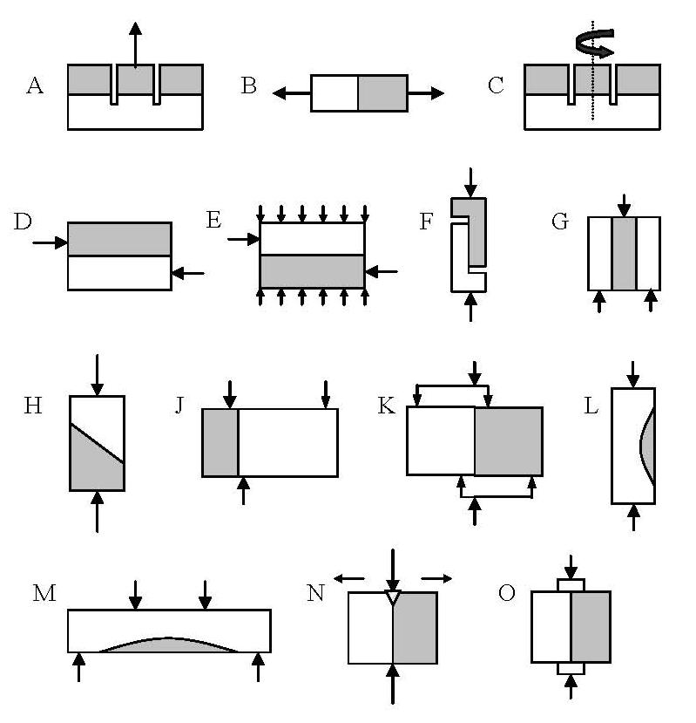

Fig.1. Test methods to evaluate to bond strength [6].

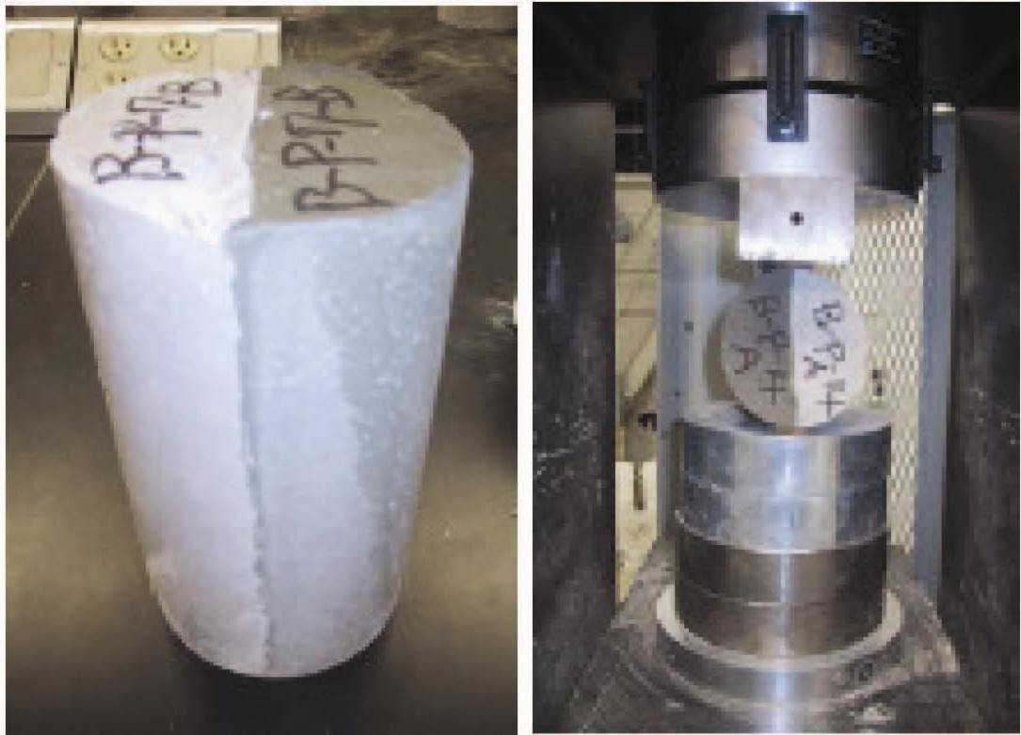

Fig. 2 Indirect tensile strength test [8].

**Table 1 Test Variables**

|  |  |  |
| --- | --- | --- |
| **Variables** | **1** | **2** |
| Interface Condition | Sand-blasted | Smooth |
| Size of Specimen (contact area) | 4 x 8 cylinder (32 in2) | 8 x 16 cylinder (128 in2) |
| Types of fiber | Strux BT50 | Stealth e3 |

**Table 2 Summary of Mixture Designs [from 10]**

|  |  |  |  |
| --- | --- | --- | --- |
| **Material** |  | **Micro-Fiber Reinforced Concrete**  **(PCC)** | **Structural Macro-Fiber Reinforced Concrete**  **(FRC)** |
| Water | kg/m3 | 187 | 187 |
| Type I Cement | kg/m3 | 328 | 328 |
| Type C Fly Ash | kg/m3 | 140 | 140 |
| Coarse Aggregate (9.5 mm NMAS) | kg/m3 | 1052 | 1052 |
| Sand | kg/m3 | 857 | 857 |
| Micro-fiber (6mm length) | kg/m3 | 0.59 | 0 |
| Macro-fiber (50 mm length) | kg/m3 | 0 | 4.6 |
| HRWR | mL/ m3 | 1028 | 1028 |
| AEA | mL/ m3 | 107 | 107 |

**Table 3 Research Schedule**

