MPC-452

April 1, 2014- July 31, 2017
Project Title:
Updating the Highway Safety Manual 2010 - Part C: Regional Consideration of the Rocky Mountains and Plain Regions

University:
University of Wyoming

Principal Investigators:
Dr. Mohamed M. Ahmed, Ph.D., Assistant Professor
Dr. Khaled Ksaibati, Ph.D., P.E., Professor, Director of Wyoming Tech. Transfer Center
Civil & Architectural Engineering
University of Wyoming
1000 E. University Ave., Laramie, WY 82071
Phone: (307) 766-5550, (307) 766-6230
Fax: (307) 766-2221 (307) 766-4444
mahmed@uwyo.edu , khaled@uwyo.edu

Research Needs:
The release of the first edition of AASHTO’s Highway Safety Manual (HSM) in 2010 was a significant milestone in the advancement of the practice of road safety analysis. Highway Safety Manual (HSM) is a result of extensive work spearheaded by the TRB committee on Highway Safety Performance. HSM will enable officials to benefit from the extensive research in safety of highways as it bridges the gap between research and practice. The HSM’s analytical tools and techniques provide quantitative information on crash analysis and evaluation for decision making in planning, design, operation, and maintenance. Already there are various state and transportation authorities applying HSM methods through the AASHTO lead state initiative.
Although the HSM is considered as the sole national resource for quantitative evaluation of traffic safety on different roadway facilities, it is understood that it is only the “first edition” and there remains room for improvement. The main limitation within the first edition of the HSM is that the development of Safety Performance Functions is based on data from few states that do not adequately represent all states and regions. It should be noted that each one of these states has different crash reporting thresholds and forms, geographical and weather features as well as demographic attributes.
The main objectives of this research project are to identify the adequacy of the first edition of the HSM to quantify the safety performance of different roadway facilities in the region, calibrate and assess Safety Performance Functions based on regional data and to provide guidelines and recommendations for future research.

Research Objectives:
The main objectives of this research project are to:
- Identify limitations and possible improvements of the implementation of the first edition of AASHTO’s Highway Safety Manual (HSM) for the Rocky Mountains and Plain Regions.
- Calibrate Safety Performance Functions by severity level and crash type for rural roadways taking into consideration the regional effect of;
- low traffic volumes,
- roadway geometry,
- crash reporting thresholds and forms,
- weather conditions,
- driver population,
- and the increase in energy related activities.
- Provide a description of the statistical and practical advantages and disadvantages of the methodology developed in the research and potential barriers to implementation.
- Provide guidelines and recommendations for future research.

Research Methods:
The main limitation within the first edition of the HSM is that the development of Safety Performance Functions is based on data from few states (California, Minnesota, Michigan, New York, Texas, and Washington State) that do not adequately represent the Rocky Mountains and Plain Regions.
The following are a few specific issues related to the implementation of the HSM in the Rocky Mountains and Plain Regions:
- Certain facility types are not addressed, including rural roadways with low traffic volumes, challenging roadway geometry and high percentage of heavy trucks.
- Each state of the abovementioned states has different crash reporting thresholds and using different reporting forms.
- Adverse weather conditions and different driver population within the region are not considered.
- The effect of specific activities in some areas (e.g., energy related activities) is not addressed.
Resolving these issues will result in more accurate crash prediction by crash type and severity which is crucial for the following reasons:
- Many crash modification factors (CMF’s) in the HSM apply only to certain collision types or crashes at certain severity levels. Proper application of these CMF’s requires accurate prediction of the number of crashes of the corresponding collision type and severity level.
- The HSM safety management methodology includes economic evaluation of the expected crash outcomes of road improvement scenarios. These evaluations apply standardized values of different crash severity levels to predicted crash count by severity level. Fully accounting for all of the factors associated with crash severity will result in better prediction of crash counts by severity, and thus, more accurate economic evaluations.
                - Data Issues
As mentioned earlier that the development of SPFs in HSM 1st edition, is based on data from the following states: Minnesota, Michigan, Texas, California, New York, and Washington State. Basic statistics of data collection can be summarized in Table 1- 4 for urban and suburban arterial segments, rural two-lane and rural multilane highway segments, and intersections, respectively.

Table 1 Data collection for urban and suburban arterials
Data Sources | Years of data | No. segments |  |  |  |  | Min.  segment  length | Total length  (mile)
 |  | 2U | 3T | 4U | 4D | 5T | 0.04 mi
Minnesota | 1998-2002 | 577 | 380 | 741 | 540 | 198 |  | 303.9
Michigan | 1999-2003 | 590 | 100 | 440 | 140 | 549 |  | 294.4
(2U: two-lane undivided arterials; 3T: three-lane arterials including a center TWLTL
4U: four-lane undivided arterials; 5T: five-lane arterials including a center TWLTL)

Table 2 Data collection for rural two-lane highways
Data Sources | Years of data | No. segments | Min.  segment  length | Total length  (mile)
Minnesota | 1985-1989 | 619 | 0.1 mi | 700
Washington | 1993-1995 | 712 |  | 530

Table 3 Data collection for rural multilane highways
Data Sources | Years of data | No. segments |  | Min.  segment  length | Total length  (mile)
 |  | Divided | Undivided | 0.1 mi | Divided | Undivided
Texas | 5 | 1733 | 1522 |  | 1749.53 | 848.29
California | 3-10 | 1087 | 356 |  | 518.9 | 150.5
New York | 7 | 197 | 159 |  | 138.79 | 85.38
Washington | 4 | 476 | 35 |  | 195.55 | 6.67

Table 4 Data collection for intersections
 |  | 4-legged SG | 3-legged  SG | 4-legged  TWSC | 4-legged  MNST | 3-legged  MNST
Rural  Two-lane | Minnesota |  |  |  | 324 | 382
 | California | 18
 | Michigan | 31
Rural  Multilane | California | 37 | 13 | 267 |  | 403
 | Minnesota | 43 | 8 | 224 |  | 171
 | New York | 71 | 282 | -
Urban and suburban arterials | Minnesota | 64 | 34 |  | 48 | 36
 | NC | 44 | 42 |  | 48 | 47
(SG: signalized; TWSC: two-way stop sign control; MNST: minor road stop sign control)
There are a few potential issues in the data that have been employed to develop SPFs for the HSM:
1) These states do not follow consistent crash reporting criterion, which will result in inconsistent underreporting rate in crash data, especially for PDO crashes. Table 5 presents the crash reporting criterion of states that have been selected for developing SPFs in HSM.

Table 5 Crash reporting criteria
States | Crash reporting threshold | Crash reporting form
Minnesota | $500 before 1994, $1000 after | Uniform form (changed in 1991)
Michigan | $200 before 1992, $400 after | Uniform form (changed in 1992)
Washington | $500 before 2000, $700 after | Uniform form, code only state route crashes. Residence reported crashes are not reported to the HSIS.
Texas | $1000 | Uniform form
California | Vary by city ( $500,$750,$1000)  Some do not report PDO | Vary by city  Short & long forms
New York
North Carolina | $500 before 1996, $1000 after | Uniform form

It can be observed from Table 5 that the threshold varies across states during the same time period, and also varies across years in a specific state. This raises a few issues. First, to develop SPFs with mixed data from different states may result in biased parameter estimates. Second, to develop SPFs with data from a specific state ignoring the change of threshold may lead to incorrect SPFs. Third, to develop one SPF with the years of data before the threshold changed and the other SPF with the years of data after the threshold changed will produce inconsistent inference. Therefore, it is very important to develop SPFs with either original consistent datasets or calibrated consistent datasets.
In addition, when developing SPFs for urban and suburban arterials, crash data collected from Washington State (2002-2004) and Florida were used to validate SPFs for road segments and intersections, respectively. As it is shown in Table 5, the crash data used for developing road segment SPFs in urban and suburban arterials has a threshold of $1000 in Minnesota and $400 in Michigan. However, the threshold in Washington State is $700, where only state route crashes were coded into the database. On the other hand, the intersection SPFs were developed with Minnesota and North Carolina crash data. To validate intersection SPFs, crash data collected from Florida were employed. However, unlike Minnesota and North Carolina, Florida uses two types of crash reporting forms, which are so-called long form and short form. Long form reports crashes including death or personal injury, leaving the scene involving damage to attended vehicles or property, and driving under the influence. Also PDO crashes are sometimes reported on long forms at the discretion of the police officer. Short form reports the other PDOs, which were not coded into database.
In order to account for the variation in thresholds, crash reporting forms, as well as other attributes, calibration factors are used to adjust crash frequency prediction in different jurisdictions when validate SPFs. The validation results show that the SPFs developed for road segments provide fair prediction of crash frequency in Washington State, while SPFs for intersections perform very poorly in Florida. This leads to the question of whether calibration factors for different jurisdictions are sufficient to account for the differences of thresholds, crash reporting forms, geographical features, as well as demographic attributes.
2) Crash data employed for rural two-lane SPF models are more than 20 years old. Within these twenty years, the change of vehicle features, and traffic mode is significant. Therefore, it is desirable to update crash models with up-to-date crash data.
3) Road segments selected for the urban and suburban study have the minimum length of 0.04 mile. It has been argued that the employment of short segments may bring about a few issues. First, crashes are normally located to the nearest 1/10 mile in rural area. Therefore, the employment of short segments increases the chance of misrepresenting crashes. Second, most of short segments have zero crashes during a few years. The preponderance of zeros may affect the performance of statistical models. Third, small segments are caused by the change of geometric or traffic features in a short distance, which may lead to unexpected crash patterns.
4) Since the procedure provided in the Highway Safety Manual is based on roadway safety performance (substantive safety) rather than design standards (nominal safety), the process is purely data driven. Quality data and data collection processes are crucial aspects of the calibration and validation of HSM SPF and CMF (Susan et al., 2010).

                - Driver Behavior
There are many factors that contribute to crash occurrence, including driver behavior, traffic and geometric characteristics, weather conditions and interrelationships between these different factors. Unfortunately, the driver behavior factors are usually not available and hard to be incorporated with crash frequency analyses. Moreover, driver populations vary substantially from location to another in age distribution, driving experience, alcohol usage, cell phone usage (using hand-held mobile devices are permitted in some states and banned in others), seat belt usage, and many other behavioral factors.
Figure 1 shows a map of hand-held cell phone bans for all drivers; talking on a hand-held cell phone is banned in 10 states (California, Connecticut, Delaware, Maryland, Nevada, New Jersey, New York, Oregon, Washington, and West Virginia) and the District of Columbia. It is worth mentioning that the use of all cell phones by novice drivers is restricted in 32 states and the District of Columbia. Text messaging is banned for all drivers in 39 states and the District of Columbia as shown in Figure 2.
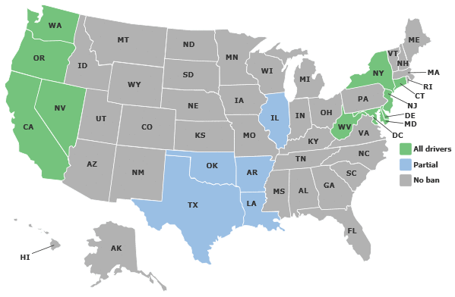
Figure 1: Map of hand-held cell phone bans (all drivers), Source (Insurance Institute for Highway Safety)
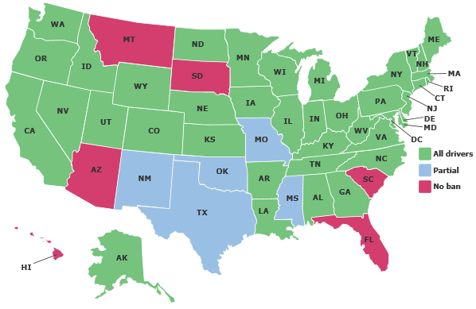
Figure 2: Map of texting bans (Note: Florida banned texting October, 2013)
                - Climate Change
While the effects of climate conditions may be accounted for in some way by adjusting the SPFs using specific-sites calibration factors, the effect of weather in the HSM first edition is not explicitly addressed.
Through climate analysis, National Climatic Data Center scientists have identified nine climatically consistent regions within the contiguous United States as shown in Figure 3. Although the development of the HSM SPFs depended on crash data collected from different states (California, Michigan, Minnesota, New York, North Carolina, Texas, and Washington State) which may represent different climatic regions, there are some regions that were not considered. Moreover, the data used for estimation of the HSM 2010 SPFs were collected for years from 1985 up to 2003, it is worth mentioning that within the last 10 to 25 years the climate has changed dramatically; the National Climatic Data Center indicated that there are many scientific evidence that the Earth’s climate is changing and the global warming will continue. The analyses showed that the 10 warmest years have all occurred in the past 12 years.
“Climate change will lead to fewer traffic accidents in West Midlands, UK”, is according to a research study from the University of Gothenburg, Sweden. The results estimates climate change to decrease the number of days with temperature below zero degrees which will also results in reduction in the number of traffic crashes. U.S. Drought Monitor reported that 48 states were affected this year because of extreme heat this summer and the odds of severe heat waves are increasing due to climate change according to various climate studies.
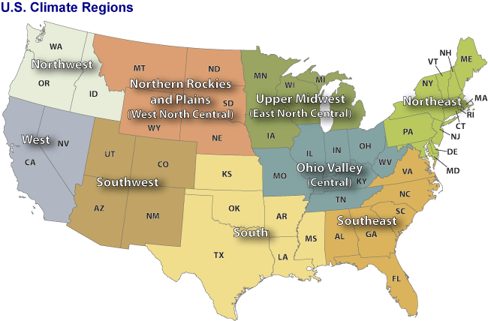
Figure 3: US Climate Regions, Source (National Climatic Data Center, NOAA)

Ahmed et al., 2012, concluded that crash frequency during snowy seasons could be approximately 82% higher than in dry seasons using crash data collected from the I-70 mountainous freeway in Colorado. In a later study, Ahmed et al., 2011, modeled crash occurrence in dry and snow seasons separately to account for the variability of climate conditions. Figures 4 and 5 from the National Climatic Data Center show the different regions by precipitation and snowfall rates. We propose that these regional differences should be considered in the process of developing SPFs.

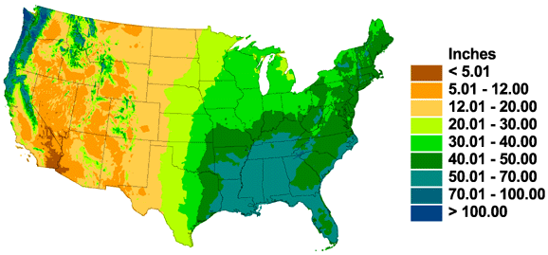
Figure 4: Annual Mean Total Precipitation, Source (National Climatic Data Center, NOAA)

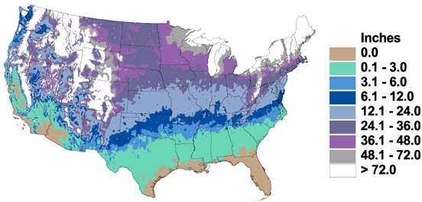
Figure 5: Annual Mean Total Snowfall, Source (National Climatic Data Center, NOAA)

                - Traffic Safety Impact Regarding “Boomtowns” and Natural Resources Extraction
The rapid development of natural gas, oil, coal, power plants and other energy resources and facilities in the western United States may generate different traffic characteristics that may impose safety issues in the affected rural western communities.
An official presentation on infrastructure studies and a mail survey of licensed drivers indicated that the level and character of traffic due to oil development contribute to both road maintenance needs and costs and to driving conditions perceived as unsafe by local residents of the “oil region” (North Dakota State University, and Upper Great Plains Transportation Institute, 2012).

                - Conclusion on the Limitation of the HSM First Edition
Recently, Qin et al., 2013, applied the HSM procedure to calibrate SPF for rural local and tribal two-lane two-way highway segments in South Dakota (SD), they concluded that the jurisdiction-specific crash SPF and CMF are drastically different from what presented in the HSM.
All aforementioned facts depict that the development of the SPFs should be regionalized based on driver population, weather conditions, crash reporting thresholds, and energy activity. In addition, climate change and its tremendous effects on the HSM predictive models should be considered by updating and recalibrating SPFs every 5 to 10 years.

Expected Outcomes:
First phase of this study (year 1) will provide methodologies to calibrate Safety Performance Functions in Wyoming, second phase (year 2) will extend the methodologies to include other states in the region (i.e. North Dakota, South Dakota, Colorado and Utah).

Relevance to Strategic Goals:
This project fits under the local and rural roadways safety area.

Educational Benefits:
One graduate student will be involved in various tasks including; conducting review of literature, data collection, defining modeling framework and estimation methodology, prioritize different roadway facilities and calibrating SPFs for them, participating in documenting the results and writing scientific journal papers.

Work Plan:
The following tasks will be performed in the first year of the study:

- Conduct a comprehensive literature review; background research and data assessment.
- Define data sources and variables.
- Define modeling framework and estimation methodology.
- Obtain geometric, traffic, and crash information on all local and rural roadways in the state of Wyoming.
- Calibrate SPFs for different facilities in different areas.
- Communicate with HSM experts, local governments, WYDOT, FHWA, and TRB Highway Safety Performance Committee.
- Prepare a report summarizing the conclusions and recommendations.
- Present the findings to interested parties such as WYDOT staff, local government officials, legislatures, and other transportation professionals.

The following tasks will be performed in the second year of the study:
- Update the review of literature.
- Obtain geometric, traffic, and crash information on all local, rural and urban roadways in the states of North Dakota, South Dakota, Colorado and Utah (Colorado and Utah represent different regional characteristics; more urbanized roadways and intersections)
- Calibrate SPFs for different facilities in different areas.
- Communicate with HSM experts, local governments, state DOTs, FHWA, and TRB Highway Safety Performance Committee.
- Prepare a report summarizing the conclusions and recommendations.
- Present the findings to interested parties such as DOT staff, local government officials, legislatures, and other transportation professionals.

Project Cost:
The first set of tasks described in this project will be performed in one year
Budget for first year:

MPC Funds Requested: $ 73,614
Matching Funds: $73,798 Source of Matching Funds: Wyoming LTAP, UW
Total: $147, 412

References:

Ahmed, M., Abdel-Aty M., and Yu R., “Assessment of Interaction of Crash Occurrence, Mountainous Freeway Geometry, Real-Time Weather and Traffic Data”. Transportation Research Record: Journal of the Transportation Research Board, Volume 2280 / 2012, Pages 51-59.
Ahmed, M., Huang H., Abdel-Aty M., Guevara B., “Exploring a Bayesian Hierarchical Approach for Developing Safety Performance Functions for a Mountainous Freeway”. Accident Analysis & Prevention. Volume 43, Issue 4, July 2011, Pages 1581-1589.
AASHTO Highway Safety Manual, 2010.
Qin, X., Chen, Z., and Cutler, C., “Evaluating Local and Tribal Rural Road Design with the Interactive Highway Safety Design Model (IHSDM)”, Final Report, 2013.
Herbel S., Laing L., and McGovern C., “Highway Safety Improvement Program (HSIP) Manual”. Federal Highway Administration, Report No. FHWA-SA-09-029, 2010.
University of Gothenburg. "Climate change will lead to fewer traffic accidents, research suggests." ScienceDaily, 15 Feb. 2010. Web. 8 Nov. 2013.

