MPC-409 (Year 2)

June 12, 2015

Project Title:
Identification of Fatigue Countermeasures for Adjusted Work Schedules Designed to Manage Fatigue During Peak Service Demand Periods in the Shortline Railroad Industry -
Phase II (Year 2)

University:
University of Denver

Principal Investigators:
Patrick Sherry, PhD, Research Professor , NCIT, 2400 S Gaylord, University of Denver, Denver, CO 80208, psherry@du.edu, 303-871-2495

Research Needs:
Based on results from our study in (MPC- 409) and input from representatives of the Short Line Railroad Association (ASLRRA) it is apparent that railroad employees in the shortline railroad industry work long hours and often during the time between midnight and 5am. The Rail Safety Improvement Act of 2008 creates difficulty for short line railroad operators during peak harvest season. The Hours of Service Act (HOS) was amended by the 2008 RSIA. Currently, if railroad employees work for six consecutive days, they must have at least two days off before they can work again. Working seven consecutive days is acceptable if the seventh day is required to return employees to their home terminal. However, if employees work seven consecutive days, they must have at least three consecutive days off before they can return to duty. In peak seasons service demands are very extreme it is difficult for crews to operate within the time constraints. Consequently, there is a need to address ways to assist smaller railroads with limited budgets and fewer operating crews to better managing the fatigue associated with long hours of work.

Recently Gertler et . al (2013) released a study showing that most road freight jobs do not have a regular start time. According to the FRA, the distribution of start and end times for T&E is such that only 17 percent of T&E jobs start between 6 and 8 a.m. Figure 1 provides the median work in 2 weeks and the median daily duty hours for each T&E schedule group. By comparison, start times in

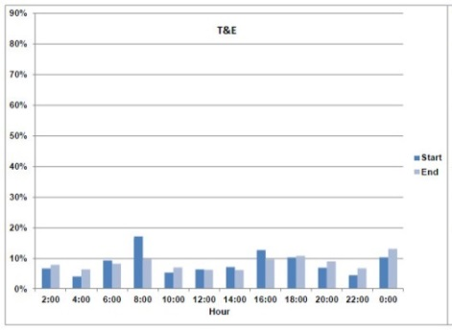 | 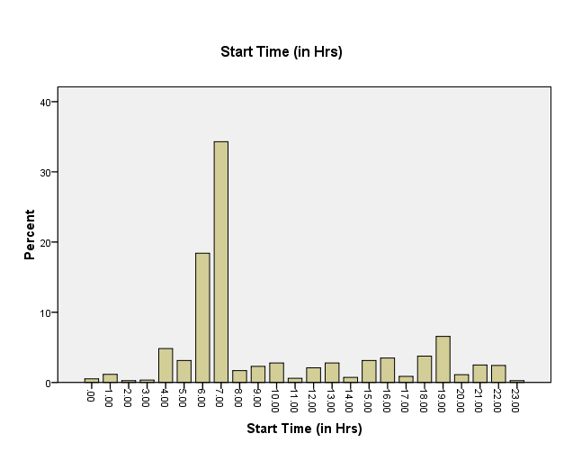
Figure 1. T&E freight railroad start times from FRA studies. (Gertler, et. al., 2013). | Figure 2. Shortline railroad start times. (Sherry, 2015).

obtained from data from the Sherry (2015) (MPC-406) study shows that shortline industry work schedules are more predictable with approximately 53% of starts occurring between 6 and 7 am with only 16% of work shifts starting after 6pm. Consequently, the identification of viable fatigue countermeasures that are viable is more likely in the shortline setting.

Many crew work schedules might have natural opportunities for the implementation of fatigue countermeasures. For example, in Figure 3, it can be seen that a typical shortline railroad employee has a regular midnight shift job commencing at 23:00 hours and ending at 8:00 hours the next day. Results of the analysis of the work schedule against the standard FRA Fatigue Analysis Scheduling Tool (FAST) (Gertler, 2012) suggested that there are several days where the individual becomes so fatigued that their cognitive performance falls below recommended levels and into the high risk area (red zone). Strategic application of napping and rest periods might reduce fatigue (and bring the plot up out of the red zone) as shown by the plot of the effects of fatigue in Figure 4.
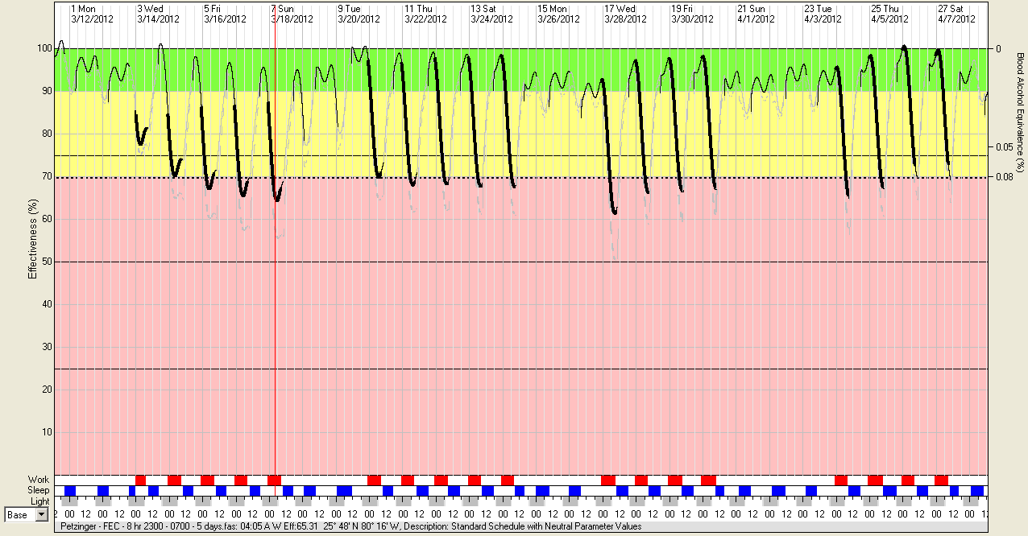
Figure 3.
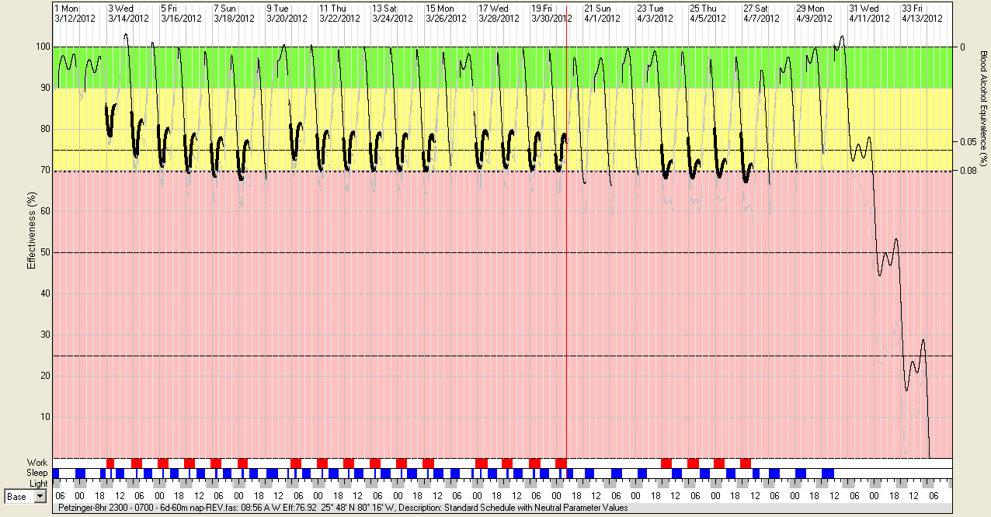
Figure 4.

This is an important issue for railroads operating in the Bakken area, hauling crude oit. For example, Then in 2011, the crew of a BNSF coal train in Red Oak, Iowa, fell asleep and instead of stopping struck the rear of a parked equipment train, crushing the cab and killing the crew of the coal train, sparking a diesel fire and causing $8.7 million worth of damage. Several report in news media have questionnaire the possible role of fatigue in contributing to rail accidents due to the fact that so many shipments involve crude oil nowadays. (Rail Workers Raise Doubts About Safety Culture As Oil Trains Roll On). Crude oil was once a rare commodity in rail cars. Last year BNSF, the leading crude oil transporter, hauled more than 600,000 barrels per day across its network, including as many as 18 trains per week through the Columbia River Gorge.

Evaluating the effects of fatigue countermeasures inserted in the work schedules will provide evidence as to the effectiveness of these countermeasures and also hopefully lead to a safer and more productive and therefore more economically competitive transportation system. Accordingly, by gathering data on hours worked, hours of sleep, alertness and fatigue prior to, during, and after implementation of fatigue countermeasures for a period of at least ninety days we will be able to evaluate the effectiveness of the countermeasures. Data collection will consist of three 30 day periods using sleep diaries and other self-report techniques, as well as observations and data gathered through sleep monitoring techniques. In addition, the fatigue models approved by the FRA will be utilized to evaluate the effectiveness of the interventions (Hursh, Raslear, Kaye, & Fanzone, 2009).

Thus, the proposed study will, based on previous research, identify various fatigue countermeasures that will be tested in the operational environment. Ultimately, the schedules and the appropriate countermeasures will be posted on the web sites and distribute to the ASLRRA.

Research Objectives:
The objectives of this project are as follows

- Identification of fatigue countermeasures that can be implemented in short-line railroad work schedules.
- Implementation of fatigue countermeasures that may lead to significant reduction of fatigue.
- Evaluation of fatigue countermeasures in an operational environment for reduced fatigue.
- Recommendations for best practices to implement findings.
- Recommendations for managing high service demands in short line environments.

Research Methods:
The project will begin with review of available literature on fatigue and fatigue countermeasures in the railroad industry. The literature review will help in identifying what adjustments and countermeasures have already been utilized. These efforts may have already taken place in the passenger industry. Following the literature review, using data obtained in the previous study we will attempt modifications or adjustments to the schedules.

Interventions
Proposed countermeasures will be implemented by the participants and management. The proposed countermeasures, obtained through the literature review and also through the reslts of the previous project will include:

- Education. Study participants will receive briefings and handout with information pertaining to sleep hygiene.
- Close Supervision. Given the fact that we are asking the individuals to work in a setting that is more at risk for fatigue and its negative consequences, railroad managers will be asked to provide closer supervision of their employees during this time in the form of visual inspection or phone contact during these times.
- Adjusted Hours: In some cases it may be possible to adjust the start times, end times etc. that employees work to create a work situation more favorable to the alleviation of fatigue. One such adjustment would be to end work prior to 5 am.
- Napping. Railroads participating in the study will be expected to provide at least 60 minutes of opportunity for employees to sleep or nap during the hours between midnight and 5 am. This time period should afford the opportunity for at least a 30-minute nap and accommodate the operational requirements necessary for the nap to be undertaken.

Data Collection

Data will be collected at three different times: prior to, during and after the implementation of the proposed fatigue countermeasures.

Table 1. Overview of data collection procedures.

Phase | Instruments | Duration | Interventions
1. Pre-Test | Sleep Diary  Fatigue Survey  Operational Data  Sleep Monitors | 30-days
2. Intervention | Sleep Diary  Fatigue Survey  Operational Data  Sleep Monitors | 30-days | Napping &  Additional Supervision
3. Post Intervention Phase | Sleep Diary  Fatigue Survey  Operational Data  Sleep Monitors | 30-days

Data collection will consist of the collection of hours of sleep, ratings of alertness, fatigue, stress and caffeine intake according to the plan outlined in Table 1. Finally, post intervention follow -up data will be analyzed to determine whether a reduction in fatigue took place.

Measures

Sleep Diary. A standard sleep diary or sleep log (Gertler & DiFiore, 2011) will be provided to the study participants with the expectation that they will complete the sleep log daily during the course of the study. Previous research has demonstrated that the Sleep Diary is a reliable and effective method for recording and measuring the actual amount of sleep obtained. In addition, the Sleep Diary has been used, and is recognized by the FRA as an acceptable measure of actual sleep obtained in an operational environment.

Sleep Questionnaires. All study participants will complete a sleep questionnaire designed to gather information about sleep habits, sleep patterns, effects of sleep, level of activity, level of fatigue, moods, stress, etc. This is a standard questionnaire that has been used for several studies of sleep and fatigue. The Epworth Sleepiness Questionnaire and the World Health Organization Work Performance scales are also included in the packet. (Sherry, 2015).

Operational Data. Additional operational data will be gathered in the course of the study. Information regarding start times, end times, length of time on duty, accidents, incidents, derailments, etc. will also be gathered. Crew rosters, line-ups, and other operational incident reports will be used to assess the feasibility and safety of the proposed interventions.

Behavioral Data. One additional measure being considered is the inclusion of a behavioral monitor of sleep using the Fitbit or Jawbone device. These devices are similar to actigraphs used by Gertler, et. al. (2012) in their study of trainmen. Such a device would add some additional information to the study and might also be helpful to include and motivate people to participate in the study. The novelty of these devices, combined with the educational information associated with it, could add greatly to the acceptance of the idea and the enrollment of persons in the study.

Expected Outcomes:
The research will identify effective fatigue countermeasures that augment the effectiveness of adjusted schedules and reduce fatigue will be obtained. This information will be disseminated and made publicly available to inform the public and other shortline railroads.

Relevance to Strategic Goals:
This project will contribute to the safety of employees and personnel of the railroad industry by examining the safety risk of various employee work schedules in the short-line railroad industry. In addition, it will enhance and contribute to the safety of the rail industry and the public at large. The project will enhance the existing federal effort by contributing to safety, economic competitiveness and efficiency and developing the work force in the transportation system in the US.

Educational Benefits:

A graduate student will assist with the project thereby contributing to the development and education of graduate students who will later be employed in the industry.

Work Plan:

Achieving the overarching goal of this project requires the completion of several different tasks. Due to the fact that the project will be built upon the initial work undertaken a shorter timeline is anticipated and most work should be able to be completed in under six months. Permission from railroads and FRA will be needed to implement these interventions with the railroads and the FRA.

Task 1 - Literature Review
Various sources will be consulted to identify relevant psychological, operational, and experimental studies and papers. These papers will be reviewed for their identification of relevant work practices, schedules, and proposed fatigue countermeasures that have been thought to reduce fatigue and the associated risk of accident of injury.

Task 2 – Implementation of Fatigue Countermeasures
In cooperation with the ASLRRA the investigators will identify work schedules and implement the proposed fatigue countermeasures during the peak season (June to October).

Task 3 – Data Collection
Data collection will proceed according to the plan outlined in Table 1 above.

Task 4 – Data Analysis
Data will be analyzed to assess the changes and improvement in amount of sleep obtained, reduction of fatigue and increased alertness. In addition, the work schedules will be subjected to analysis byt eh FAST tool to assess the potential for fatigue and accident risk.

Task 5 - Reporting and Dissemination
A final report will be produced describing the results of the research and identification of successful countermeasures. Recommendations for the implementation of countermeasures to the work schedules will also be reviewed. These results will be disseminated at regional and national meetings where members attend and posted on relevant web sites. The results will be presented at national conferences and disseminated in the form of scholarly papers which will be published in reputable journals.

 | Months
Task | 1 | 2 | 3 | 4 | 5 | 6 | 7
1
2
3
4
5

Project Cost:
Total Project Costs: $188,312
MPC Funds Requested: $ 93,312
Matching Funds: $ 93,312
Source of Matching Funds: PI time and effort, and short-line railroad association (ASLRRA)

TRB Keywords: Fatigue, Human Factors, Safety, Hours of Service

References:

- Raslear, T. (2009). Validation and calibration of a fatigue assessment tool for railroad work schedule. US Department of Transportation Federal Railroad Administration. DOT/FRA/ORD -06/21.

- Hursh, S., Redmond, DP, Johnson, ML, et. Al. (2004). Modeling fatigue for applied research. Aviation Space and Environmental Medicine, 2004, 7, 3, (Suppl) A44-A53.

- Raslear, T., & Coplan, M. (2004). Fatigue models as practical tools: Diagnostic accuracy and decision thresholds. Aviation Space & Environmental Medicine, 75, 3, (Suppl), A168-A-172.

- Hursh, S., Raslear, T., Kaye, S., & Fanzone, J. (2006). Validation and calibration of a fatigue assessment tool for railroad work schedules, summary report. (Report No. DOT/FRA/ORD-06/21). Washington, DC: Federal Railroad Administration. (Available at http://www.fra.dot.gov/eLib/details/L02535)

- Gertler, J., Hursh, S., Fanzone, J., & Raslear, T. (2012). Validation of FAST model sleep estimates with actigraph measured sleep in locomotive engineers. (DOT/FRA/ORD-12/05). Washington, DC; Federal Railroad Administration. (Available at http://www.fra.dot.gov/eLib/details/L01288).

- Gertler, J., DiFiore, A., Raslear, R. (2013). Fatigue Status of the U.S. Railroad Industry. (Report No. DOT/FRA/ORD-13/06). Washington, DC: Federal Railroad Administration. (Available at http://www.fra.dot.gov/).

- Gertler, J., & DiFiore, A. (2011). Work schedules and sleep patterns of railroad train and engine service employees in passenger operations. (DOT/FRA/ORD-11/05). Washington, DC: Federal Railroad Administration. (Available at http://www.fra.dot.gov/eLib/details/L01305).

https://www.documentcloud.org/documents/1229805-ntsb-railroad-accident-report-1202.html#document/p9/a2
http://www.opb.org/news/article/workers-question-safety-culture-in-railroads-hauli/
http://www.fra.dot.gov/Elib/Document/3436

