MPC-472

May 9, 2015
Project Title:
Developing an Optimization Model for Managing County Paved Roads
University:
University of Wyoming
Principal Investigators:
Khaled Ksaibati, Ph.D., P.E.
Professor
Dept. of Civil & Architectural Engineering
University of Wyoming
Laramie, WY 82071
(307) 766-6230
khaled@uwyo.edu

Promothes Saha, Ph.D.
Postdoctoral Research Associate
Dept. of Civil & Architectural Engineering
University of Wyoming
(307) 399-8650
psaha@uwyo.edu

Research Needs:
In the state of Wyoming, there are a total of 27,831 miles of roadway owned and maintained by federal, state, and local entities. Approximately, 63 percent of these roads are maintained by local governments. Approximately, 15 percent of these local government roads are paved while the rest are unpaved.
According to Moving Ahead for Progress in the 21st Century Act (MAP-21), each state is required to develop a Pavement Management System (PMS) to improve or preserve the present pavement condition and the performance of the system (FHWA, 2014). All state DOTs already have their own pavement management systems. The Wyoming Department of Transportation (WYDOT) utilizes their PMS to maintain 6,844 miles of interstate and state highways. Currently, there is no PMS or road maintenance database for the 63 percent of roads maintained by Wyoming local governments. In a recent study by Huntington et al, 2013, a recommendation was made to establish a pavement management system for local roads. This proposal concentrates on establishing an optimization procedure for managing the 2,550 miles of county paved roads shown in Figure 1. The proposed PMS for county roads will be developed considering local factors and traffic conditions which are significantly different from the state managed roadways (Wolters, Zimmerman, Schattler, & Rietgraf, 2011).
Any PMS consists of two basic components: a comprehensive database and a set of tools or methods that can assist decision makers in establishing cost effective strategies for evaluating and maintaining pavements. The comprehensive database should contain current and historical information on pavement condition, structure, and traffic. The set of tools or optimization techniques will determine existing and future pavement conditions, predict financial needs, as well as identify and prioritize pavement preservation projects. In 2014, WYDOT and the State Transportation Innovation Council (STIC) funded a research project to develop a comprehensive database for county paved roads. As part of that study, a comprehensive data collection effort was conducted by the Wyoming T2/LTAP center to collect roadway inventory data, traffic counts, roadway widths, pavement condition data and roadway thickness. This proposal seeks to develop the second component of PMS which includes developing a set of tools to optimize the conditions of county paved roads.
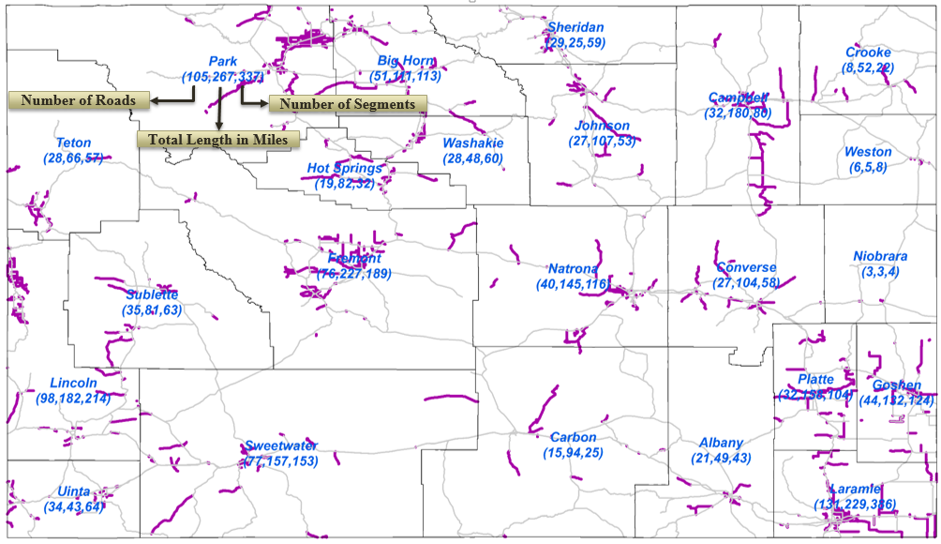
Figure 1: Locations of County Paved Roads

Research Objectives:
This research project has the following main objectives:
- Develop a county model for estimating PSI as a function of PCI, IRI and Rut Depth.
- Propose a pavement performance model for county paved roads.
- Develop a model to optimize county road conditions.
- Incorporate the optimization model into a software which can be used by local governments for managing county paved roads.

Research Methods:
The overall methodology of this study is summarized in Figure 2. The pavement condition data collected on all paved local roads by the Wyoming T2/LTAP center in 2014 will be fully utilized in this study. The proposed methodology is structured as a two-year effort. It is envisioned that the aforementioned research objectives will be achieved by completing the seven major tasks described below. Tasks 1 through 3 will be performed in Year 1 while the remaining tasks 3 through 7 will be completed in Year 2.

IRI, Rut Depth
and PCI
Pavement Serviceability Rating (PSR)
Roadway Segmentation
Develop PSI Model
Obtain PSI for each Roadway Segment
Optimization Model
Treatment Selection
Road Width
Rut Depth
List of Projects
Budget
Performance Model
Next Year PSI
Analysis Period
Output: List of Projects with Selected Treatment for Each Year within Budget

Figure 2: Research Project Methodology

Task 1: Conduct a comprehensive Literature Search
A comprehensive literature search will be conducted on pavement management systems for counties. The search will concentrate on low volume roads, PSI prediction models, pavement performance models, and optimization techniques utilized in PMS.
Task 2: Develop a PSI Prediction Model
WYDOT is currently using the following model to calculate PSI for state highways:
$$PSI=5.35e^{-0.0058*IRI} -4*RUT^{2}-3\left\{1-\left(\frac{PCI}{100}\right)\right\}$$ | (1)
As this model was developed for state highway system, there is a need to develop a similar model that fits well with county paved roads. The following two sub-tasks describe the data collection and regression analysis required to develop the county PSI model:
Task 2.1: Data Collection
In order to develop a model for estimating PSI as a function of PCI, IRI and Rut Depth, all of these parameters need to be collected. In 2014, IRI and Rut Depth, and video logs which resulted in PCI data were collected and the Wyoming T2/LTAP has already summarized this data in a comprehensive data base. In order to develop a PSI model, Pavement Serviceability Ratings need to be collected. Gulen et al. and Al-Omari and Darter (Gulen, Woods, Weaver, & Anderson, 1994; Al-Omari & Darter, 1994) studied correlation of PSI with IRI where procedures for PSI data collection were documented. According to this procedure, appropriate number of representative drivers and passengers should be selected to rate an appropriate number of test sections using representative cars. Each person rates the sections once as a driver and once as a right front seat passenger. The collected ratings should be then entered and summarized in spreadsheets.
Task 2.2: Data Analysis
This task focuses on developing a PSI model for county paved roads. Many statistical techniques are already available. They include straight line extrapolation, regression, mechanistic-empirical, polynomial constrained lease squares-shaped curve, probability distribution and Markova (Shahin, 2005). This task will consider regression techniques in developing a model for calculating PSI using pavement condition parameters (PCI, IRI and Rut Depth).
Task 3: Develop a Pavement Performance Model
In order to predict future PSIs, the development of pavement performance model for county roads is needed. WYDOT has a database which contains historical PSIs for secondary roads. That database was used by WYDOT to develop the following performance model:
$Pavement Age=0.00005*PSI^{3}-0.0029*PSI^{2}-0.0306*PSI +4.2744$ | (2)

This task will concentrate on validating this model for use on county paved roads. If the model does not fit, recommendations will be made to do the necessary changes to develop a more suitable model for county paved roads.

Task 4: Develop an Optimization Model
This task focuses on identifying and developing the most suitable network level optimization model to manage county paved roads. The structure of an optimization model can be separated into two general levels: network and project. The network level deals with the pavement network as a whole and it is generally useful for planning and budget. On the other hand, the project level deals with condition, maintenance, construction and rehabilitation activities for specific projects.
The proposed optimization model considers the network-level analysis only to provide decision makers with the tools so that they can establish budget needs. Network optimization models consider the most sophisticated techniques to simultaneously evaluate an entire local pavement network. Specific Maintenance, Rehabilitation, and Repair (MR&R) projects can be selected based on maximum budget levels, or minimum performance level. Such information can be provided to decision makers when requesting funding.
Task 5: Develop PMS Software
Under this task, a user-friendly software will be developed to help counties in selecting various rehabilitations and maintenance strategies. The software will incorporate all the models developed in tasks 2 and 3 in addition to the optimization model developed in task 4. The inputs of this program will include: IRI, rut depth, PCI, roadway width, analysis period, and budget. Outputs will include a list of the projects within the specified budget levels considering several options such as: maximizing overall PSI, minimizing rut depth and etc.
The developed software will be implemented in one county for verification and then it will be implemented on the overall data set from all 23 counties.
Task 6: Report Preparation
A final report containing all aspects of the proposed research will be prepared and submitted to MPC at the conclusion of the project. The final report will include outcomes of the proposed Tasks 1 to 5.
Task 7: Implementation
The research findings and the developed software will be made available to interested local governments in the state of Wyoming. In addition, the research findings will be disseminated through technical presentations at local, regional and national conferences.
Expected Outcomes:
The research outcomes will provide local governments and state agencies as well as other transportation agencies nationwide the necessary tools to optimize budgets for managing county paved roads. It is believed that the research outcomes will be of immediate interest not only to local governments in Wyoming but also other states.
Relevance to Strategic Goals:
The project outcomes will address four of the strategic goals associated with the MPC program and the U.S. Transportation Research Board as well as the USDOT’s requested emphasis areas described as follows:
- Economic Competiveness– Achieve the maximum societal benefit from transportation investments at the local levels.
- State of Good Repair – The proposed PMS would improve the overall pavement condition.
- Safety – Reducing rut depth as a result of better utilization of fund will improve safety.
- Environmental Sustainability – Enhancing pavement performance and optimizing treatment applications is consistent with environmental sustainability.
Educational Benefits:
Both graduate and undergraduate students will be working on this study. The study will provide the students with an excellent opportunity to interact with transportation professionals and learn about transportation related studies. In addition, the techniques developed in this study will be incorporated in the Pavement Management System class taught at UW.
Work Plan:
The projected duration for the research presented in this proposal is 24 months. It is envisioned that tasks 1 through 3 will be performed in year one and the rest of the tasks will be completed in year 2.
Project Cost:
MPC Funds Requested: $84,585
Matching Funds: $ 85,156
Source of Matching Funds: UW,WY LTAP, State of Wyoming
Total Project Costs: $169,741

TRB Keywords:
Pavement Management System (PMS), county roads, risk-based PMS, optimization model.
References:
Al-Omari, B., & Darter, M. (1994). Relationships between international roudhness index and present serviceability rating. Transportation Research Record (1435).
CDOT. (2013). CDOT's Risk-based Asset Management Plan. Retrieved June 17, 2014, from http://www.tamptemplate.org/wp-content/uploads/tamps/022_coloradodot.pdf
City of Milton. (2009). Pavement Management Evaluation and Recommendation. Retrieved October 10, 2014, from http://www.cityofmiltonga.us/vertical/Sites/%7BABDC6828-BCD1-4EB9-8063-A52F3C899020%7D/uploads/%7BB03B7881-A9A0-419F-89C5-86833466698E%7D.PDF
FHWA. (2014). Asset Management. Retrieved May 23, 2014, from http://www.fhwa.dot.gov/asset/plans.cfm
Gulen, S., Woods, R., Weaver, J., & Anderson, V. (1994). Gulen, S., Woods, R., Weaver, J., & Anderson, V. L. (1994). Correlation of present serviceability ratings with international roughness index. Transportation Research Record (1435).
Huntington, G., Pearce, A., Stroud, N., Jones, J., & Ksaibati, K. (2013). Mitigating Impacts of Oil and Gas Traffic on Southeastern Wyoming County Roads. Cheyenne: Wyoming Department of Transportation.
Saha, P., & Ksaibati, K. (2015). A Risk-based Optimization Methodology for Managing County Paved Roads. The 94th Transportation Research Board Annual Meeting 2015.
Saha, P., Liu, R., Melson, C., & Boyles, S. (2014). Network Model for Rural Roadway Tolling with Pavement Deterioration and Repair. Computer-Aided Civil and Infrastructure Engineering,29, 315-329.
Shahin, M. (2005). Pavement Management for Airports, Roads and Parking Lots (Vol. 501). New York: Springer.
Wolters, A., Zimmerman, K., Schattler, K., & Rietgraf, A. (2011). Implementing Pavement Management Sysems for Local Agencies. Illinois Center for Transportation.
WYDOT. (2014). Transportation Asset Management Plan. Retrieved June 17, 2014, from http://www.tamptemplate.org/wp-content/uploads/tamps/021_wyomingdot.pdf

