MPC-490

July 31, 2015
Project Title:
Longevity of Air Pollution Mitigating Photo-Catalytic Coatings on Transportation Infrastructure

University:
University of Utah

Principal Investigator:
Amanda C. Bordelon, Ph.D., Assistant Professor
University of Utah, Civil and Environmental Engineering
110 Central Campus Drive, Room 2038, Salt Lake City, UT 84112
Phone: 801-581-3578
E-mail: bordelon@civil.utah.edu

Research Needs:
It is known that in large urban areas, a high concentration of air pollutants at the street level can harm severely sensitive populations and affect the general public health with cumulative exposure. The sensitive population groups include children and elderly as well as some with weakened immune systems. When these people are exposed to high air-pollutant concentrations, they present higher risk to be diagnosed of respiratory diseases like asthma and emphysema. As reported by the United States Environmental Protection Agency (EPA) the most commonly found harmful air-polluting chemicals in urban areas include Nitrogen Oxides (NO_{x}), Ground Level Ozone (O₃), Particulate Matter (PM₁₀ and PM_{2.5}), Carbon Monoxide (CO), Sulfur Dioxide (SO₂), and Lead (Pb). The Clean Air Technology Center (CATC), defines NOx as one of the main man-made air polluting chemicals, of which can be found in seven forms (N₂O, NO, N₂O₂, N₂O₃, NO₂, N₂O₄, N₂O₅)(1). Even when all mentioned nitrogen oxide forms impose a threat to human health, the EPA only regulates Nitrogen Dioxide (NO₂) levels, because the NO₂ form is the most common in the atmosphere. This form is directly generated from the combustion of fossil fuels by humans who use vehicle transportation and heating furnaces, as well as through power generation and industrial production plants exhaust. Moreover, when in the presence of Ultra Violet (UV) light during the day, NO₂ actively reacts in the atmosphere with any other synthetic or naturally produced Volatile Organic Compounds (VOCs) to produce ground level tropospheric ozone O₃, acid rain, and PM_{2.5}.

NO_{x} plays a significant role in air pollution as it can create O₃ in the presence of UV, and it contributes to the formation of PM_{2.5}. It has been reported that breathing O₃ and inhaling PM_{2.5} can trigger a variety of health problems that include chest pain, coughing, throat irritation, congestion, and can also reduce lung function and produce inflammation of the lining of the lungs (2). It has been observed that all regions of the United States have been in-compliance with the current National Ambient Air Quality Standards (NAAQS) (1) for NO₂ (defined as 53 ppb averaged annually, or 100 ppb averaged over one hour). In addition, the country has reduced concentrations of PM_{2.5} below of the national standard in recent years due to tighter restrictions on vehicle and industrial exhaust (3). However, most regions of the US do not meet the O₃ standards as shown in Figure 1(4). It is anticipated that although the limits of the NO_{x} are lower than the standard, they will contribute to this heightened O₃ concentration. Consequently, large portions of the population are still being exposed to hazardous levels of ozone. However, because NO_{x} is the main pollutant that is created by human activities, this research project will be targeting it in an attempt to reduce it further.

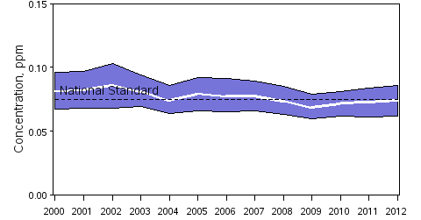
90% of sites have concentrations below this line.
10% of sites have concentrations below this line.
National Standard
Figure 1 Ozone Air Quality National trend (Annual Average of 897 sites 4th Maximum of Max 8-Hr Average Concentration) (4).

It is imperative to find new and better ways to reduce the amount air pollutants on behalf of the health and wellbeing of people living in urban areas. Over the past ten years, a significant number of studies have been focused on understanding photocatalytic properties of several materials for air and water purification. Amongst these photocatalytic materials, titanium dioxide (TiO₂) is a naturally occurring compound found in four stable crystalline forms: ilmenite, brookite, rutile, and anatase. Because it has no absorption in the visible region, TiO₂ appears to be white to the human eye, and it has been widely used as a white pigment for centuries (5). It is also similarly used in common household products such as toothpaste, food coloring, sunscreen, paint, plastics, and cosmetics. Photocatalytic TiO₂ has been studied because of its ability (while in the presence of UV light) to break down water molecules into hydroxyl radicals without consuming itself. These hydroxyl radicals are highly reactive and can further combine with nearby molecules in air or water. In the presence of harmful pollutants such as NOx’s or VOC’s in the air, the hydroxyl radicals generated by photocatalysis will combine with these molecules breaking them up to form other non-toxic compounds. Additionally, photocatalytic TiO₂ activated by UV light can decompose other non-volatile organic materials like dirt, grime, oil, and particulates, which gives materials coated with TiO₂ self-cleaning characteristics.

Some commercial building materials have been designed including TiO₂ in their formulations and are reported to reduce NOx significantly (up to 97.92%) from the surrounding air (5). These photocatalytic construction materials often are highly expensive to produce, causing most contractors not to utilize them in their bids in order to stay economically competitive, unless environmental-based goals are specified. More importantly, it has been recently observed that the photocatalytic efficiency of concrete containing embedded TiO₂ is drastically reduced by 77% to 86% within less than a year, and is specifically associated with the acceleration of a chemical reaction and limestone by-product formed on the surface of the concrete (6–8). Researchers have identified that Relative Humidity (RH) of the surrounding air, in combination with UV irradiance levels, do affect the TiO₂ photocatalytic reaction rates (6, 9–12). Previous research at the University of Utah focused on rejuvenation methods to restore the reduced photocatalytic properties of concrete containing TiO₂ (6). A separate study focusing on the TiO₂ efficiency for removing toluene instead of NOx, found that the photocatalytic efficiency was blocked after low RH conditions, but then completely rejuvenated after a short exposure of high RH along with UV light (9). It is hypothesized that TiO₂ products such as spray-on coatings may be more effective than embedded TiO₂, particularly if concrete is used as the constructed surface material. This research will specifically investigate using TiO₂ coatings on various transportation infrastructure materials in order to investigate if not only the coating can effectively remove NOx, but more importantly to understand an appropriate method to rejuvenate or reactivate TiO₂ surface treatments should they become blocked or present reduced NOx removal efficiency.

Research Objectives:
The main objective of this research is to evaluate experimentally the durability of construction materials used in transportation infrastructure (concrete, asphalt, aluminum, wood and galvanized steel) coated with TiO₂ surface treatments and evaluate their durability in terms of their photocatalytic NOx removal efficiency over time, and their physicochemical integrity.

Research Methods:
Humidity Effect
The University of Utah Concrete lab currently houses a photo-catalytic efficiency measuring system (Figure 2). This includes a chemiluminescent NO_{x} analyzer (Horiba APNA 370) in conjunction with a photo-reactor designed based on a modified ISO 22197-1 International Standard that measures NOx reduction efficiency of different photocatalytic materials. Since it has been observed that humidity plays an important role in the photocatalytic reactions, this device has been recently modified to apply a given humidity condition to the specimen as it is tested. Specimens with 1 ft² surficial area will be fabricated and then coated with different TiO₂ surface treatments. The specimens will be analyzed by comparing the amount of NO_{x} removal efficiency at different constant values of RH (ranging from 15, 35 and 70% humidity) in order to establish the initial NOx removal efficiencies under different climatic conditions (from dry to humid).

Simulated and Natural Weathering
A recently purchased environmental chamber, which can be programmed to cycle humidity and temperature levels over time on several specimens inside the chamber, will be used. This chamber will allow us to simulate weather cycles in a controlled and clean environment. It is anticipated that additional durability testing including salt scaling, freeze-thaw cycles, and abrasion will also be applied to the surface of these TiO₂-coated materials as part of the simulated weathering protocols for this research. These protocols will allow us to measure NOx removal efficiency of specimens under simulated weathering conditions, and compare it to the specimens that underwent natural weathering. For natural weathering, the specimens will be placed outdoors on the rooftop of the Civil and Environmental Engineering Building at the University of Utah. Access to weather data from the University of Utah weather station will allow us to learn about the conditions the specimens endured outdoors.
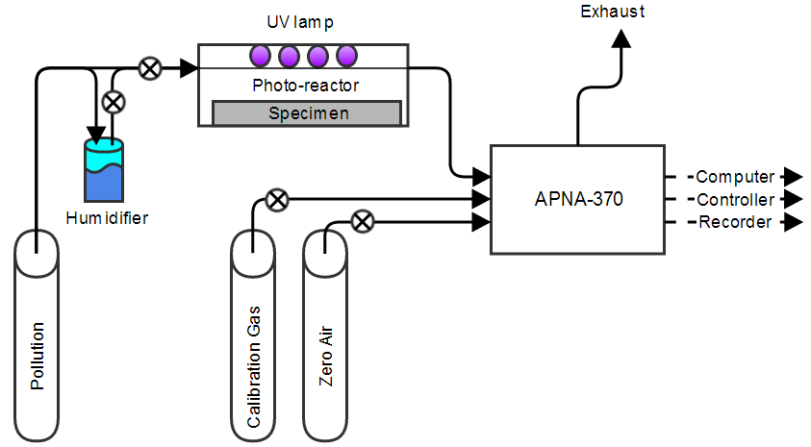
Figure 2 Schematic diagram of experiment system configuration measuring photocatalytic activity.
Monitoring Surface Chemistry
In order to observe of any changes that may take effect on the TiO₂ coatings due to weathering, and in order to assess the physical integrity of these coatings, a Scanning Electron Microscopy (SEM), and/or Spectroscopy techniques will be used. Moreover, an investigation including qualitative and quantitative assessment of chemical species possibly deposited on the surface of these materials that could reduce the photocatalytic efficiency of TiO₂ coatings will be performed.

Rejuvenation Techniques
When the NOx removal efficiency of the photocatalytic materials starts to decline, different techniques to reactivate or rejuvenate the surface coating will be tested. Some of the techniques include regular washing with just water, washing with water and common detergents, power washing, sand or corn-cobb blasting, acid etching, high humidity exposure to UV light (9), among others. After applying the rejuvenation treatments, NOx removal efficiencies will be measured and compared to initial pollutant reduction when the TiO₂ coating was first applied.

Expected Outcomes:
From this research project, one potential outcome is to find a sustainable and viable technique for the production of photocatalytic construction materials to be used in infrastructure for pollution control of urban areas. From the results of this research, the advantages and pitfalls of TiO₂ coatings will be known, allowing further research to develop in order to improve durability and viability of these materials. Results of this project can be used by practitioners to evaluate feasibility of implementing air-cleaning technologies in future projects, and as guidelines for application and maintenance of TiO₂ coatings. Additionally, instructional manuals and videos on the application of these coatings for different materials will be developed if allowed by the manufacturers. Beyond the research report, it is expected that at least three journal papers be produced along with presentations at conferences such as the Transportation Research Board Meeting and the American Concrete Institute convention.

Relevance to Strategic Goals:
The proposed project and its expected outcomes are related to the Environmental Sustainability, and Livable Communities strategic goals in the sense that the technology studied has the potential to reduce environmental impact of emissions generated by transportation activities, and improve the air quality in urban areas.

Educational Benefits:
Findings will be presented in courses taught at University of Utah: specifically 5920 Sustainable Materials, 6225 Concrete Science, 7560 Advanced Construction Materials, and 7920 Advanced Materials Testing. Additionally, findings will be communicated to youths participating in recruitment of future engineers in Hi-Gear summer camp program for high-school girls interested in engineering.

Work Plan:
The project presents four major tasks or steps shown in Figure 3. The first step includes preparation of specimens and initial NOx removal efficiency evaluation and SEM surface characterization. The second task consists of weathering the specimens both under laboratory conditions and in the field. This task includes collection of weather data, testing of NOx removal efficiency, and SEM surface characterization every quarter. The third task will involve testing of rejuvenation techniques, as well as evaluation of NOx reduction and surface characterization by means of SEM. Finally, the last task will consist in compiling all data and preliminary report findings into a final report.

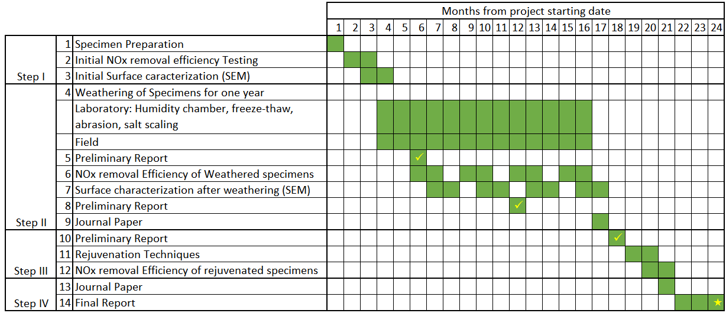
Figure 3. Estimated timeline for the project.

Project Cost:
Total Project Costs: $ 67,177
MPC Funds Requested: $ 33,484
Matching Funds: $ 33,693
Source of Matching Funds: University of Utah Start-Up Funds for Amanda Bordelon

TRB Keywords:
Emerging technologies, materials, sustainability, air quality, maintenance, transportation infrastructure, durability

References:
1. CATC. EPA 456/F-99-006R Nitrogen Oxides ( NOx ), Why and How They Are Controlled. Research Triangle Park, NC 27711, 1999, p. 48.
2. EPA. Ground Level Ozone. http://www.epa.gov/groundlevelozone/.
3. EPA. EPA - Air Quality Trends. http://www.epa.gov/airtrends/aqtrends.html.
4. EPA. Ozone. http://www.epa.gov/airtrends/ozone.html.
5. Burton, M., S. Shen, B. Jobson, and L. Haselbach. Pervious Concrete with Titanium Dioxide as a Photo-catalyst Compound for a Greener Urban Road Environment. Pullman, WA, 2011, p. 78.
6. Hanson, S. Doctoral Dissertation: Evaluation of Concrete Containing Photocatalytic Titanium Dioxide. University of Utah, 2014.
7. Ballari, M. M., M. Hunger, G. Hüsken, and H. J. H. Brouwers. NOx photocatalytic degradation employing concrete pavement containing titanium dioxide. Applied Catalysis B: Environmental, Vol. 95, No. 3-4, 2010, pp. 245–254.
8. Hassan, M. M., H. Dylla, L. N. Mohammad, and T. Rupnow. Evaluation of the durability of titanium dioxide photocatalyst coating for concrete pavement. Construction and Building Materials, Vol. 24, No. 8, Aug. 2010, pp. 1456–1461.
9. Jeong, M., E. Park, H. Seo, and K. Kim. Humidity effect on photocatalytic activity of TiO 2 and regeneration of deactivated photocatalysts. Applied Surface …, Vol. 271, Apr. 2013, pp. 164–170.
10. Samie, L., A. Beitollahi, N. Faal-Nazari, M. M. Akbar Nejad, and A. Vinu. Effect of humidity treatment on the structure and photocatalytic properties of titania mesoporous powder. Journal of Materials Science: Materials in Electronics, Vol. 22, No. 3, May 2010, pp. 273–280.
11. Jo, W.-K., and J.-T. Kim. Application of visible-light photocatalysis with nitrogen-doped or unmodified titanium dioxide for control of indoor-level volatile organic compounds. Journal of hazardous materials, Vol. 164, No. 1, May 2009, pp. 360–6.
12. Mo, J., Y. Zhang, Q. Xu, J. J. Lamson, and R. Zhao. Photocatalytic purification of volatile organic compounds in indoor air: A literature review. Atmospheric Environment, Vol. 43, No. 14, May 2009, pp. 2229–2246.

