MPC- 508

March 29, 2016

**Project Title:**

Experimental Evaluation of a New Double Composite System for Steel Bridges

**University:**

Colorado State University

**Principal Investigators:**

Hussam Mahmoud

Assistant Professor

[hussam.mahmoud@colostate.edu](mailto:hussam.mahmoud@colostate.edu)

970-491-6605

**Research Needs:**

Steel bridges are constructed using steel sections that consist of either rolled wide flanges or built-up girders. Built-up girders, also known as plate girders, are made up of flanges, webs and stiffeners, which are typically welded together. The problem with plate girders is that long-term fatigue crack initiation can manifest at the welded details. Moreover, the webs are relatively thin, which require the addition of transverse stiffeners to achieve the required shear capacity. The thin webs can also corrode through fairly quickly once corrosion begins. From a maintenance perspective, the added stiffeners to enhance the shear capacity can trap debris and moisture on the bottom flange. This can give rise to corrosion fatigue, which is not addressed in the AASHTO Design Specifications.

On the other hand, the use of rolled beams in steel bridges can be very advantageous since the webs are an integral part of the flanges in that the beams are rolled out of one piece of steel and the webs are significantly thicker than built-up girder webs. Therefore, there is no need for transverse stiffeners to enhance the shear capacity of the web. From a maintenance and deterioration perspective, the beams have smoother lines with no stiffeners to trap moisture and debris on the bottom flange. Despite their advantage, rolled beams are limited in sizes, which impose constraint on their use to relatively short spans due to deflection requirements.

The newly proposed superstructure utilizes rolled beams in combination with a reinforced concrete slab, resting on the bottom flanges of the beams, to enhance the deflection of the system and allow for longer spans to be built using rolled beams. The added slab increases the cross-sectional moment of inertia; thereby lowering the deflection of the whole system. The bottom slab also significantly enhances the torsional stability of the bridge as the geometry of the bridge is transformed to a closed-section. The enhanced torsional stability eliminates the need for cross-bracing or lateral bracings, which eradicates potential problems associated with distortion fatigue at the web gab of connection plates. In addition, the new system will employ the concept of Simple Made Continuous (SMC) where the connection of the spans over the pier are “simple for dead – continuous for live” or SD-CL. Typically, continuous bridges are more economical than simple span bridges because they develop smaller positive interior span moments due to the negative moments at the continuous ends.

The proposed system is shown in Figure 1. The figure shows a 3D finite element model that has been developed for preliminary assessment of the system potential.

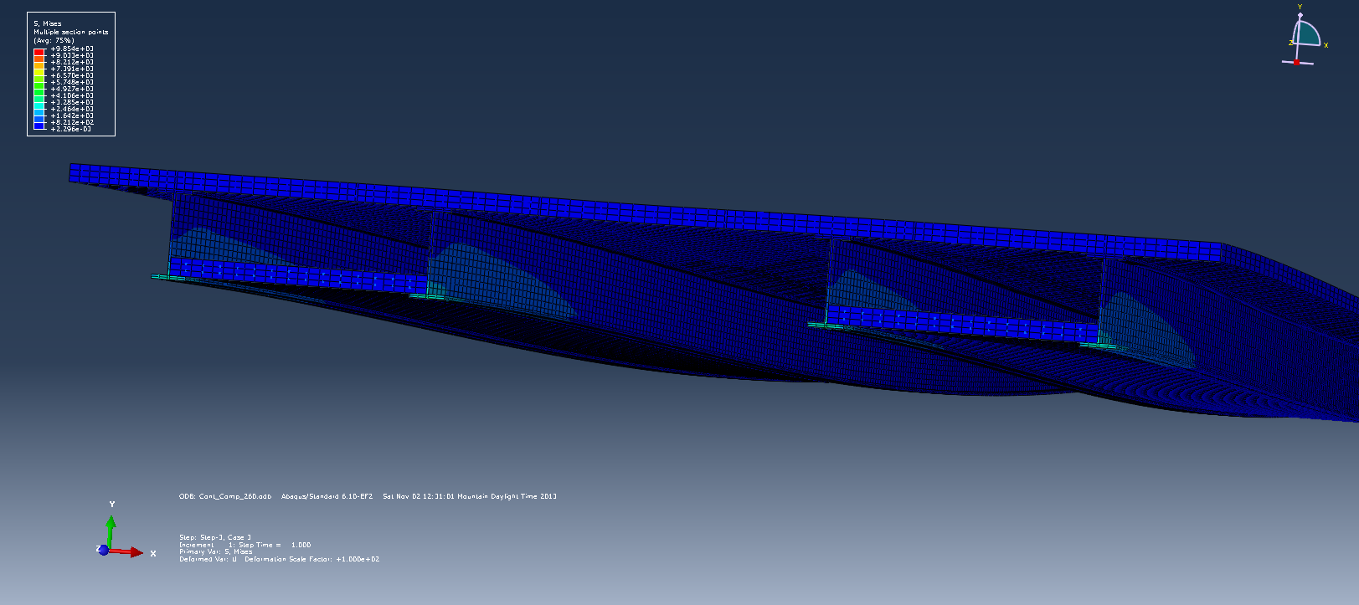

Figure 1 - cross sectional cut at the intermediate support of the 260 ft bridge

**Research Objectives:**

The overarching primary objective of the proposed research is to experimentally develop and assess a new double composite steel bridge system that allows for the construction of long span bridges using hot rolled steel beams. Various sub-objectives are thought for the complete assessment of the proposed system including:

* Evaluating the system characteristics including stiffness, strength, and ductility
* Assessing the demand in slabs and beams including moment, shear, and deflection under specified AASHTO loading
* Comparing the response between the proposed bridge system and conventional bridge superstructures
* Evaluating the use of rolled beam sections covering up to 44 inches in height.

The abovementioned objectives will be realized through the implementation of various tasks including 1) conducting extensive literature review, 2) Developing prototypes for the new bridge system, 3) Designing a dense instrumentation plan, 4) Devising the required experimental setup and conducting the laboratory tests, 5) Evaluating test results and developing design recommendations.

**Research Approach:**

The research approach will consist of seven (5) major tasks, each of which is detailed below:

**Task 1: Conduct extensive literature review**

This initial task will consist of (1) a literature review encompassing NCHRP reports, TRB papers, journal papers, and state department of transportation reports to determine the existing state-of-knowledge on analysis and design of double composite bridge systems including joint detailing in the negative moment region. In addition, international codes will be scanned to evaluate existing design provisions, if any. The results of the extensive literature review will include (but is not limited to) 1) procedures or guidelines used for conducting the analysis including the need for 2D versus 3D analysis; 2) The main parameters required for designing such system including designing for strength and torsional stability; and 3) construction sequences that are typically followed for ensuring simple for live load and continues for dead load.

**Task 2: Develop prototypes for the new bridge system**

Prototypes for the new system will be developed with variations in parameters that will allow for a comprehensive evaluation of the full potential of this system. This for example will include the span

length, bridge width, prestressing configurations, connection at the piers, simple versus continuous bridges, etc. In addition, variations in material strength will be considered, within the range of practical values. The developed prototypes will allow for the evaluation of the proposed system through its full range of behavior all the way up to failure including stiffness (influenced by moment of inertia), strength (influenced by material properties) and ductility (influenced by joint detailing and material properties). These representative bridges should represent an overall possible construction in Colorado, including logical superstructure and substructure dimensions. In addition, this task will focus on developing the detailing requirements at the piers for simple-made-continuous in the cases of multiple span applications. It is worth noting that a current ongoing project with CDOT is being conducted to numerically evaluate the proposed system. Therefore, this task will be conducted in collaboration with CDOT.

**Task 3: Design an extensive Instrumentation plan**

Figure 2 - One CR1000 available at the structural laboratory at CSU



The development and implementation of the instrumentation plan will be conducted in collaboration with CDOT. Dense instrumentation arrays will be utilized to capture the localized connection behavior and provide comprehensive information for dissemination of research as part of the project deliverables. The parameters measured during lab testing will include displacement, rotations, and strains. The instrumentation will allow for proper calibration and correlation between the computer models (developed as part of the ongoing CDOT project) and the actual laboratory specimens being tested. The sensors will be installed on the reinforcing steel, shear studs, concrete slabs, and main beams. The data will be collected using a DAQ system available at CSU. The available DAQ is Campbell Scientific CR1000 (Figure 2). It is worth noting that three to four large scale tests will be conducted in the laboratory, therefore the budget for this project will include the purchasing of an additional DAQ system to allow for multiple instrumentation and testing at the same time.

**Task 4: Devising the required experimental setup and conducting the laboratory tests**

The envisioned prototype bridges will be tested based on the results of the ongoing numerical study for CDOT. This will allow for a more directed correlation between the two studies. Three to four scaled down 3D specimens will be designed and tested to 1) quantify the load distribution in the new bridge system and 2) evaluate the full characteristic response of the system including stiffness, strength, and ductility, all the way up to and including failure. Scaling is often used to overcome both monetary and experimental limitations and is used within every engineering discipline. Within the field of structural engineering, models have been used to test a gamut of structural elements and assemblies ranging from single connections to multi-story buildings. It is however important to recognize that scaling has its disadvantages. Specifically it is difficult to maintain complete similarity as defined by similitude relationships. In addition the potential for fracture is not well represented since fracture is size dependent. Despite the limitations, it is believed that the tests will be very valuable in quantifying load path in the different specimens such that relative behavior between the tested specimens can be made. The experimental setup will be designed such that the imposed load on the specimens can be developed using reaction frames. The reaction frames will be built using existing steel that is available in the structural laboratory at CSU. The applied loads will be specified using various hydraulic actuators, ranging from 110 kips to 220 kips. The structural laboratory at CSU is fully equipped with the needed actuators. It is envisioned that the specimens to be fabricated will encompass the following variation. Exact refining of these parameters, in terms of what is to be tested, will be based on the numerical analysis conducted for CDOT.

* The configuration of the bridges
  + Number of spans
  + Span length
  + Bridge width (number of lanes)
  + Number of beams
  + Depth/size of beam
  + Thickness of slab
* The material properties of the steel and concrete
  + Variation in concrete compressive strength
  + Variation in steel grade
* Simple made connection detailing
  + Full steel connection
  + Full concrete diaphragm
  + A combination of steel and concrete

**Task 5: Evaluating test results and developing design recommendations**

The load applied to the specimens in the laboratory will represent a suite of load combinations, representing moving AASHTO trucks with single and multiple presents. The obtained results will be used as the basis for performance evaluation. This will include parameters that influences the fundamental characteristics (stiffness, strength, and ductility) of components and systems as influenced by the bridge configuration, the amount and distribution of reinforcements, material properties, damage accumulation in the steel and concrete. Descriptive notes, sketches, and detailed flowcharts will be included to highlight the test results. In addition, design recommendations will be made based on the results.

**Expected Outcomes:**

The primary deliverable from the proposed project will be the envisioned new bridge system and test results highlighting the expected performance. This can lead to this structural system being utilized by CDOT for building new double composite bridges in the Colorado. This new bridge system could prove competitive in a marketplace that is dominated by the concrete industry and could have a broader implications if adapted by other states around the country. The PI anticipate that the project will lead to opportunities for technology transfer of state-of-the-art experimental testing into the state-of-the-practice. Dr. Mahmoud has done extensive amount of laboratory testing and will ensure that the proper test setup is devised and validated test data are produced.

**Relevance to Strategic Goals:**

The proposed study is developed with the vision to provide alternative bridge configuration that can be extremely beneficial in minimizing the required inspection and repair for bridges. The use of rolled sections for the construction of long span bridges will allow for the elimination of the use of plate girders (and the corresponding welded stiffeners); thereby reducing the potential for fatigue cracks and debris entrapment. This knowledge and the proposed testing directly relate to enhancing the safety of transportation corridors in mountain states, with particular emphasis on reducing/eliminating welded connections in a typical bridge, and thereby reducing the potential for developing fatigue cracks. This will enhance the state-of-good-repair and provide long-term benefits via reducing damage to transportation infrastructure. Thus, broader impacts of the proposed research are not only the assessments of economic competitiveness of this type of bridge configuration, in comparison to other systems, but also the sustainability benefits of this in relation to longer bridge life and reduced inspection intervals.

**Educational Benefits:**

The proposed project will support a Graduate Research Assistant (GRA) at Colorado State University (CSU) in pursuit of an MS degree in Civil Engineering. This GRA will lead the proposed research, and successful implementation of the project plan will allow the graduate student to prepare and defend an MS thesis. The GRA will gain invaluable knowledge and experience related to relevant and practical modeling tools for a future career as a Structural Engineer. In particular, the GRA will have an understanding of current steel bridge design and provisions, assessment and mitigation strategies, and modeling capabilities to design and evaluate the double composite bridges. Thus, the GRA will be well-equipped to transition into an engineering consulting career with unique state-of-the-art tools.

The proposed project will provide an opportunity for the PI to expand and enhance their understanding of design provisions and behavior of steel bridges. This knowledge will be used in both undergraduate and graduate courses. Dr. Mahmoud currently teaches the following structural engineering courses at CSU: CIVE 466 – Design and Behavior of Steel Structures, CIVE 561 – Advanced Steel Behavior and Design, and CIVE 664 – Mechanics of Fatigue and Fracture. Case studies, model development, and findings from the proposed research will be integrated into all three courses. Specifically, in CIVE 561, the students will be given a group project where they will model the double composite bridge system using SAP2000 and conduct full analysis on the system.

**Work Plan:**

A timeline for the proposed project is included in Figure 3. The proposed project will require 24 months for completion. Durations of specific research tasks (i.e., Tasks 1, 2, 3, 4, and 5) are identified in Figure 2 and correspond to each of the research objectives discussed previously. Project reports for the Mountain Plains Consortium will be developed at 6, 12, and 18 months.

|  |  |  |  |  |  |  |  |  |  |  |  |
| --- | --- | --- | --- | --- | --- | --- | --- | --- | --- | --- | --- |
|  | Months | | | | | | | | | | |
| Task | 1-2 | 3-4 | 5-6 | 7-8 | 9-10 | 11-12 | 13-14 | 15-16 | 17-18 | 19-21 | 22-24 |
| 1 |  |  |  |  |  |  |  |  |  |  |  |
| 2 |  |  |  |  |  |  |  |  |  |  |  |
| 3 |  |  |  |  |  |  |  |  |  |  |  |
| 4 |  |  |  |  |  |  |  |  |  |  |  |
| 5 |  |  |  |  |  |  |  |  |  |  |  |

Figure 3 - Estimate timeline of the primary tasks for completing the proposed project

**Project Cost:**

Total Project Costs: $170,000

MPC Funds Requested: $85,000

Matching Funds: $ 85,000

Source of Matching Funds: Current CDOT project which is to numerically evaluate the proposed system.

**TRB Keywords:**

Steel bridges, long span, rolled beams, double composite, maintenance.