MPC-509

April 26, 2016

Project Title
Expansive Soil Mitigation for Transportation Earthworks by Polymer Amendment

University
Colorado State University

Principal Investigators
Joseph Scalia, Ph.D.
Assistant Professor
Colorado State University
Phone: (970) 491-3774
Email: joseph.scalia@colostate.edu
Christopher Bareither, Ph.D., P.E.
Associate Professor
Colorado State University
Phone: (970) 491-4660
Email: christopher.bareither@colostate.edu

Research Needs
Expansive soils pose prevalent problems to transportation infrastructure throughout much of the Northern Great Plains region of the western United States (Nelson and Miller 1992). Pavements are particularly susceptible to damage from the shrink-swell behavior of expansive soils due the combination of low ground pressures and large surface areas. The pervasiveness of expansive soils in the northern-mountain-plains region is illustrated in Fig. 1. When transportation infrastructure cannot be routed to avoid expansive soils, subgrade treatments are often used to mitigate damaging shrink-swell behavior. Traditional subgrade soil treatments are based on methods and technologies primarily developed and refined in the 1950s to 1980s (Petry and Little 2002), and do not incorporate state-of-the-art (i.e., nontraditional) expansive soil stabilizers (for example, refer to the practices described in the Colorado Department of Transportation 2015 Pavement Design Manual, CDOT 2015).
Stabilizers used to mitigate shrink-swell behavior of expansive soils can be divided into three categories, traditional stabilizers (lime, portland cement, and fly ash), byproduct stabilizers (cement kiln dust, lime kiln dust, ect.), and nontraditional stabilizers (sulfonated oils, potassium compounds, polymers, etc.) (Petry and Little 2002). Shrink-swell reductions with traditional and byproduct stabilizers are mechanistically based on calcium exchange (swell reducing) and pozzolonic (cementing) reactions. Nontraditional stabilizers, rely on alternative methods for stabilization. For example, potassium-based stabilizers rely on the penetration of potassium ions into the inter-clay-platelet galleries of high swelling smectite clay to form (relatively) lower swelling illite clays.
Use of traditional stabilizers for expansive soil mitigation in transportation earthworks is relatively straightforward, but requires careful design of a soil-specific treatment program (heterogeneous site conditions must be accounted for in the design), and rigorous quality assurance during implementation. The design program will determine the optimum combination of additive (percent by mass), soil compaction, and soil moisture content to attain required engineering properties. This program will then be implemented in the field by pulverizing the native expansive soil to a prescribed maximum clod size and to a prescribed depth, in-place mixing of a prescribed mass-percent of additive in slurry form, 24-48 hour (or more) in-place curing if using lime, and soil compaction to a prescribed range of densities (Little et al. 2000, Petry and Little 2002). Unfortunately, the effectiveness of traditional stabilizers decreases as soil activity increases, becoming ineffective for highly expansive soils (with a plasticity index ≥ 50; Petry and Little 2002). Traditional soil stabilizers are also ineffective (or even swell causing) in clayey soils containing sulfate salts or with potentially soluble sulfates in response to changes in pH or redox conditions (e.g, soils containing gypsum or pyritic sulfur) (Petry and Little 2002).
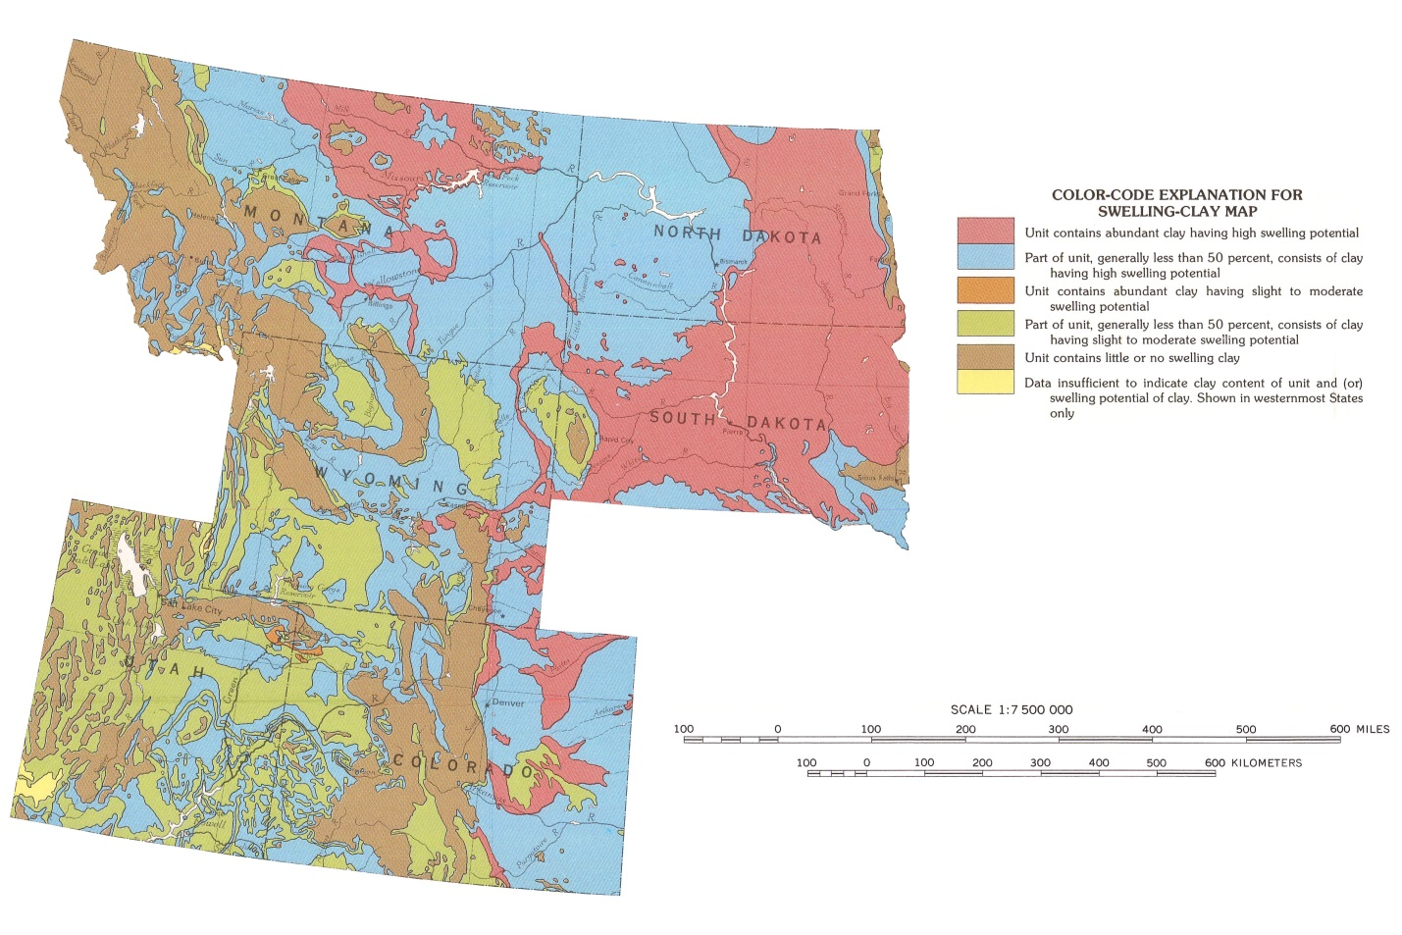
Fig. 1. Map of expansive soils in the northern-mountain-plains region of the continental U.S. (adapted from Olive et al. 1989).
Numerous nontraditional stabilizers have been previously proffered, and some of these stabilizers have been demonstrated to be effective for specific soil-additive combinations (Petry and Little 2002). The current state-of-the-art in nontraditional stabilizers is polymer based additives; these polymer stabilizers include Global Road Technologies GRT7000 Soil Stabilizer, AggreBind, Enviroseal LBS, and Soilworks Soiltac and Gorrilla-Snot. Polymer based stabilizers are touted in the manufactures literature to be “effective and green”, “sustainable”, and “cost effective” alternatives to existing soil stabilization technologies. However, adoption of these stabilizers, as is always the case of nontraditional stabilizers (Petry and Little 2002), is hindered by both a lack of un-biased information on their effectiveness, and a lack of understanding of the mechanisms by which these materials function. Understanding mechanisms if fundamental to predicting soil conditions were a specific additive might be effective, and to forecasting long-term behavior in real-world conditions.
Polymer-based stabilization of expansive soils, including stabilization of high swelling sodium montmorillonite, has been demonstrated (e.g., Inyang et al. 2007, Mohammed and Vipulanandan 2012, Mousavi et al. 2014). Additionally, extensive scientific literature is available examining the mechanisms of clay-polymer interactions, including mechanisms that reduce or eliminate shrink-swell behavior (e.g., Theng et al. 2015). However, independent demonstration of the effectiveness (or ineffectiveness) of commercially available polymer stabilizers for expansive soils, and identification of the specific mechanisms through which these stabilizers function, is minimal to nonexistent.
The proposed project will evaluate if recently developed and commercialized polymer-based stabilizers are a viable option for future transportation earthwork construction that involves expansive soil problems. The proposed project will enhance the ability of transportation practitioners to improve highway conditions and performance via innovative technologies. The current lack of independent assessment inhibits the adoption of potentially valuable materials, as does a lack of information on the mechanisms underpinning stabilization. The proposed project will provide a basis for moving forward on expansive soil mitigation techniques for transportation infrastructure via review of relevant technical literature to summarize the current state-of-art and state-of practice in expansive soil mitigation, and by providing an independent laboratory evaluation of expansive soil-polymer composites. Laboratory testing will be used to assess treatment effectiveness relative to traditional stabilization methods, and to describe mechanistic behavior of polymer modification to aid in creating improved practices for construction of transportation infrastructure. The proposed project will also create a methodology for independent evaluation of future polymer-stabilization technologies.

Research Objectives
The primary objective of the proposed research is to identify and assess the effectiveness of expansive soil mitigation for transportation earthworks by commercially available polymer amendment. The following research tasks will be completed to achieve this objective:
- Conduct a literature review to compile the state-of-practice in expansive soil mitigation, and the state-of-art in commercial polymeric products used as expansive soil stabilizers;
- Prepare concise summary reports on the state-of-practice in expansive soil mitigation for transportation earthworks, and the state-of-art in polymeric stabilization of expansive soils for transportation earthworks;
- Conduct laboratory tests on representative natural expansive soils to assess swelling behavior if untreated;
- Conduct laboratory tests on conventionally treated expansive soils;
- Conduct laboratory tests on polymerically treated expansive soils; and
- Evaluate the effectiveness of polymer treatments relative to untreated and conventional treatment conditions.
Task 1 will expand our current knowledge of expansive soil mitigation strategies (e.g., Petry and Little 2002) to develop a state-of-practice review of expansive soil mitigation, and a state-of-art review of commercially available polymer-based stabilizers for expansive soils. This task will allow identification of potentially viable commercially available polymer-based stabilizers. Task 2 will lead from knowledge gained in Task 1, and will include the preparation of both a summary report on the state-of-practice in expansive soil mitigation for transportation earthworks and a summary report on commercially available polymer-based expansive soil mitigation technologies. These reports will be prepared as stand-alone documents, with the objective of informing engineers and contractors engaged in expansive soil stabilization in transportation earthworks with existing options for mitigation. Tasks 3-5 will be performed in the Graduate Geotechnical and Geoenvironmental Engineering Laboratory at Colorado State University (CSU). Laboratory testing on untreated expansive soils (Task 3), conventionally treated expansive soils (Task 4), and polymerically treated expansive soils (Task 5) will be conducted. Expansive soils will be selected from natural expansive soils encountered in the mountain-plains region (refer to Fig. 1) based on consultation with state departments of transportation (DOTs) and their consultants. Conventional and commercially available polymer treatments will be selected based on information gathered in Task 1. Finally, Task 6 will be conducted assess the primary research objective of the proposed project, and a report will be prepared to disseminate the findings of this assessment, and to answer the question, do commercially available polymer stabilizers for expansive soils work.

Research Methods
Research efforts needed to complete the proposed study will include (1) literature review, (2) material collection, (3) laboratory testing, and (4) data analysis.
- Literature review
  - Literature review of conventional expansive soil mitigation technologies used in the mountains-plains region
  - Literature review of commercially available polymer stabilization technologies
- Material identification and procurement
  - Identification and procurement of natural expansive soils encountered in the Mountain-Plains region representing typical and worst-case conditions (e.g, sulfate bearing expansive soils); both grab and undisturbed samples of identified soils will be collected and transported to CSU for testing; undisturbed samples will consist of 0.3-m diameter block samples (refer to Fig. 2)
  - Identification and procurement of commercially available polymer-based expansive soil stabilizers
- Laboratory testing
  - Laboratory testing of untreated expansive soils, refer to Table 1
  - Conventional and polymer treatment of expansive soils
  - Laboratory testing of conventionally treated expansive soils (Table 1)
  - Laboratory testing of polymer-treated expansive soils (Table 1)
- Data analysis
  - Analysis of results from laboratory testing, including comparison of potentially statistically significant reductions (or increases) in swelling values of conventionally-treated and polymer-treated expansive soils relative to untreated soils
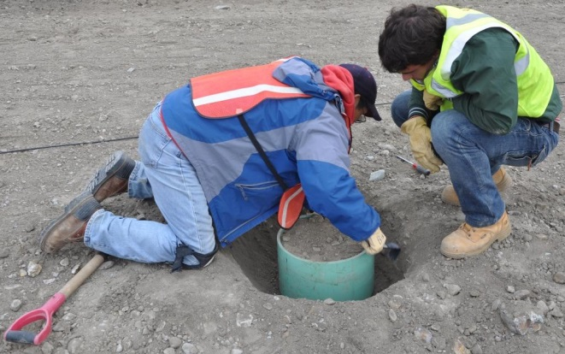
Fig. 2. Example excavation of an undisturbed 0.3-m-diameter block sample.
Table 1. Proposed laboratory testing program.
Test | Test method | Test objective(s) | Material(s) to be tested
Particle size analysis | ASTM D421 & D422 | Description of natural soils, assessment of treatment effects on soil properties, & evaluation on polymer-treatment mechanisms | US
Standard compaction | ASTM D698 |  | US, CS, PS
Water content | ASTM D2216 |  | US
USCS soil classification | ASTM D2487 |  | US
Atterburg limits | ASTM D4318 |  | US
Hydraulic conductivity | ASTM D5084 |  | US, CS, PS
Exchange complex | ASTM D7503 |  | US, CS, PS
Swelling potential | ASTM D4546 | Assessment of soil swelling potential, and mitigation of swelling | US, CS, PS
Expansion index | ASTM D4829 |  | US, CS, PS
Modified swelling potential (large scale) | CSU in-development test method | Assessment of soil swelling potential, and mitigation of swelling under field-representative testing conditions | US, CS, PS
Unconfined compressive strength | ASTM D5102 | Assess strength gained from amendment | US, CS, PS
US = untreated typical and worst-case expansive soils, CS = conventionally treated typical and worst case expansive soils, PS = polymer treated worst case and expansive soils
The laboratory testing program (Table 1) is designed to (1) classify the soils tested, (2) measure and compare the swelling of the untreated, conventionally treated, and polymer treated soils to assess the impacts of swell mitigation techniques, and (3) provide soil properties to assess the mechanistic underpinning for treatment-derived reduction in swelling behavior. Testing is intended to provide necessary information to parse swell reduction from (i) minimization of moisture changes by reducing hydraulic conductivity, (ii) physical binding of soil particles or grains together (by cementation or mineral precipitation in the case of conventional treatments, or polymer crosslinking in the case of polymer treatments), or (iii) increased porewater ionic strength (porewater chemistry will be measure following the methods described in Scalia and Benson 2010, as well as by measuring the outflow chemistry during hydraulic conductivity testing).
A final report will be prepared on the potential use of commercially available polymeric stabilizers for mitigation of expansive soils in transportation earthworks.

Expected Outcomes
The primary deliverable from the proposed project will be an assessment of expansive soil mitigation for transportation earthworks by polymer amendment. Emphasis will be placed on comparing polymer-based stabilization of expansive soils to conventional stabilization strategies. These findings will inform practitioners working on expansive soil problems in transportation earthwork applications as to the validity of claims made by polymer-amendment manufacturers. If true, state-of-the-art polymer amendments for expansive soil mitigation may allow for more sustainable transportation infrastructure in much of the Mountain-Plains region. This assessment also will have broader implications for expansive soils throughout the United States.
The Principal Investigators (PIs) also anticipate that the project will lead to opportunities for technology transfer of state-of-the-art soil amendment with polymers. Potential technology transfer will include subgrade stabilization (in non-expansive application) and dust suppression in transportation applications, as well as use of polymers for stabilization of mine wastes and to produce or enhance engineered containment systems.

Relevance to Strategic Goals
Polymer-based stabilization of expansive soils has the potential to improve the longevity of transportation infrastructure while simultaneously increasing economic competitiveness and enhancing environmental sustainability relative to conventional mitigation techniques. However, for these potential benefits to be realized, the viability of polymer-based stabilization technologies to mitigate expansive soils, particularly expansive soils in the Mountain-Plains region, must first be demonstrated; the proposed project will provide such a demonstration. If polymer-based stabilization technologies do not exhibit mitigation of expansive soils greater than or equal to current stabilization technologies, the proposed project will help practitioners avoid the costly mistake of attempting use of these materials.

Educational Benefits
The proposed project will provide the necessary resources for a student at CSU to pursue a Masters (MS) degree in Civil and Environmental Engineering. This graduate student will lead the proposed research, and the successful implementation of the project plan will allow the graduate student to prepare and defend a MS thesis. The graduate student will gain invaluable knowledge and experience for a future career as a Geotechnical Engineer. In particular, the graduate student will have an understanding of expansive soils, current and future expansive soil mitigation techniques and technologies, clay-polymer interaction, geotechnical laboratory testing, and critical review of engineering literature. Thus, the graduate student will be well-equipped to transition into an engineering consulting career with state-of-the-art knowledge and skills.
The proposed project will also support an undergraduate researcher for one summer of research at CSU. The undergraduate researcher will be under direct supervision of the graduate student, with oversite from the PIs. The undergraduate researcher will gain invaluable knowledge and experience related to research, geotechnical laboratory testing, and expansive soils. During the summer, the undergraduate researcher will work closely with the graduate student in expansive soil testing at CSU. The undergraduate researcher will work closely with the graduate student, allowing the graduate student to gain experience in supervising and mentoring, both critical work-place skills. The undergraduate will be exposed to academic research, and if they so choose, should have a leg up in pursuing graduate study in Civil Engineering.
The proposed project will provide an opportunity for the PIs to expand and enhance their understanding of expansive soil mitigation in transportation earthwork applications. This knowledge will be used in both undergraduate and graduate courses to provide students tangible connections to relevant civil engineering problems, as well as future research in this area by Drs. Bareither and Scalia. Dr. Scalia will integrate expansive soil mitigation into his future graduate-level course on unsaturated soil geoengineering, and will incorporate the mechanisms of both conventional and clay-polymer expansive soil mitigation in his future class on fundamentals of soil behavior.

Work Plan
A timeline for the proposed project is included in Fig. 3. The proposed project will require 48 months for completion. Duration of specific tasks (Tasks 1, 2, 3, and 4) are identified in Fig. 3 and correspond to each of the research objectives discussed previously. Project updates for the Mountain Plains Consortium will be developed at 6, 12, 18 months, with a final report prepared at the completion of the project (48 months).
Fig. 3. Estimated timeline of primary tasks for completing the proposed project; Reports 1 & 2 will consist of state-of-practice summary of conventional subgrade treatments and state-of-art summary of polymer-based subgrade treatments, Report 3 will assess the possible effectiveness of polymer-based subgrade treatments. The estimated timetable includes a delay to allow for development of representative (large scale) testing apparatus and method as part of MPC-538.

Project Cost
Total Project Costs: $ 120,000
MPC Funds Requested: $ 60,000
Matching Funds: $ 60,000
Source of Matching Funds: Colorado State University

References
Colorado Department of Transportation (CDOT). (2015). M-E pavement design manual, CDOT, 198 pp.
Petry, T., and Little, D. (2002). Review of stabilization of clays and expansive soils in pavement and lightly loaded structures—history, practice, and future, Journal of Materials in Civil Engineering, 14(6), 447-460.
Inyang, H., Bae, S., Mbamalu, G., and Park, S. (2007). Aqueous polymer effects on volumetric swelling of Na-montmorillonite, Journal of Materials in Civil Engineering, 19(1), 84-90.
Little, D., Males, E., Prusinski, J., Stewart, B. (2000). Cementitious stabilization, 79th Millennium Rep. Series, Transpiration Research Board, Washington D.C.
Mohammed, A., and Vipulanandan, C. (2012). Behavior of polymer modified expansive CH soils, Proceedings of Center for Innovative Grouting Materials and Technology (CIGMAT) 2012 conference.
Mousavi, F., Abdi, E., Rahimi, H. (2014). Effect of polymer stabilizer on swelling potential and CBR of forest road material, Korean Society of Civil Engineers Journal of Civil Engineering, 18(7) 2064-2071.
Nelson, J., and Miller, D. (2002). Expansive soils: Problems and practice in foundation and pavement engineering, John Wiley & Sons, Hoboken New Jersey, USA, 288 pp.
Olive, W., Chleborad, A., Frahme, C., Shlocker, J., Schneider, R., and Schuster, R. (1989). Swelling clays map of the conterminous United States, Map I-1940, United States Geological Survey Miscellaneous Investigation Series.
Scalia, J., and Benson, C. (2010). Effect of permeant water on the hydraulic conductivity of exhumed GCLs, Geotechnical Testing Journal, 33(3), 1-11.
Theng, B. (Ed.). (2012). Developments in clay science, Volume 4: Formation and properties of clay-polymer complexes, Elsevier, Amsterdam, Netherlands, 528 pp.

http://globalroadtechnologies.com/expansive-soils/
http://aggrebind.com
http://www.enviroseal.com/lbs.htm
http://www.soilworks.com/products-and-services/soiltac.aspx
http://www.soilworks.com/products-and-services/gorilla-snot.aspx

