MPC-510

May 4, 2016

**Project Title:**

Business and Commute Optimization System: Development and Denver-Based Case Study

**Universities:**

University of Colorado Denver, Colorado State University

**Principal Investigators:**

|  |  |
| --- | --- |
| Caroline M. Clevenger  Associate Professor  [caroline.clevenger@ucdenver.edu](mailto:caroline.clevenger@ucdenver.edu)  303-556-5834 |  |
| Mehmet E. Ozbek  Associate Professor  [mehmet.ozbek@colostate.edu](mailto:mehmet.ozbek@colostate.edu)  970-491-4101  Moatassem Abdallah  Research Assistant Professor  [Moatassem.abdallah@ucdenver.edu](mailto:Moatassem.abdallah@ucdenver.edu)  303-556-5287 |  |

**Research Needs:**

Mitigating traffic congestion and reducing transportation emissions are among the leading goals of most local, regional, national and international agencies. Several guidelines rely primarily on strategies that support: (1) mixed land-use and transit-oriented developments, (2) multimodal transportation systems, and (3) design of active-transportation friendly environments. While these approaches have successfully contributed to the reduction of transportation GHG and air pollutions emissions, this research proposes to implement an innovative system that can add further improvements and provide more effective and individualized action plans. Specifically, this proposal focuses on implementing an innovative system called, Business+ Commute Optimization System (B+COS) to identify the optimal selection of business commute alternatives to minimize negative environmental impacts, commute time, and cost for commuters in Denver and eventually USA. Pilot implementation among student commuters demonstrated potential GHG and air pollution emissions reduction of 24% with only 15 minute commute time flexibility.

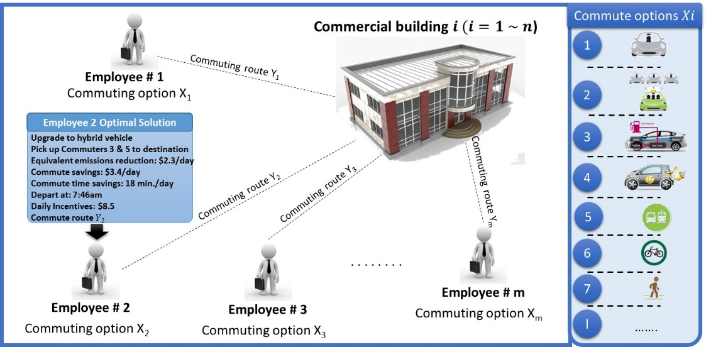

Figure 1. Layout of the proposed Business+ Commute Optimization System

**Research Objectives:**

The goal of this proposal is to develop and evaluate the Business+ Commute Optimization System (B+COS) components using a comprehensive case study in Denver, Colorado. Specific objectives include

1. Expand capabilities of B+COS to analyze a large business’ commute network using integrated transportation network model and optimization model components. The existing capabilities of B+COS is limited to 40 commuters and the system will be expanded to optimize large commute networks and businesses.

2. Demonstrate and validate the capabilities of B+COS. In particular, use new data to extend and inform the system by integrating individualized preference and value data for business commuters in Denver.

To date, as shown in Figure 2, the team has performed a pilot case study that supports both research objectives. The preliminary results validated the system performance in aiding decision-makers to identify the optimal selection of business’ commute alternatives that simultaneously minimizes negative environmental impacts and total commute time of a business commute while complying with commuter’s tolerance/flexibility, limited budgets for incentives, and convenience. Such a system can support businesses seeking to minimize transportation-related emissions and commute time as well as improve local and regional air quality.

|  |  |
| --- | --- |
|  |  |

Figure 2. Optimal Solutions for Commuter’s Tolerance of 25min (L) and their Frequencies (R).

**Research Methods:**

B+COS consists of a transportation system model and a multi-objective optimization model, as shown in Figure 3. The transportation system model is developed to generate data regarding route and commute mode alternatives as well as corresponding GHG emissions and time. The output from this model is fed into the multi-objective optimization model where it identifies the optimal selection of business commute alternatives that generates optimal tradeoffs among the optimization objectives.

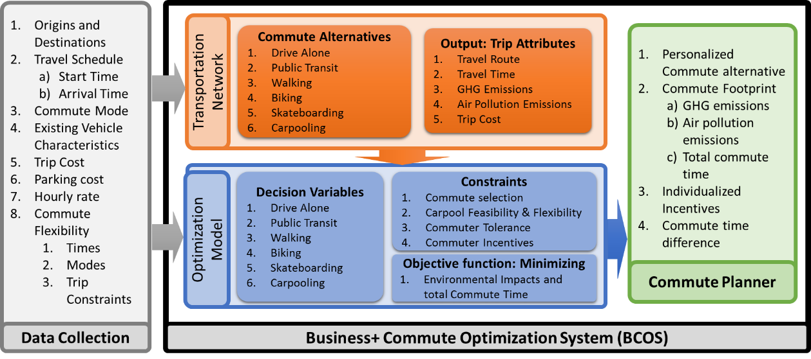

Figure 3. Business+ Commute Optimization System Process Diagram

**Expected Outcomes:**

A primary outcome of the research will include expansion of the existing capabilities of the developed system, Business+ Commute Optimization System (BCOS), to enable businesses reduce their commute footprints. This system will a) identify the optimum employee commute plan and associated set of employee-specific personalized incentives, and b) quantify the resulting benefits, while taking into account individual employees’ travel limitations (e.g. desired departure times), as well as business budget constraints. Findings are planned to lead to a series of publications that measure and quantify business commute factors and identify individual-specific commute incentives. Such results will prove critical for decision-makers seeking to minimize transportation-related emissions, and improve local and regional air quality.

**Relevance to Strategic Goals:**

Relevance to Strategic Goals: This study will address the “Environmental Sustainability” and “Livable Communities” strategic goals as it focuses on the issues related to (i) reducing carbon emissions and (ii) promoting quality of life by increasing transportation choices.

**Educational Benefits:**

To perform such research, we identified a dynamic interdisciplinary, multi-university team including MPC faculty and student researchers from the disciplines of construction management, and construction, transportation and computer science engineering. As such, our team is highly collaborative, uniting faculty from University of Colorado Denver and Colorado State University. Such a collaboration is unique and exemplifies MPC’s vision to “be a leader… in research, interdisciplinary education, workforce development, and technology transfer while serving the unique and critical needs of the Mountain-Plains Region.”

**Work Plan:**

The following research tasks will be implemented in support of the proposed research.

**Task 1:** Conduct literature review of latest research studies on i) existing tools for quantifying vehicle miles traveled and GHG and air pollution emissions of commuting alternatives, and ii) models for minimizing GHG and air pollution emissions of business commute systems.

**Task 2:** Collect commute information based on the selected Denver, Colorado business case study involving individuals’ commute origins and departure times, durations and modes of transportation, and destination location and arrival times, to serve as the basis of the optimization system.

**Task 3:**  Expand B+COS capabilities to analyze large commute networks. Analyze the transportation system defined by the business case study’s real-world commuter data to generate data regarding route and commute mode alternatives as well as corresponding GHG emissions.

**Task 4:**  Feed transportation network outputs into an optimization model to measure and quantify business commute factors and identify individual-specific commute incentives.

**Task 5:** Analyze the performance of B+COS in identifying tradeoff solutions based on business case study’s findings. In addition, case study results will be analyzed for statistical significance to identify the potential impact of implementing the system on various other businesses.

**Task 6:** Prepare final report of the project that summarizes all research findings and project outcomes.

**Time Line**:

Table 1. Project Schedule and Roles and Responsibilities



**Project Cost:**

UC Denver MPC Request: $50,000

UC Denver In-kind: $50,000

CSU MPC Request: $9,000

CSU In-kind Match: $9,000

**Total MPC Request: $59,000**

Total Project Cost: $118,000

**TRB Keywords:**

Commute; Commute Decisions; Multi-modal Transportation; Optimization; Emission Reduction

**References:**

P. and E. U.S. EPA Office of Policy, Inventory of U.S. greenhouse gas emissions and sinks : 1990-1994, U.S. Environmental Protection Agency, Washington, DC, 2015.

Environmental Protection Agency, Sources of Greenhouse Gas Emissions, (2013). http://www.epa.gov/climatechange/ghgemissions/sources/transportation.html (accessed August 1, 2015).

E. Heinen, K. Maat, B. van Wee, Day-to-Day Choice to Commute or Not by Bicycle, Transp. Res. Rec. J. Transp. Res. Board. 2230 (2011) 9–18. doi:10.3141/2230-02.

D. Chatman, How Density and Mixed Uses at the Workplace Affect Personal Commercial Travel and Commute Mode Choice, Transp. Res. Rec. J. Transp. Res. Board. 1831 (2003) 193–201. doi:10.3141/1831-22.

C.R. Bhat, R. Sardesai, The impact of stop-making and travel time reliability on commute mode choice, Transp. Res. Part B Methodol. 40 (2006) 709–730. doi:10.1016/j.trb.2005.09.008.

A. Hamre, R. Buehler, Commuter Mode Choice and Free Car Parking, Public Transportation Benefits, Showers/Lockers, and Bike Parking at Work: Evidence from the Washington, DC Region, J. Public Transp. 17 (2014) 67–91. doi:10.5038/2375-0901.17.2.4.

L. Yang, J.A. Hipp, D. Adlakha, C.M. Marx, R.G. Tabak, R.C. Brownson, Choice of commuting mode among employees: Do home neighborhood environment, worksite neighborhood environment, and worksite policy and supports matter?, J. Transp. Heal. 2 (2015) 212–218. doi:10.1016/j.jth.2015.02.003.

US Federal Highway Adminstration, US Environmental Protection Agency, Commuter Choice Decision Support System, (n.d.). http://www.ops.fhwa.dot.gov/primerdss/index.htm (accessed February 16, 2016).

A. Tawfik M, H. Rakha A, J. Du, Modeling Driver Heterogeneity in Route Choice Behavior Based on a Real-Life Naturalistic Driving Experiment, in: 2012: p. 11p.

Environmental Protection Agency, The Social Cost of Carbon, (2014). http://www.epa.gov/climatechange/EPAactivities/economics/scc.html (accessed July 27, 2015).

Victoria Transport Policy Institute, Transportation Cost and Benefit Analysis II – Air Pollution Costs, Victoria Transport Policy Institute, 2013. http://www.vtpi.org/tca/tca0510.pdf (accessed July 27, 2015).