MPC-545

November 15, 2017

Project Title:
Self-Centering Bridge Bent for Accelerated Bridge Construction in Seismic Regions

University:
University of Utah

Principal Investigators:
Chris Pantelides
Professor
University of Utah
Phone: (801) 585-3991
Email: c.pantelides@utah.edu
ORCID: 0000-0003-3309-3488

Research Needs:
Current design philosophy in bridge design for seismic regions aims to reduce residual displacements after an earthquake. After the Kobe earthquake, Japanese design criteria for bridges have changed to require designers to limit permanent drifts to less than 1% (Japan Road Association 2002). The aftermath of the Christchurch earthquake has highlighted difficulties in assessing future performance and repair of damage to plastic hinge zones in conventional reinforced concrete structures (Routledge et al. 2016). Low-damage ductile-jointed systems have been developed to control damage in plastic hinge regions and avoid residual displacements. These systems provide self-centering capability using un-bonded post-tensioning and axial load, and provide energy dissipation through yielding of non-prestressed reinforcement or yielding dampers.

Unbonded post-tensioning, in which prestressing forces are introduced at the construction site during the erection process has been proposed for reducing residual displacements after an earthquake. Post-tensioning was combined with high-performance cementitious materials to limit damage in the hinging region by Billington and Yoon (2004). Mahin et al. (2005), Cohagen et al. (2008), Motaref et al. (2010), Restrepo et al. (2011), and Guerrini et al. (2015) who studied the benefits of introducing post-tensioning into bridge columns. However, post-tensioning which is an extra step performed at the bridge site can delay construction because of the jacking operation. In addition, stress concentration where a wedge grips the unbonded strands may reduce the cyclic stresses that anchorages can withstand (Walsh and Kurama 2012).

Post-tensioning

Shake table tests of single and two-column bents with a central unbonded, post-tensioned tendon showed good recentering capability (Mahin et al. 2005); however, some mild steel bars buckled. In one specimen, a steel jacket combined with debonding of mild steel achieved high displacement ductility with no apparent damage. Quasi-static cyclic tests of half-sized columns for a column-to-footing and column-to-cap beam connection using a central unbonded, post-tensioned tendon showed that increases in posttensioning force led to slight increases in damage at high drift ratios (Cohagen et al. 2008). For this reason, more tendons should be used and the initial post-tensioning force should be reduced. One-third scale columns were tested on a shake table without a complete connection of a column to a footing and cap beam; a central unbonded, post-tensioned tendon was used (Motaref et al. (2010). Fast assembly, minimal damage at the plastic hinge area, and minimum residual displacement were observed in both column models. A precast post-tensioned composite steel-concrete hollow-core column was combined with supplemental energy dissipation to minimize post-earthquake residual lateral displacements (Guerrini et al. 2015). The column consisted of two steel cylindrical shells, with high-performance concrete cast in-between. Both shells acted as permanent formwork; the outer shell was used to substitute the longitudinal and transverse reinforcement, whereas the inner shell removed unnecessary concrete volume from the column, prevented concrete implosion, and buckling of energy dissipating dowels.

Grouted ducts

For the proposed research, the embedment length of reinforcing bars inside galvanized grouted ducts has to be determined. In addition, embedment of the grouted ducts themselves needs to be determined for good performance. From previous research on pullout strength of large reinforcing bars including #18 bars for monotonic loads carried out by Steuck et al. (2009), it is known that yield and fracture can be achieved with embedment lengths of 6 and 10 bar diameters, respectively; however the grout average compressive strength used was only 8,250 psi. Raynor (2000) proposed that development length for cyclic loads should be 40% longer than for monotonic loads. Tazarv and Saiidi (2014) proposed development length equations controlled by either the length of the steel bar or the galvanized duct length; the grout had an average compressive strength of 24,200 psi and monotonic load was used for the pullout tests; the bar development length was found to be inversely proportional to the square root of the grout compressive strength. For a grout with a compressive strength equal to 13,000 psi which is expected to be used in this research, the development length of the bar could be reduced by a factor equal to √(8.25/13.0) = 0.80. The resulting development length factor for combining cyclic load and high strength grout is thus expected to be equal to 1.40*0.80 = 1.12.

Duct size was found to have a significant effect on bond strength in the tests by Tazarv and Saiidi (2014); they recommend that the duct diameter for single column longitudinal bars should not be less than 3 times the bar diameter. Caltrans SDC (2013) recommends that the cap beam depth must be sufficient to develop the column longitudinal reinforcement without hooks. Straight column longitudinal bars should extend 24 bar diameters into the cap beam.

Research Objectives:
- Develop and test under cyclic loads alternative methods for constructing bridge bents in high seismic regions using self-centering in terms of post-tensioning of bridge columns
- Develop analytical models for self-centering in terms of post-tensioning of columns in bridge bents under cyclic loads, which will assist in the design and implementation of such bridges
- Present the results at national conferences and journal publications

Accelerated Bridge Construction (ABC) has been practiced in many parts of the country; however, in high seismic regions the challenge of providing ductile connections between columns and footings and columns and pier-caps is a topic of research currently still in progress. All similar research carried out so far on post-tensioned columns has considered a single bridge column. The proposed research considers a two-column bent with scaled dimensions representing an actual bridge bent that has been built in the state of Utah. Moreover, the debonding of the steel bars is an innovative feature that is expected to improve displacement ductility of the bridge bent.

Research Methods:
The proposed research will evaluate the seismic performance of bridge bents constructed with ABC under cyclic loads. The research will be performed by conducting a half-scale experiment of a prototype bridge bent constructed using post-tensioned columns. Analytical models will be developed for implementing the two bridge systems using OpenSees (McKenna et al. 2000).

Expected Outcomes:
The proposed research will provide alternative methods to construct bridge bents constructed with ABC methods in high seismic regions. In addition to the results of the half-scale experiment, analytical models will be developed including design recommendations for implementing the proposed system using OpenSees (McKenna et al. 2000).

Relevance to Strategic Goals:
- State of Good Repair
- Safety

Seismically resilient bridges improve safety and livability of a community. The State of Utah is likely to experience a strong earthquake in the next 50 years. Successful completion of the proposed project will ensure that the alternative method of constructing bridge bents will improve seismic resilience of the bridge inventory for large earthquakes.

Educational Benefits:
At least three university students will be involved in the project. One PhD student will be involved in the experimental and analytical portion of the work. Two undergraduate students will be funded from the Office of Undergraduate Research Opportunities program at the University of Utah. At the local level, the technology transfer activity will involve high school students through an Annual Exploring Engineering Camp, during which small-scale models will be built to show details of the wall piers and how they would be retrofitted. In addition, the P.I. will make a presentation at the annual UDOT Engineering Conference and at other national conferences including the Annual AASHTO Subcommittee on Bridges and Structures Meetings and the Annual Transportation Research Board Meeting.

Tech Transfer:
The main objective of this research is to create an alternative for the accelerated construction of bridges in seismic regions using self-centering in terms of post-tensioning of columns of a bridge bent. There is great need for developing such technology and the proposal addresses that need. The resulting technology will produce bridges that are sustainable and resilient. The work will be presented at leading conferences on this topic such as the Transportation Research Board Meeting and leading journals such as the Journal of Bridge Engineering, ASCE. In addition, a webinar will be arranged through the Mountain Plains Consortium and a presentation will be made at the Utah Department of Transportation Annual Conference.

Work Plan:
- Build a half-scale bridge bent
- Perform seismic test of bridge bent
- Analysis and seismic design of bridge bent

Task 1. Build a half-scale bridge bent – 3 months
A bridge bent with the general details shown in Fig. 1 will be built. The bridge bent dimensions and reinforcement are based on a 1:2 scale bent of the Riverdale Road Bridge over I-84 in Riverdale, Utah (UDOT 2008). The tests will be carried out at the University of Utah Structures Laboratory. The concrete will have a compressive strength of 6,000 psi and the steel reinforcement will have a tensile yield strength of 60,000 psi. The columns will be 8 ft long with an octagonal cross-section 21 in. thick. The cap beam will be 15 ft long with a 2-ft square cross-section and will be subjected to a constant axial load at the third points and a horizontal quasi-static cyclic load, as shown in Fig. 1. The axial load will be 110 kips at each of the two locations on the cap beam shown in Fig. 1. The scaled reinforcement of the cap beam will consist of 8#7 bars top and bottom bars and 3#4 bars on each side of the beam; the shear reinforcement will consist of #4 hoops at 5 in. on center. The two footings will have a dimension of 6 ft x 3 ft x 2 ft as shown in Fig. 1. The steel reinforcement will consist of #8 bars at 4 in. top and bottom; the stirrups will be #4 at 5 in. In addition, the cap-beam column joints will be reinforced with 12#4 J-bars and a #3 spiral with a 2.5 in. pitch surrounding the grouted ducts. The lateral drift history will consist of increasing amplitudes of the predicted column yield drift ratio; two cycles will be employed for each drift ratio step to the east and west (ACI Committee 374 2013).

Task 2. Perform seismic test of bridge bent – 3 months
The bridge bent system proposed in this research has the overall dimensions shown in Fig. 1. In this task the reinforcement and details of the columns of the bent are described. The bridge bent will have two columns with post-tensioned bars with additional mild steel in grouted ducts.

The bridge bent is a post-tensioned system for self-centering with mild steel in grouted ducts for energy dissipation, as shown in Fig. 2. The main reinforcement details include four 1 in. post-tensioning (PT) bars located as shown in Fig. 2 that are unbonded. The post-tensioning bars are made of Grade 150 steel and are anchored in the footing and post-tensioned at the top of the cap beam. The mild steel consists of two sets of steel bars; six #7 bars are grouted into the cap beam and footing, using grouted ducts. The effect of debonding the ends of the #7 bars for a length of four bar diameters in the region near the interface will be studied; this debonding will take place in both the column and cap beam/footing. The second set of steel rebar within the middle section of the column consists of six #4 bars. The steel spiral reinforcement consists of #3 diameter steel bar at a 2.5 in. pitch.

There is a need to balance the self-centering forces (gravity and post-tensioning) and the energy dissipating forces. In order to ensure self-centering behavior, gravity and post-tensioning forces must be large enough to overcome the overstrength capacity of the energy dissipating forces. The following upper bound for the re-centering coefficient Λ_{C} has been proposed (Guerrini et al. 2015):
${ Λ}_{C}=\frac{F_{ED}}{P_{u}+F_{PT}}≤$0.6 (1)

Figure 1. Test setup and two-column bent dimensions.

Figure 2. Bridge Bent: Post-tensioning with mild steel in grouted ducts.

where F_{ED} is the ultimate energy dissipation force from mild steel, P_{u} is the gravity force, and F_{PT} is the effective posttensioning force. The limit of 0.6 is suggested to account for uncertainty on post-tensioning losses and the presence of debris from gap opening in the rocking interfaces. On the other hand, enough energy dissipation should be provided to the system to avoid the large scatter on lateral displacement demands observed on purely rocking systems, in which additional energy is lost due to plastic deformation at the contact points (Makris and Roussos 1998). The following energy dissipation coefficient has been proposed (Guerrini et al. 2015):

${ Λ}_{D}=\frac{F_{ED}}{P_{u}+F_{PT}+F_{ED}}≥$0.1 (2)

In this study, Λ_{C} based on the design shown in Fig. 2 is evaluated as follows: F_{PT} = 4*0.85*90 = 306 kips; F_{ED} = 6*0.60*60 = 216 kips; P_{u} = 110 kips; Λ_{C} =216/(110+306) = 0.52<0.6. Also Λ_{D} is equal to Λ_{D} =216/(110+306+216) = 0.34>0.1.

Based on the given details, the embedment length based on the yield and fracture modes for combining cyclic load and high strength grout would approximately be equal to 7 and 11 bar diameters, respectively; this translates to an embedment length of 6 in. and 10 in. which is easily accommodated within the 24 in. deep cap beam and footing. For the galvanized duct itself, corrugated galvanized strip metal ducts conforming to ASTM A653 with 26-gauge (0.018 in.) wall thickness will be used. The bar development length based on duct bond strength, L_{d,duct}, is given as follows (Tazarv and Saiidi 2014):

${ L}_{d, duct }= \frac{d_{b}^{2}f_{s}}{27d_{d}\sqrt{f_{c}^{'}}}$ (3)

where d_{b}=bar diameter, f_{s}=bar stress, d_{d} =duct diameter, and $f_{c}^{'}$=compressive strength of concrete outside the duct. Based on Eq. (3), a duct diameter equal to three times the bar diameter will be used, which is 3.0 in. Hence, in this case the required length of the duct for concrete with a compressive strength equal to 6,000 psi, bar diameter equal to 7/8 in. and duct diameter equal to 3 in. requires L_{d,duct} = 12.5 in. which is less than the provided length of 24.0 in. The steel reinforcement of the cap beam and footing, as discussed in Task 1, were scaled from the original details of the Riverdale Bridge (UDOT 2008) and they meet the AASHTO General Specifications (2014).

Task 3. Analysis and seismic design of bridge bent – 6 months
In this task, an analytical model will be created to assist in the development of a design method for implementing the proposed bridge bent. First, the analytical model will be calibrated with the results of the test presented in Task 2. Secondly, the analytical model will be used to study two full-scale bridge bents, including the Riverdale Bridge and an alternative, similar to the post-tensioned bridge with the details of Fig. 2.

3.1 Analytical Model of Experiment
The analytical model of the bent with post-tensioned bars and precast columns is shown in Fig. 3. The columns are modeled with nonlinear beam-column elements with a fiber cross-section representing a circular section. The radius of the circular section is calculated using an area equivalent to the octagonal section. High-strength PT bars are modeled using Steel02 material model and corotational truss elements in OpenSees (McKenna 2010).

The rocking behavior of the column is simulated by modeling a series of zero length, uniaxial, compression-only springs at the base of the column. The rocking plane is modeled with elastic rigid elements connecting the main and slave nodes. At the rocking plane, the gross column cross-section is discretized radially and circumferentially and springs are assigned
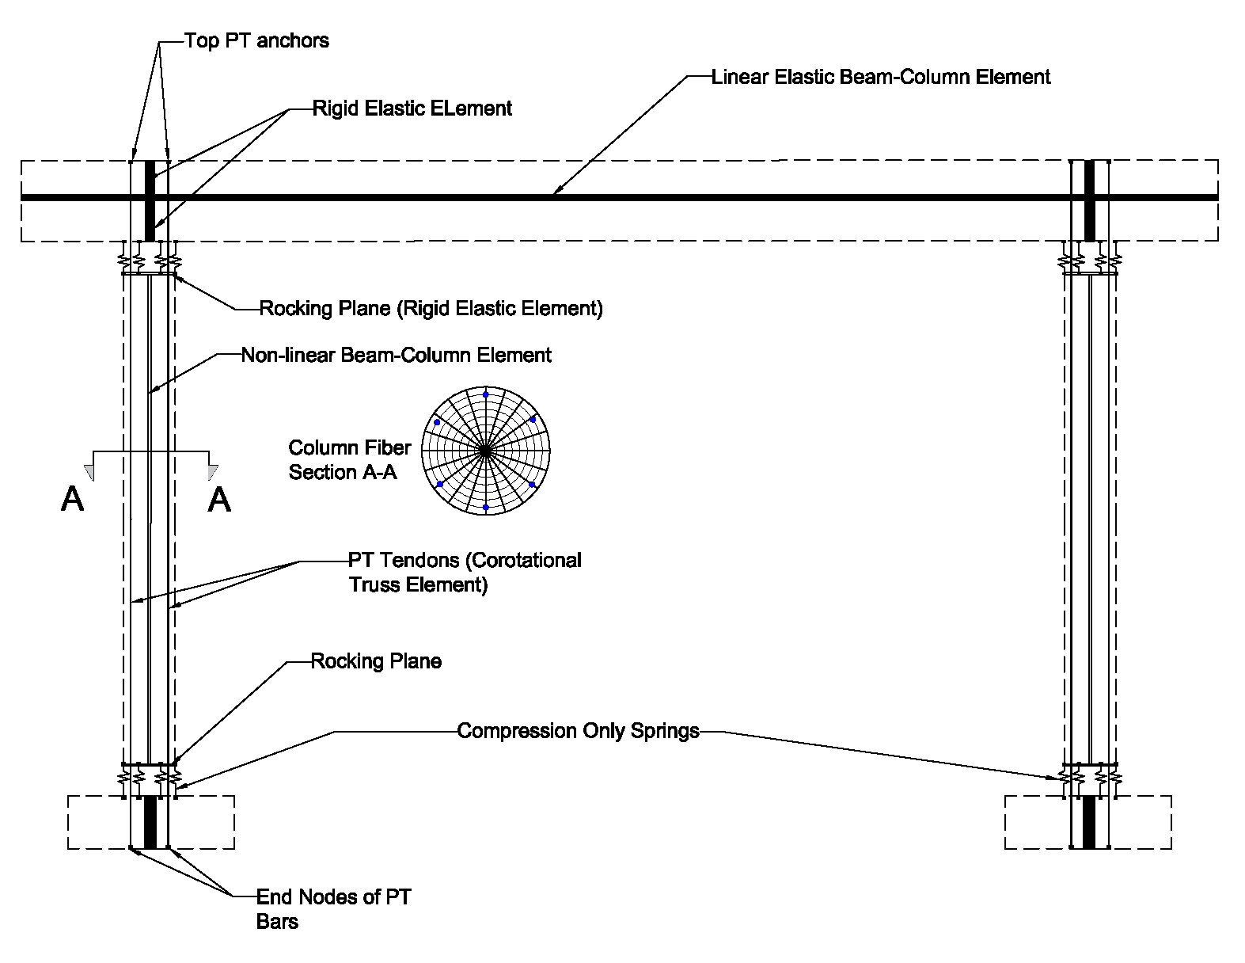
Figure 3. OpenSEES model for bent with PT bars.

inelastic material properties using concrete04 uniaxial material model. The unbonded mild-steel reinforcement for energy dissipation is modeled separately from the column fiber section using corotational truss elements fixed at the bottom and top of the unbonded length. The cap beam is modeled with elastic beam-column elements. Initial tension in the PT bars of the post-tensioned columns (Fig. 2) is simulated using the “InitialStress” command; an equivalent vertical load is assigned at the top anchor of the PT bars.

A bond model will be developed to extend the test results. In addition, an equation for the required embedment length for typical bar and grout properties under monotonic and cyclic loads will be developed. The analytical model will be developed in the OpenSees framework
(McKenna et al. 2000; McKenna et al. 2010). A local response criterion which is fracture of reinforcing bars due to low-cycle fatigue will be included in the model as an indication of ultimate displacement capacity.

A nonlinear one-dimensional finite element model will be used to investigate the bond-slip of reinforcing bars inside the grouted duct. This model will be developed in OpenSees based on the general schematic model described in past research studies (Viwathanatepa et al. 1979; Raynor et al. 2002; Steuck et al. 2009). The proposed model is composed of a series of discretized reinforcing bars (nonlinear truss elements) connected to bond-slip springs (zero-length elements) at each node. Both confined and unconfined regions will be included in the model, as shown in Fig. 4, which presents the schematic of the bond-slip model. The unconfined
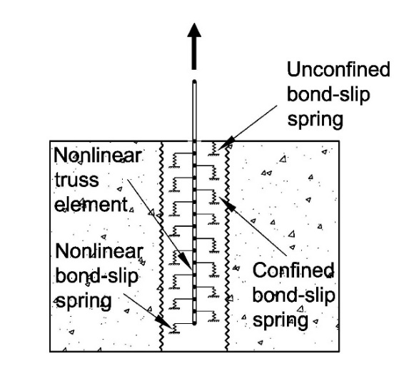

Figure 4. Analytical model using bond-slip springs.
[
region represents the concrete outside the duct, near the end of the reinforcing bars; the confined region represents the concrete inside the grouted duct. Bond constitutive laws for the unconfined and confined regions will be compared to existing experimental results of bars grouted in corrugated steel ducts (Steuck et al. 2009; Tazarv and Saiidi 2014). A similar approach was used to model grouted splice sleeves in ABC connections between columns and footings successfully (Ameli et al. 2016; Ameli and Pantelides 2016).

The equation to be developed for the required embedment length for typical bar and grout properties will consider development length based on both bar bond strength as well as duct bond strength under reversed cyclic loads. Thus, it is expected that two equations will be developed. The equations will be calibrated with the test data obtained from Task 2. The equations will be a function of bar yield strength, bar diameter, grout compressive strength, and concrete compressive strength. Moreover, the equations will be a function of the duct diameter (Steuck et al. 2009; Tazarv and Saiidi 2014). The effect of the length of the 45 degree cone in the region near the pulled end of the bar will also be taken into account. This region is relatively unconfined, resulting in resistance that is expected to be lower than the remaining embedded length of the steel bar. In addition to the existing relationships, it is expected that cyclic effects will result in a correction factor for the derived equations. The effect of debonding the end of the bar for a length of four bar diameters in the region near the pulled end of the bar will result in better performance as explained in Task 2.
3.2 Analytical Model of Full-scale Bents
The analytical models developed and verified with the half-scale experiment will be used to study the predicted performance of two full-scale bridge bents, including the Riverdale Bridge and the alternative similar to the post-tensioned bent of Fig. 2. The two models, designated as Type 1 and 2, will have the following details:

Type 1: For the Riverdale Bridge, the typical two-column bent with post-tensioned columns with typical dimensions is shown in Fig. 5. The cap beam has a typical span of 42 ft and the columns a typical clear height of 16 ft. The columns shown in Fig. 6 are 42 in. octagonal with six 1 3/8 in. diameter PT bars. In addition, they are reinforced with 12#6 mild steel bars that do not cross into the footing or cap beam. Details of the cap beam and footing steel reinforcement will be obtained from the original construction drawings of the Riverdale Bridge (UDOT 2008).

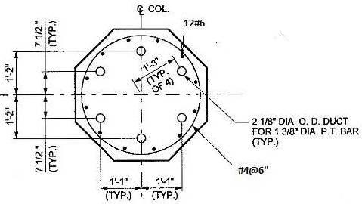

Figure 5. Typical Riverdale Bridge Post-tensioned Bent.

Analysis of the full-scale bent of the Riverdale Bridge will follow the models developed for the Post-tensioned Bent.

Type 2: For the full-scale bent simulating the Post-tensioned Bent similar to the scaled model of Fig. 2, the two-column bent dimensions of Fig. 5 will be used. The only difference with the Type 1 model is that the 12#6 mild steel bares will continue into the cap beam and footing using the grouted ducts, which will be scaled up for the full-scale bridge model.

Two types of analysis will be performed for the two bent types: (1) static cyclic analysis to find the capacity of the system, and (2) nonlinear time-history analysis to find the level of demand on the bridge bents. This will provide information on capacity-demand relationships for the two bridge bent alternatives, and will reveal more insight into the overall behavior of the two bents under various input ground motions.

Project Cost:
Total Project Costs: $222,835
MPC Funds Requested: $108,935
Matching Funds: $113,900
Source of Matching Funds: Private Investor, Structural Technologies, Corebrace

References:
AASHTO. (2014). "LRFD Bridge Design Specifications." American Association of State Highway and Transportation Officials, Washington, DC.
Ameli, M.J., Brown, D.N., Parks, J.E., and Pantelides, C.P. (2016). “Seismic column-to-footing connections using grouted splice sleeves.” ACI Structural J., May-Jun., 113(5), 1021-1030.
Ameli, M.J., and Pantelides, C.P. (2016). “Seismic analysis of precast concrete bridge columns connected with grouted splice sleeve connectors.” J. Structural Engineering, ASCE, 10.1061/(ASCE)ST.1943-541X.0001678, 04016176.
American Concrete Institute (ACI). (2013). “Guide for Testing Reinforced Concrete Structural Elements Under Slowly Applied Simulated Seismic Loads.” ACI 374, Farmington Hills, MI.
Billington, S. L., and Yoon, J. K. (2004). “Cyclic response of unbonded posttentioned precast columns with ductile fiber-reinforced concrete.” J. Bridge Eng., 10.1061/(ASCE)1084-0702(2004)9:4(353), 353–363.
California Department of Transportation (2013). “Seismic Design Criteria.” Version 1.7, 180 pp.
Cohagen, L. S., Pang, J. B. K., Eberhard, M. O., and Stanton, J. F. (2008). “A precast concrete bridge bent designed to recenter after an earthquake.” Rep. No. WA-RD 684.3, Washington State Dept. of Transportation, Washington, DC.
Guerrini, G., Restrepo, J. I., Massari, M. A., and Vervelidis, A. (2015). “Seismic behavior of post-tensioned self-centering precast concrete dual-shell steel columns.” J. Structural Eng., 141(4), 10.1061/(ASCE)ST.1943-541X.0001054.
Japan Road Association (2002). “Design Specifications of Highway Bridges. Part V: Seismic Design.” Japan.
Mahin, S. A., Sakai, J., Jeong, H., Espinoza, A., Hachem, M. M., and Buckman, B. (2005). “Shake table and analytical investigations of single column bents.” Proc., Caltrans Bridge Research Conf., California Transportation Foundation, Sacramento, CA, and California Dept. of Transportation, Los Angeles, Paper 01-501.
Makris, N., and Roussos, Y. (1998). “Rocking response and overturning of equipment under horizontal pulse-type motions.” Rep. No PEER 1998/05, Pacific Earthquake Engineering Research Center, Berkeley, CA.
McKenna, F., Fenves, G., and Scott, M. (2000). “Open System for Earthquake Engineering Simulation (OpenSees).” Univ. of California, Berkeley, CA. (http://opensees.berkeley.edu).
McKenna, F., Scott, M., and Fenves, G. (2010). “Nonlinear Finite-Element Analysis Software Architecture Using Object Composition.” J. Comput. Civ. Eng., 10.1061/ (ASCE) CP.1943-5487.0000002, 95-107.
Motaref, S., Saiidi, M. S., and Sanders, D. (2010). “Experimental study of precast bridge columns with built-in elastomer.” Transportation Research Record, 2202, 109-116.
Raynor, D.J. (2000). “Bond assessment of hybrid frame continuity reinforcement.” M.Sc. thesis, University of Washington, Seattle, WA, 248 pp.
Raynor, D. J., Lehman, D. E., and Stanton, J. F. (2002). “Bond-slip response of reinforcing bars grouted in ducts.” ACI Structural Journal, 99(5), 568-576.
Restrepo, J., Matsumoto, E., and Tobolski, M. (2011). “Development of precast bent cap systems for seismic regions.” NCHRP Rep. 681, National Cooperative Highway Research Program, Transportation Research Board, Washington, DC.
Routledge, P. J., Cowan, M. J., and Palermo, A. (2016). “Low-damage detailing for bridges – A case study of Wigram-Magdala Bridge.” 2016 New Zealand Society for Earthquake Engineering, http://confer.co.nz/nzsee2016/.
Steuck, K.P., Eberhard, M.O., and Stanton, J.F. (2009). “Anchorage of large-diameter reinforcing bars in ducts.” ACI Structural Journal, 106(4), 506-513.
Tazarv, M., and Saiidi, M.S. (2014). “Next generation of bridge columns for accelerated bridge construction in high seismic zones.” Caltrans Report CA14-2176, 359 pp.
UDOT (Utah Department of Transportation). (2008). “Dwg. No. C-966.” Riverdale Road Bridge I-15 to Washington Boulevard, Riverdale, Utah.
Viwathanatepa, S. (1979). “Bond deterioration of reinforcing bars embedded in confined concrete blocks.” PhD Report, University of California, Berkeley, CA.
Walsh, K., and Kurama, Y. (2012). “Effects of loading conditions on the behavior of unbonded post-tensioning strand-anchorage systems.” PCI J., 57(1), 76-96.

