MPC-553

December 11, 2017

# Project Title:

Multi-Business Commute Optimization System (MBCOS): System Development and Pilot Case Study

# University:

University of Colorado Denver

# Principal Investigators:

Moatassem Abdallah

Assistant Professor

University of Colorado Denver

Phone: (303) 556-5287

Email: moatassem.abdallah@ucdenver.edu

ORCID: 0000-0002-3077-6518

Caroline Clevenger

Associate Professor

University of Colorado Denver

Phone: (303) 556-5834

Email: caroline.clevenger@ucdenver.edu

ORCID: 0000-0003-2265-8447

# Research Needs:

Traffic congestion, air pollution, greenhouse gas (GHG) emissions, and increasing energy and infrastructure costs are a few of the transportation-related challenges of the twenty first century. The United States (US) Environmental Protection Agency (EPA) reported in 2014 that GHG emissions from the transportation sector accounted, nationally, for 26% of total reported GHG, second only to the electricity sector [1], [2]. The largest source of transportation-related emissions, accounting for over half of the emissions from this sector, includes passenger cars and light-duty trucks such as sport utility vehicles, pickup trucks, and minivans. To significantly reduce negative impacts of the existing transportation system, there is a pressing need to study and modify commute behavior using an innovative system which is the focus of this research work.

Transportation engineers are constantly working hard to address such challenges. Until recently, US engineers and policy makers generally believed that construction and operation of new highways was a reasonable approach. Today, however, an effective solution requires efficient planning for, and utilization of all transportation modes – instead of focusing on only the personal automobile and new construction of infrastructure. Work is being conducted to identify successful policies to increase modal shares of active transportation, ridesharing, and transit systems. To succeed in addressing current challenges in the transportation sector, this research project focuses on promoting the use of rideshares, public transportation, electric and hybrid vehicles, and sustainable transportation modes such as walking and biking.

The main goal of this research work focuses on the preliminary development of an innovative system named, Multi-Business Commute Optimization System (MBCOS). This system is capable of identifying incentivized optimal selection of commute alternatives for commuters commuting to a number of businesses that are co-located or closely located to minimize GHG emissions, air pollution, energy use, traffic congestion, and total commute time and cost while maximizing health benefits and maintaining convenience, as shown in Figure 1. By analyzing alternatives for each commuter with a common employer or closely located employers, MBCOS provides an optimized commute plan that complies with departure and arrival times, availability of commute alternatives, availability of budgets for incentivizing commuters, flexibility in commute time, and convenience by studying and analyzing all possible commute options, including driving existing vehicles, upgrading to hybrid or electric vehicles, carpooling, using public transportation, biking, walking, and combinations of these alternatives. An example solution for MBCOS is shown in Figure 1 for Employee 2.

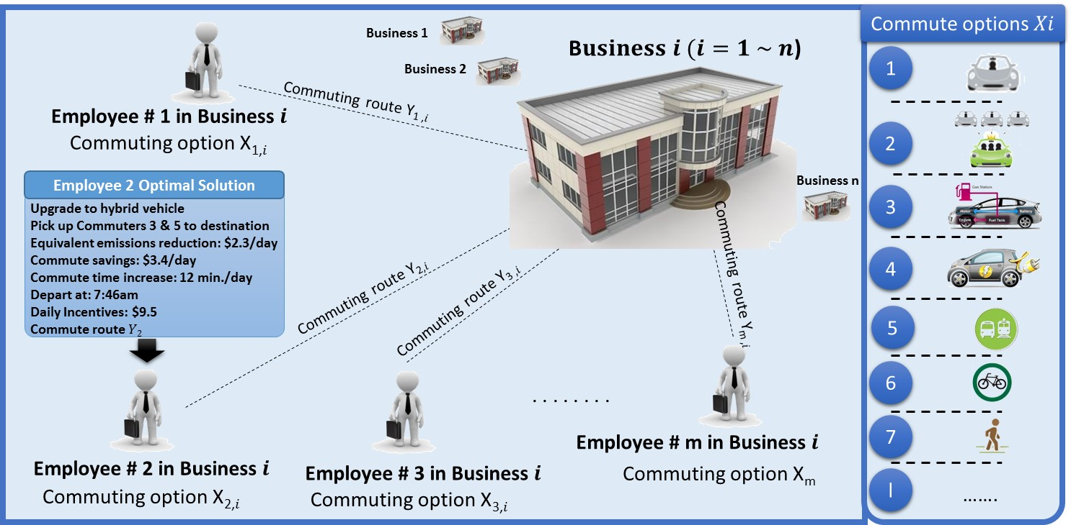

Figure 1. Layout of the proposed MBCOS

Literature Review

Commuters’ mode choices and resultant impacts received particular attention in travel behavior literature. Since commute trips represent a significant percentage of morning and evening peak traffic, previous research efforts focused on understanding reasons behind commuter mode choices, and identifying ways to decrease impacts of morning and evening commutes; primarily by reducing the share of drive-alone commutes. Outcomes of such research efforts have resulted in the development of many policies and programs. Accordingly, another part of the literature focused on the development and assessment of the effectiveness of these programs. The following sections provide brief review of existing literature.

Drive-alone commuting has been the primary mode of transportation in the US for many decades. Problematically, the trend has been increasing. In 1980 and 2010, modal share of drive-alone commute was 64.3% and 76.6%, respectively [3], [4]. Several factors appear to contribute to the high modal share of drive-alone commutes. While relative convenience of the automobile in comparison to other modes is an understandable factor, it does not explain the higher share of drive-alone commute in the US, in comparison to other societies in Europe and Asia. Several factors contribute to high drive-alone commuting, such as urban sprawl, lower gas prices, lower perceived quality of transit, and drive-alone commute subsidies.

Free or highly subsidized employee parking, compounded by absence of equivalent subsidization for alternative transportation, is believed to be a main reason for the high percentage of drive-alone commutes [5]. Several efforts and policies are being developed to increase modals shares of non-drive-alone commutes. Examples of these policies include the 1990 Clean Air Act provision that required employers with more than 100 employees located in ozone nonattainment areas to develop policies resulting in a 25% increase in their employees commute auto occupancy [6], [7]. Other common groups of programs include ones that seek to increase percentages of telecommuting and employee parking cash-out programs where employees can opt to receive the value of a parking space as additional income and arrange their own means of commute transportation. The impacts of these policies remain minimal. In 2015, the National Compensation Survey revealed that most employers offer their employees with free parking at work; yet, only 7% offer subsidies for alternative modes of transportation [8]. Despite the contribution of this research work, the generalized nature of these policies represents significant limitations. For example, parking cash-out programs offer all employees the same, flat compensation regardless of their commute footprint. It is not uncommon for a single employee with a long commute to cause a footprint that is equivalent to the combined footprint of several employees with shorter commutes. It may be more efficient, therefore, to convince this single employee to switch to an alternative mode, by offering higher compensation than that offered to employees with shorter footprints. Since different employees have different mode preferences, businesses that offer mode-specific compensations (such as tax-free transit vouchers) may be able to achieve higher impacts by individualizing their alternative transportation policies, and associated incentives.

Literature on commuter mode choice is rich; yet, tools that businesses can utilize to identify optimum policies and incentives, and associated benefits are limited. Three available tools include Commuter Choice Decision Support System (CCDSS), CUTR_AVR Model, and Business Benefits Calculator. CCDSS is supported by the USDOT and US EPA. It is designed to help employers determine most appropriate types of commuter choice options for their worksite [9]. CUTR_AVR Model, developed in 1999 by the Center for Urban Transportation Research at the University of South Florida, is “based on a large, real-world data set” and uses an artificial neural network to predict mode share and average vehicle ridership by inputting attributes of the employer-based TDM program” [10]. Business Benefits Calculator, developed by the US EPA, is a “Web-based Calculator that enables an employer considering Best Workplaces for CommutersSM to estimate financial, environmental, traffic-related, and other benefits of joining the program” [11].

All these tools provide businesses with generalized recommendations for commuting policies and estimates on benefits (e.g. GHG savings). They base their recommendations and estimates on aggregate measures of commute data, rather than individualized commute information and individual-specific incentives. This proposal addresses this particular limitation and significantly extends previous research efforts.

# Research Objectives:

1. Develop Multi-Objective Commute Optimization System that is capable of identifying incentivized optimal selection of commute alternatives for commuters commuting to a number of businesses that are co-located or closely located in order to simultaneously minimize (i) GHG and air pollution emissions, (ii) energy use, (ii) traffic congestion, (iv) total commute time, and (v) total commute cost while maintaining convenience.
2. Improve efficiency of the model computations to identify optimal solutions in reasonable computational time and effort.
3. Demonstrate the capabilities of the new system using a pilot case study of multiple businesses.
4. Study broader impacts of wide spread application of MBCOS.

The main goal of this research work is to develop and evaluate an innovate system named Multi-Business Commute Optimization System (MBCOS) that is capable of identifying optimal commute plans for businesses. The objectives of this research are listed above.

# Research Methods:

The primary goal of the proposed research methodology is to develop, test and refine innovative theories and models to support multi-objective and dynamic optimization of business commute systems. MBCOS consist of Geographical Information System and Multi-Objective Optimization Model as shown in Figure 2. The GIS and Optimization model require a number of input data, including location of businesses, location of employees, travel schedule, existing commute behavior and its characteristics, trip costs, and convenience. The GIS calculates different trip attributes for every commute mode. It computes 6 trip attributes (energy use, GHG emissions, air pollution emissions, and travel time, distance and cost) associated with every commuting option for every commuter. This GIS integrates existing transportation system data with information about every employee’s home and work locations, available modes, desired commute times, flexibility in departure and travel times, and trip-chaining necessities. The optimization model then identifies the optimal commute method for each commuter in order to simultaneously minimize total GHG and air pollution emissions, commute time, commute cost, and energy consumption while maintaining convenience. MBCOS provides an optimized commute plan that complies with departure and arrival times, availability of commute alternatives, availability of budgets for incentivizing commuters, flexibility in commute time, and convenience by studying and analyzing all possible commute options, as shown in Figure 2. The PI of the project has extensive expertise and have successfully developed numerous single and multi-objective optimization models that utilized linear and integer programming as well as evolutionary algorithms to support decision making [12-18].

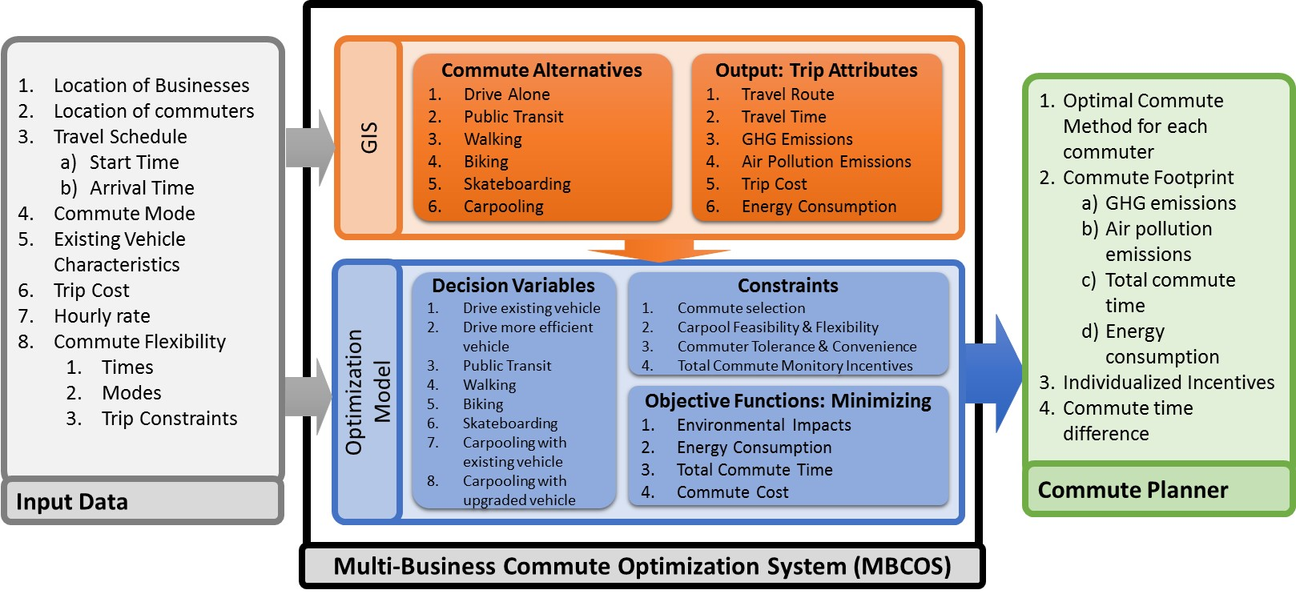

Figure 2. Input data and Components of MBCOS (See attached file).

# Expected Outcomes:

One of the unique concepts explored in this project is the integrated multi-objective optimization methodology that promotes transit ridership and sustainability of business commute systems. This integrated approach and its potential for wide spread application holds a strong promise to initiate a fundamental shift in transit modal shares of commute trips. The widespread application of the proposed system is expected to result in various benefits to communities and the transportation network by 1) Increasing transit ridership; 2) Reducing transportation related GHG emissions; 3) Improving air quality; 4) Increasing transportation efficiency; and 5) reducing congestion. For example, the proposed system will provide optimal solutions that will focus on minimizing transportation related emissions by increasing (a) public transit sharing, (b) carpooling, (b) the use of low emission vehicles, and (d) the use of green-friendly transportation modes such as walking and biking.

The findings of this research project will lead to a series of journal and conference publications. Furthermore, the research team is planning to prepare and submit a research proposal to BIGDATA program at the National Science Foundation. The findings of the research development along with the results of the case study will provide preliminary results for developing a large scale system that can optimize commuting to numerous businesses located in a city center such as downtown. Such system is expected to require huge and dynamic computations that can be executed using cloud computing.

# Relevance to Strategic Goals:

* Environmental Sustainability
* Livable Communities

The expected outcomes are expected to contribute to “Environmental Sustainability” and “Livable Communities” strategic goals as they will focus on achieving:

1. Reduction in transportation related GHG emissions: Currently Greenhouse Gas emissions from the transportation sector accounted, nationally, for 26% where more than half of surface transportation emissions are produced by passenger cars. The proposed system will provide optimal solutions that will focus on minimizing transportation related emissions by increasing (a) public transit sharing, (b) carpooling, (b) the use of low emission vehicles, and (d) the use of green-friendly transportation modes such as walking and biking.
2. Better air quality: The proposed system will quantify the emissions of the existing commute systems based on existing vehicles along with commute routes and time to capture the major contributors of emissions and air quality problems. Accordingly, the proposed optimal solutions will reduce emissions and improve air quality by providing higher incentives to commuters with higher impacts and potential for improvements.
3. Efficient transit systems, reduction in transportation demand, and less congestion: The proposed solution will provide optimal commute mode choice solutions and, accordingly, optimal use of existing commute systems in terms of transit modal share, carpooling and use of low emissions and green transportation modes. Widespread implementation of MBCOS would increase transit demand; leading to reductions in traffic congestion and a more optimized transportation system.

# Educational Benefits:

To perform this research work, a team consisting of two professors and a graduate student at University of Colorado Denver. Over the past years, the faculty members have successfully advised and mentored hundreds of undergraduate and graduate students. The majority of these students are currently active and advancing in various industries today including transportation, planning, construction, engineering and consulting. This project will provide the research team with sustained support to train one Ph.D. student for one year. Also, the faculty members will seek involvement from undergraduate and other graduate students in the Construction Engineering and Management program.

The proposed research and outcomes will serve as the foundation for new educational modules and coursework to be integrated into graduate courses. Modules will be carefully designed and implemented to enable students to study and measure environmental impacts associated with transportation networks; and better understand the conflicting optimization objectives related to transportation network and budget-constrained incentive plans. Specifically, the PI is planning to develop a new course: Optimization and Decision-Making for Civil Engineers at the Civil Engineering Department at University of Colorado Denver. The course will be an advanced course for graduate students which focuses on optimization and decision-making, including evolutionary computations, mathematical programming and parallel computing and optimization.

# Tech Transfer:

The research team will broadly disseminate and transfer the knowledge generated from the proposed research using: (1) publications in scientific journals and presentations in national conferences to disseminate the research findings to the broad research and industrial community; (2) presentations to professionals in the transportation and construction industries including heavy civil and infrastructure contractors, and state and federal transportation agencies such as Colorado Department of Transportation (CDOT) and California Department of Transportation (Caltrans)). To facilitate the transfer of new technologies to the industry; additional opportunities will include individual businesses or communities that will be directly benefit to apply the proposed system; and (3) educational material to train graduate and undergraduate students and prepare them for the construction and transportation workforces.

# Work Plan:

1. Conduct Comprehensive Literature Review on Commute Behavior.
2. Develop Multi-Objective Commute Optimization Model.
3. Improve Efficiency of the Optimization Model Computations.
4. Demonstrate System Performance and Capabilities using Case Study.
5. Explore and Study Impacts of Widespread Application of MBCOS.
6. Prepare Final Report of the Project Findings.

In order to accomplish the objectives of this research work, the following research tasks will be implemented:

Task 1: Conduct Comprehensive Literature Review on Commute Behavior. The literature review will focus on: (1) motivation for commute modal shares, (2) commuter mode choices behavior, (3) impact of commuter mode choices, and (4) tools for business commuting programs.

Task 2: Develop Multi-Objective Commute Optimization Model. The development steps of the optimization model will include (i) identifying model decision variables, (ii) formulating objective functions and constrains, and (iii) implementing the model computations using reasonable optimization technique. The optimization model will be designed to identify optimal commuting plan for a number of business that simultaneously minimize GHG and air pollution emissions, commute time, commute cost, and energy consumption. In order to enable the simultaneous optimization of the aforementioned competing objectives, this task will explore and implement robust multi-objective algorithms such as (a) weighted linear and integer programming that guarantee an optimal solution with short computational time; and (b) evolutionary algorithms that adopt the survival of the fittest approach in addition to the concept of Pareto optimality in order to converge to a set of non-dominated optimal solutions that represent various trade-offs among the conflicting optimization objectives. The PI has extensive expertise in modeling and solving multi-objective optimization models that utilize mathematical and heuristic optimization techniques.

Task 3: Improve Efficiency of the Optimization Model Computations. The research team is aware that solving the aforementioned multi-objective optimization problem is prohibitively time-complex. For example, solving the optimization problem for only 21 commuters while allowing carpooling for up to three passengers will lead to more than 200,000 decision variables and more than 400,000 constrains in a linear mixed integer programming model. The research team will use innovative techniques such as repairing method and heuristics to eliminate dominated solutions before running the optimization and improve the efficiency of the optimization computations.

Task 4: Demonstrate System Performance and Capabilities using Case Study. The research team is planning to evaluate the model performance using a number of businesses located in downtown of Denver or an application example that involves a number of businesses. Accordingly to availability and willingness of businesses to implement MBCOS, data of business commuters will be collected using online survey, website services, or smartphone app. The collected data will be analyzed using the GIS and fed into the optimization model. The optimization model will be used to identify optimal selection of commute alternatives for business commuters. The identified optimal commute plan will be sent to commuters using emails or stored on a website where commuters can access and follow.

Task 5: Explore and Study Impacts of Widespread Application of MBCOS. The research team will study the impacts of implementing the system for a large number of businesses in a city. Based on the results of the analyzed case study, the team will study its extension to benefit business in downtown of medium size cities such as Denver.

Task 6: Prepare Final Report of the Project Findings. The research team will prepare and submit a final project report that summarizes the findings of the research work.

Project Plan

The proposed research tasks will be carried out according to the following schedule.



**Project Cost:**

Total Project Costs: $120,361

MPC Funds Requested: $59,994

Matching Funds: $60,337

Source of Matching Funds: Academic and summer salaries.

# References:

[1] P. and E. U.S. EPA Office of Policy, Inventory of U.S. greenhouse gas emissions and sinks: 1990-1994, U.S. Environmental Protection Agency, Washington, DC, 2015.

[2] Environmental Protection Agency, Sources of Greenhouse Gas Emissions, (2013). http://www.epa.gov/climatechange/ghgemissions/sources/transportation.html (accessed August 1, 2015).

[3] M. Rossetti A, B. Eversole S, Journey to work trends in the United States and its major metropolitan areas, 1960-1990, 1993.

[4] American Association of State Highway and Transportation Officials, Commuting in America 2013: the national report on commuting patterns and trends., American Association of State Highway and Transportation Officials, Washington, DC, 2013.

[5] D. Shoup, The high cost of free parking, Planners Press American Planning Association, Chicago, 2005.

[6] W.R. Black, Sustainable transportation: problems and solutions, Guilford Press, New York, 2010.

[7] J.R. Meyer, J.A. Gomez-Ibanez, W.B. Tye, C. Winston, Essays in transportation economics and policy a handbook in honor of John R. Meyer, (1999).

[8] National Compensation Survey, Civilian Access to Subsidized commuting, (2015).

[9] US Federal Highway Adminstration, US Environmental Protection Agency, Commuter Choice Decision Support System, (n.d.). http://www.ops.fhwa.dot.gov/primerdss/index.htm (accessed February 16, 2016).

[10] Center for Urban Transportation Research (CUTR), CUTR_AVR model, (1999).

[11] J. Damsted, Business benefit, (2006).

[12] M. Abdallah, K. El-Rayes, Optimizing the selection of building upgrade measures to minimize the operational negative environmental impacts of existing buildings, Build. Environ. 84 (2015) 32-43. doi:10.1016/j.buildenv.2014.10.010.

[13] M. Abdallah, K. El-Rayes, L. Liu, Optimal Selection of Sustainability Measures to Minimize Building Operational Costs, in: Constr. Res. Congr., American Society of Civil Engineers, Atlanta, GA., 2014: pp. 2205-2213. http://ascelibrary.org/doi/abs/10.1061/9780784413517.224 (accessed July 18, 2014).

[14] M. Abdallah, K. El-Rayes, L. Liu, Minimizing Upgrade Cost to Achieve LEED Certification for Existing Buildings, J. Constr. Eng. Manag. 142 (2016). doi:10.1061/(ASCE)CO.1943-7862.0001053.

[15] M. Abdallah, K. El-Rayes, L. Liu, Automated Decision Support System for Optimizing The Selection of Green Building Measures, in: 30th Int. Symp. Autom. Robot. Constr. Min., International Association for Automation and Robotics in Construction (IAARC), Montreal, Canada, 2013.

[16] M. Abdallah, K. El-Rayes, L. Liu, Optimizing the selection of sustainability measures to minimize life-cycle cost of existing buildings, Can. J. Civ. Eng. 43 (2016) 151-163. doi:10.1139/cjce-2015-0179.

[17] M. Abdallah, K. El-Rayes, Multiobjective Optimization Model for Maximizing Sustainability of Existing Buildings, J. Manag. Eng. (2016) 4016003. doi:10.1061/(ASCE)ME.1943-5479.0000425.

[18] M. Abdallah, Optimizing the selection of sustainability measures for existing buildings, University of Illinois at Urbana-Champaign, 2014. http://hdl.handle.net/2142/50355.