MPC-568

June 27, 2018

Project Title
Mitigation of Flooding-Related Traffic Disruptions with Green Infrastructure Stormwater Management

University
Colorado State University

Principal Investigators
Aditi Bhaskar
Assistant Professor
Colorado State University
Phone: (970) 491-8339
Email: aditi.bhaskar@colostate.edu
ORCID: 0000-0001-9803-4003
Suren Chen
Associate Professor
Colorado State University
Phone: (970) 491-7722
Email: schen@rams.colostate.edu
ORCID: 0000-0002-3708-5875

Research Needs
Increasing the density of roadways with urban development results in changes in hydrologic response to storm events. Impervious surfaces, such as roadways, have a low infiltration capacity, and therefore with more impervious surfaces, larger volumes of stormwater are generated along with flashier urban streamflow hydrographs. The increase in stormwater generated in urban areas leads to flooding of streams, roadways, erosion, and degradation of urban stream health (Walsh et al., 2005) and therefore is of national environmental concern (NRC, 2009).
Advances in stormwater management have sought to minimize the adverse effects of impervious surfaces by reducing the volume of stormwater generated with infiltration-based and evapotranspiration-based stormwater control measures (US EPA, 2000). These urban flooding mitigation technologies are often referred to as ‘green infrastructure’ stormwater control measures and include facilities such as bioretention cells, dry wells, and permeable pavement. These stormwater control measures are designed to store stormwater, infiltrate stormwater, and allow plants to take up stormwater. Previous work has focused on how effective green infrastructure is for ameliorating the effects of impervious surfaces on hydrologic response and urban water budgets (Bhaskar et al., 2016; Jefferson et al., 2017).
Green infrastructure is valued for its benefits to mitigate stormwater flows, as well the numerous co-benefits of green infrastructure. The co-benefits of green infrastructure that have been studied are increases in urban biodiversity, mitigation of the urban heat island, and urban human health improvements from exposure to more parks, recreation areas, and green spaces. A potential green infrastructure benefit that has not been well-studied is the mitigation effect of green infrastructure on traffic disruption caused by flooding.
Green infrastructure has the potential to increase the resilience of the transportation network to traffic disruptions by mitigating urban flooding. The relationship between the implementation of green infrastructure, flooding on roadways, and the traffic disruption on roadways caused by the flooding, has been studied under very limited conditions. A single green infrastructure scenario (conversion of all roofs to green roofs) was found to reduce roadway floodwater depth and resulting total travel time delays due to flooding by up to 25% (Pregnolato et al., 2016). The connection between green infrastructure, traffic disruption, and traffic network performance has not been studied considering a range of green infrastructure strategies. The number and location of green infrastructure facilities would directly affect the depth of roadway flooding as well as the spatial pattern of roadway flooding. The depth and spatial patterns of roadway flooding will then define the specific traffic disruption scenarios, which directly affect the emergency response efficiency, such as accessibility and travel time.
Our work proposes to model the implementation of green infrastructure scenarios, their mitigation of flooding on roadways, and traffic network performance subjected to the roadway flooding. The area in which we focus our work is an urban watershed within the Front Range of Colorado, a region which has seen numerous major flooding events (Grigg et al., 1999).

Research Objectives
- Predict how green infrastructure will reduce urban flooding response in the stream and transportation network in a semi-arid urban watershed.
- Conduct probabilistic simulation of the effect of green infrastructure implementation on traffic disruption in a semi-arid urban watershed.
The following conceptual diagram shows the modeling framework and linkages to meet the research objectives: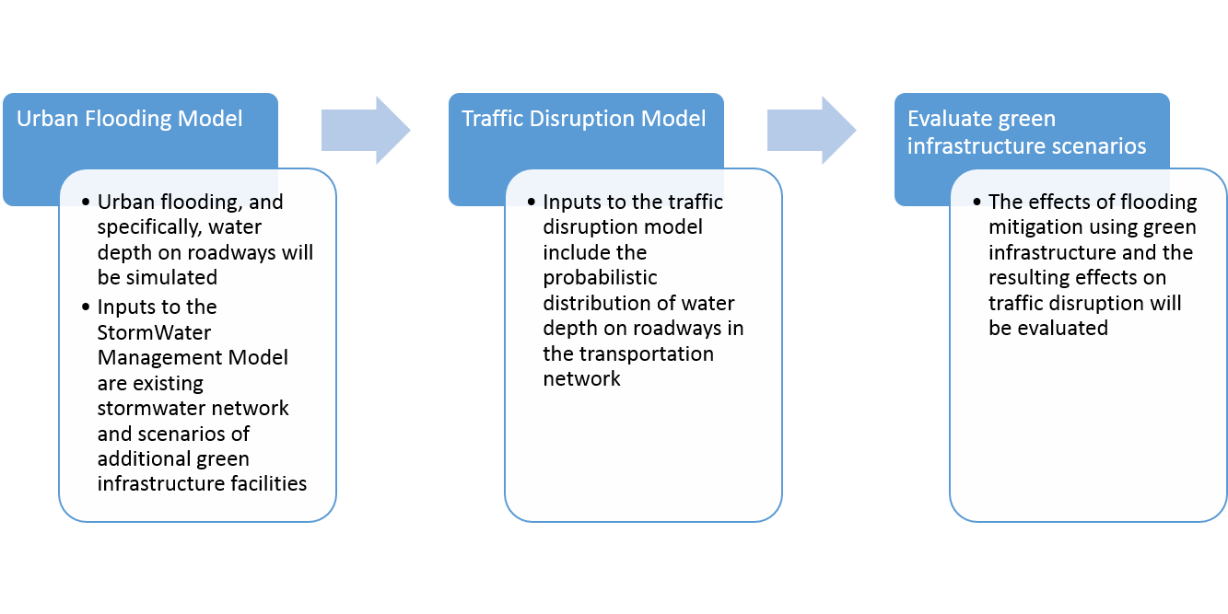

Research Methods
The Environmental Protection Agency’s Stormwater Management Model 5 (EPA SWMM5) will be used to model scenarios of green infrastructure. EPA SWMM5 includes explicit representations of various green infrastructure stormwater control measures. It also includes the surface water flood response to rainfall inputs. We will simulate a range of design storm conditions, ranging from a 2 year to a 500 year event. The simulations will also be run with different green infrastructure scenarios where both the number and location of green infrastructure stormwater control measures are varied.
Based on the flooding risk simulation, traffic impact study will be conducted in a microscopic scale on both roads and traffic network. The relation between water depth as well as its associated probability at different places on the road and the traffic safety risk, accessibility and possible traffic delay will be developed through probabilistic simulations.

Expected Outcomes
This expected outcomes from this project are to (1) develop a loosely coupled stormwater flooding and traffic disruption modeling system; (2) examine how green infrastructure implementation would affect traffic disruption, which can support future green infrastructure design and optimization to minimize the impact on transportation disruption.

Relevance to Strategic Goals
The USDOT strategic goals of Safety and Environmental Sustainability are addressed by the proposed project. This project will address how transportation infrastructure can be integrated with Environmental Sustainability by minimizing negative environmental outcomes related to hydrologic flows and stormwater generated. Safety will also be addressed by how flooding-related safety concerns can be addressed through improved stormwater management and green infrastructure.

Educational Benefits
Two graduate students will be mentored in the areas of stormwater management modeling and traffic disruption modeling in the Department of Civil and Environmental Engineering at Colorado State University and will carry out the proposed work and will form the basis for their theses.
The project will be used as an example study in a course taught by Dr. Bhaskar, CIVE572: Urban Water Systems Analysis, and CIVE 303 Infrastructure and Transportation Systems taught by Dr. Suren Chen.

Technology Transfer
The research team will disseminate findings through conference presentations, project reports, and journal articles. The research findings will be presented to practitioners at meetings such as the Colorado Association of Stormwater and Floodplain and Managers, presentations to the Fort Collins Stormwater and Traffic Operations departments. A webpage and social media will also be used as alternative means to communicate findings to the broader public.

Work Plan
The work plan includes 6 project tasks consisting of developing two modeling frameworks. Tasks 1 and 2 describe the initial development of the urban stormwater flooding model and are expected to be completed 8 months after the project start date. Tasks 3 and 4 develop the green infrastructure scenarios for urban stormwater flooding and are expected to be completed 16 months after the project start date. Tasks 5 and 6 involve modeling the traffic disruption and performance on roadways with green infrastructure scenarios, and are expected to be completed 2 years after the project start date.
- Develop the urban stormwater flooding model. Collect the most updated information on the current stormwater management implemented in the Colorado watershed. Incorporate the existing stormwater network, topographic conditions, soil conditions, and road locations in the watershed into an urban flooding model. Analyze the Colorado State University weather station record (1889 – 2017) to estimate the rainfall intensity and duration corresponding to recurrence interval events of 2 years, 5 years, 10 years, 50 years, 100 years, and 500 years to create design storms of varying recurrence intervals.
- Calibrate the stormwater model by simulating the response to a range of observed rainfall events. The model will be calibrated to the observed flow in Spring Creek at the Center Ave @ Spring Creek stream gage operated by the City of Fort Collins. Task 2 will be completed 8 months after the project start.
- Simulate the current urban flooding response in the urban watershed. Varying recurrence interval rainfall design events will be simulated. These simulations are referred to as the base case scenario outputs.
- Simulate the urban flooding response for green infrastructure implementation scenarios. Modify the SWMM model to include green infrastructure scenarios of 1.5, 2, 5, 10, and 20 times as much impervious surface treated by green infrastructure as compared to that modeled in the base case scenario. Compare the green infrastructure scenarios to the base case scenario in terms of flow response in the stream and depth of flow on roadways. Task 4 will be completed 16 months after the project start.
- Simulate traffic disruption on the roadways subjected to flooding for green infrastructure scenarios. The simulated scenarios will be classified into several representative cases. Accessibility of the road is evaluated for each scenario in terms of whether the road is passable. Travel time is also predicted for each passable roadway for the given representative scenario.
- Evaluate the probabilistic traffic performance of the whole road network for green infrastructure scenarios. Based on the accessibility and travel time results of each roadway, the probabilistic traffic performance of the whole road network with disruptions will be evaluated during the post-flooding emergency response and early recovery stages. The optimal routes between some critical origins and destinations will be planned for different flooding scenarios. The possible improvement in traffic performance with green infrastructure implementation scenarios will be evaluated. Task 6 will be completed 2 years after the project start date.

Project Cost
Total Project Costs: $ 120,000
MPC Funds Requested: $ 60,000
Matching Funds: $ 60,000
Source of Matching Funds: Colorado State University

References
Bhaskar AS, Hogan DM, Archfield SA. 2016. Urban base flow with Low Impact Development. Hydrological Processes 30 (18): 3156–3171 DOI: 10.1002/hyp.10808
Grigg NS, Doesken NJ, Frick DM, Grimm M, Hilmes M, McKee TB, Oltjenbruns KA. 1999. Fort Collins flood 1997: Comprehensive view of an extreme event. Journal of water resources planning and management 125 (5): 255–262
Jefferson AJ, Bhaskar AS, Hopkins KG, Fanelli R, Avellaneda PM, McMillan SK. 2017. Stormwater management network effectiveness and implications for urban watershed function: A critical review. Hydrological Processes 31 (23): 4056–4080 DOI: 10.1002/hyp.11347
NRC. 2009. Urban Stormwater Management in the United States. The National Academies Press: Washington, D.C.
Pregnolato M, Ford A, Dawson R. 2016. Disruption and adaptation of urban transport networks from flooding (M Lang, F Klijn, and P Samuels, eds). E3S Web of Conferences 7: 07006 DOI: 10.1051/e3sconf/20160707006
US EPA. 2000. Low Impact Development (LID) Literature Review and Fact Sheets. US EPA Document # EPA-841-B-00-005. Available at: http://water.epa.gov/polwaste/green/lidlit.cfm [Accessed 7 July 2015]
Walsh CJ, Roy AH, Feminella JW, Cottingham PD, Groffman PM, Morgan II RP. 2005. The urban stream syndrome: current knowledge and the search for a cure. Journal of the North American Benthological Society 24 (3): 706–723

