MPC-571

June 27, 2018

Project Title
Monitoring Transportation Structure Integrity Loss and Risk with Structure-From-Motion

University
Colorado State University

Principal Investigators
Paul R. Heyliger
Professor
Colorado State University
Phone: (970) 491-6685
Email: prh@engr.colostate.edu
ORCID: 0000-0001-6884-6967

Research Needs
Transportation structures are often used either beyond their original design life or they continue in use after they have been damaged or otherwise modified after their initial construction. In addition, the conditions of the surrounding terrain can often change because of accidents, natural processes, or natural disasters. These changes can directly impact the integrity of the structural system. For example, floodwaters can reposition soil that surrounds an embankment. Freeze-thaw conditions can alter the stability of talus fields, increasing the probability of rockslide or other threats to roads and highways. This proposal describes an automated technology that can potentially be used to monitor changes to structural integrity or potential threats to transportation structures or systems using a combination of methods based on a photographic imaging technique known as Structure-from-Motion (SfM).

Research Objectives
The objectives of this study are to 1) identify transportation structures and/or systems that are good candidates for representative analysis for the proposed methodology, 2) extend existing capabilities in the modeling of these systems using a combination of SfM and structural analysis models, 3) developing quantifiable metrics that can be used to assess percentage loss of strength and stiffness or an increase in the likelihood of a devastating failure of the system, and 4) determine if imaging methods can be used to optimize or assist in remediation efforts of these threatened transportation systems.

Research Methods
The primary analysis methods that will be used in this research involve a combination of imaging and analysis techniques. The imaging methodology is based on commercialized software (already in possession of the PI) that converts a sequence of digital photographs to a point cloud representing the surface positions of the surrounding terrain. These geometric positions can then be post-processed to build either finite element and/or discrete element models that can then be used to determine the levels of force and stress in the modeled domain.
An example of the envisioned technology is shown in Figure 1. In this photo (courtesy of CDOT), part of the construction process of rockfall barriers in Glenwood Canyon is shown. As seasons pass, the positions of the talus blocks can change either gradually because of freeze-thaw and runoff forces or dramatically as part of these same processes. It may be possible to identify several of these slopes and monitor their geometric changes in position to assist in the design and placement of these extremely expensive rockfall barriers to reduce the probability of a catastrophic rockslide that would closed down the highway for extended repair.
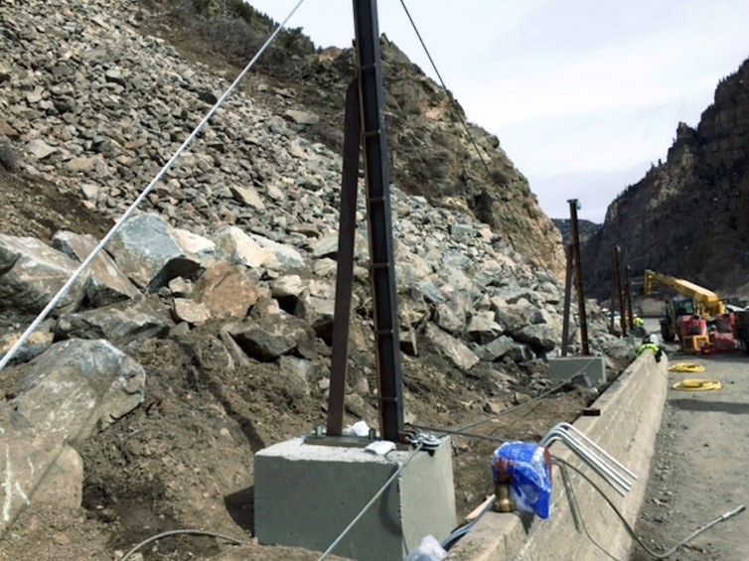
Figure 1. Construction of rockfall barriers along I-70 in Glenwood Canyon. The individual boulders in the background have the potential to be individually imaged and cataloged to monitor their changes in position as a function of time to estimate threat levels to the adjacent highway.

Expected Outcomes
The expected outcomes of this work are 1) continued development of analysis tools that can be used to eventually automate changes in structural character with the assistance of very simple digital phots, 2) a better idea of determining the costs and benefits of being able to automate such a methodology so that it can potentially be used as an assessment tool at a larger scale, and 3) being able to refine limitations or advances of using this class of technology to further transportation system maintenance, repair, and construction.

Relevance to Strategic Goals
This study has relevance to the strategic goals of State of Good Repair and Environmental Sustainability. In the case of the former, the methodology can help determine the level of structural integrity to maintain original design standards. In the second case, all transportation systems become part of the surrounding environment and the ability of these systems to mesh with, rather than conflict with, the surrounding environment can potentially be directly monitored and quantified.

Educational Benefits
The proposed study contains two educational elements. First, a graduate student will be funded to perform much of the work, particularly any analysis portion of the research. Second, the Honors section of the undergraduate class CIVE 360 (Mechanics of Solids) will be devoted towards generating imaging databanks and typical point clouds for prototype structures. These students usually work unfunded as part of their academic requirement for honors credits. The classes of Spring 2018 and Spring 2019 will both participate if they have interest.

Technology Transfer
The proposed technology will be transferred to the applied and research communities primarily through journal and conference papers in structures and/or transportation related journals and professional meetings. Very preliminary efforts have been made to combine the various technical steps in moving from digital images to a resulting numerical model into a single whole for possible commercialization. If enough resources can be obtained to assist with this process, this strategy will be aggressively pursued.

Work Plan
The major tasks associated with this research are as follows:
- Identify candidate structures and systems that have the necessary features for this study. Expected completion date: 3 months.
- Train graduate and undergraduate students in image creation and manipulation. Expected completion date: 4 months.
- Collect initial images from defined field sites. Expected completion date: 3 months.
- Monitor Colorado roadways for any transportation structures that have seen damage from crashes or other impacts and collect full image data. Expected completion date: Ongoing.
- Develop methods for quantifying level of expected damage, degradation, or threat increases. Expected completion date: 9 months.

Project Cost
Total Project Costs: $ 120,000
MPC Funds Requested: $ 60,000
Matching Funds: $ 60,000
Source of Matching Funds: CSU salary, NSF

References
Westoby MJ, Brasington J, Glasser NF, Hambrey MJ, and Reynolds JM. Structure-from-Motion photogrammetry: A low-cost, effective tool for geoscience applications. Geomorphology 179 pp. 300-314 (2012).
Koutsoudis A, Vidmar B, Ioannakis G, Anaoutoglou F, Pavlidis G, and Chamzas C. Multi-image 3D reconstruction data evaluation. Journal of Cultural Heritage 15 pp. 73-79 (2014).

