MPC-592

February 26, 2019

Project Title
Development of an Autonomous Transportation Infrastructure Inspection System Based on Unmanned Aerial Vehicles

University
Colorado State University

Principal Investigators
Yanlin Guo
Assistant Professor
Colorado State University
Phone: (970) 491-3518
Email: yanlin@colostate.edu
ORCID: 0000-0002-7162-6508
Rebecca Atadero
Associate Professor
Colorado State University
Phone: (970) 491-3584
Email: rebecca.atadero@colostate.edu
ORCID: 0000-0002-7477-1620
John W. van de Lindt, Ph.D.
Professor
Colorado State University
Phone: (970) 491-6697
Email: jwv@engr.colostate.edu
ORCID: 0000-0001-6386-4509

Research Needs
With transportation infrastructure in the United States aging and deteriorating, maintenance and inspection of the existing infrastructure are critical. Accurate and efficient inspections serve to inform engineers/managers to enable better repair decisions/planning, load-rating, and effective management of limited resources. Current human-based infrastructure inspections suffer from a number of limitations. They can be costly with significant direct costs due to inspectors and equipment particularly when specialized equipment such as a “cherry-picker” is needed, as well as the indirect cost of traffic interruption. Furthermore, current documentation techniques often lack quantitative measures and location information for damage, meaning human-based bridge inspection findings are subjective in nature and variability between inspections is common. Making maintenance and repair decisions based on ambiguous condition information can be cumbersome and, at times, inaccurate and may require additional field inspections, further increasing management cost. In addition, the subjective damage information cannot be used to develop accurate deterioration models for predicting future performance and life-cycle cost optimization. Last but not least, conventional inspection may pose a danger to inspectors in cases where inspectors need to climb on bridges/cables, or enter confined spaces (e.g. ditches) with potentially hazardous gas. These shortcomings of current practice highlight the need to develop more cost-effective, quantitative, and safe approaches for infrastructure inspection.
Recently, due to rapid technology advancements in the commercial UAV field and the diligent efforts of Federal Aviation Administration (FAA) to safely promote commercial use of UAVs through transparent operation regulations, significant interest in applying UAV-based remote sensing technology to transportation infrastructure has quickly spread in both research communities and state DOTs. A number of pilot studies launched by both communities have demonstrated the bright promise of this new technology. For example, the multi-phase project conducted by Minnesota DOT (Zink and Lovelace 2015) has proven that various damage on bridge elements reported by human inspectors is discernable from images taken by UAV and the potential inspection cost reduction compared to conventional approaches can be as high as 66%. On the other hand, research communities have investigated the feasibility of drone use in traffic monitoring, confined space assessment, and bridge deck inspection, where cracks, surface delamination and concrete spalling were identified from the UAV collected optical and thermal images (Brooks et al. 2017; Ellenberg et al. 2016; Khan et al. 2015). The efficacy of UAV-based bridge deck inspection using high-resolution thermal imagery has been validated by comparison to other non-destructive testing technologies (Omar and Nehdi 2017). In addition, some studies have shown the potential of deformation/displacement measurement of bridges through tracking the coordinates of a set of markers (Ellenberg et al. 2014) or comparing the coordinate difference between two sets of point-clouds (Hallermann et al. 2014; Hallermann and Morgenthal 2014). Beyond application in transportation infrastructure, UAV-based technology has also led to great success in other infrastructure applications. For example, cooperative multi-platform UAVs have achieved a much higher efficiency in inspecting large-scale power line systems than traditional methods (Deng et al. 2014), through real-time data transmission, communication, and decision-making. For monitoring photovoltaic (PV) systems over a large geographical area, an autonomous UAV-based inspection system with real-time image processing features has been developed to greatly increase the inspection efficiency. In addition, many advances have been achieved in the reconstruction of three-dimensional (3D) models of structures (buildings, poles, etc.) with mapped photo-realistic texture, which can later be used to facilitate damage identification, localization and visualization in infrastructure inspection (Eschmann et al. 2013; Mauriello and Froehlich 2014; Sa et al. 2015). The successes of UAV technology in these fields indicate the great promise that may be achieved with translation to the transportation sector.
Recognizing the need for advancing current infrastructure inspection practice and the rapid technology improvement of UAV-based remote sensing, the PIs propose to explore the potential of UAV based remote sensing technology in infrastructure inspection and to develop a UAV-based infrastructure inspection framework. The ultimate goal of the proposed research is to develop an autonomous and quantitative infrastructure inspection procedure that requires minimum human intervention. Through this endeavor, the research team anticipates providing transportation infrastructure management sectors (e.g. state DOTs) with a highly efficient, cost-effective, quantitative and safe proof-of-concept for infrastructure inspection. The proposed UAV-based framework includes data (images) acquisition using the UAV, 3D reconstruction of surface models of bridges, identification, localization and quantification of structural damage and documentation of the geo-referenced bridge inspection data in the database. This goal will be achieved in two phases. The first phase is the feasibility study, while the second phase is the development of machine learning and image processing tools to fully automate the data post-processing, damage identification and documentation of geo-referenced inspection data. Currently, under the support of Mountain-Plains Consortium (MPC) in 2017-2019, the PIs have conducted the Phase I study. Specifically, a UAV-based infrastructure inspection system has been tested for bridges. The Phase I study has shown that it is not only feasible but also efficient to collect optical and/or thermographic images of high quality for bridge inspection through autonomous flight missions of the UAV. Three dimensional (3D) surface models of bridges using images collected by a UAV have been established with visible damage mapped to photo-realistic models. Thus, the feasibility of damage identification/condition assessment using 3D surface models is also proved. Based on the Phase I achievements, this proposal will focus on the Phase II of the research, i.e. development of an autonomous inspection system that integrates field inspection, damage identification, and documentation of damage with quantitative measures and geo-referenced locations (Fig. 1).
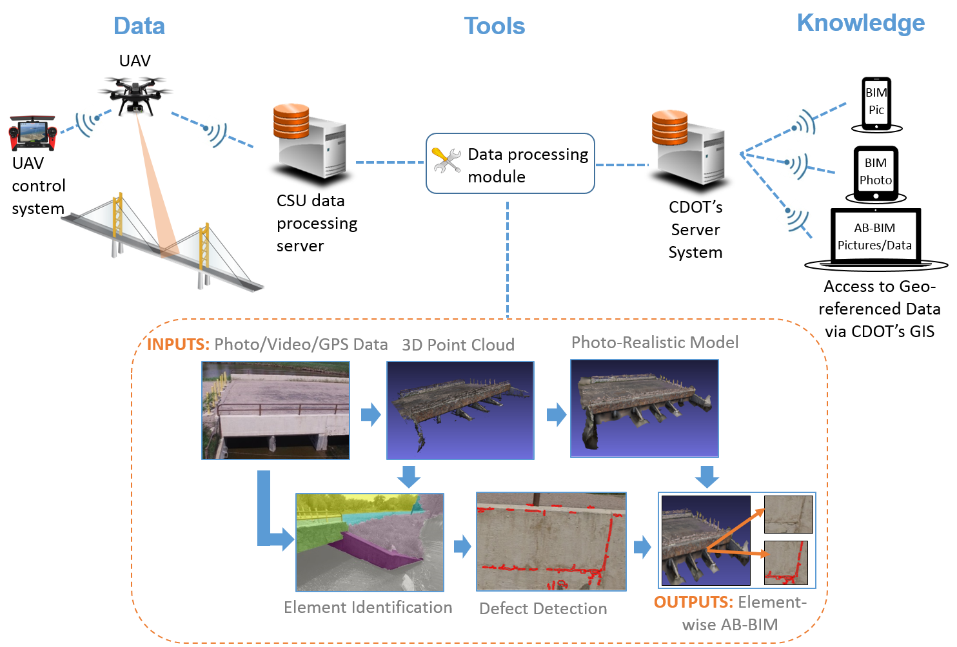
Figure 1. A UAV based infrastructure inspection framework.

Research Objectives
The research objectives of the proposal are:
- Objective R1 - An automatic process to establish as-built BIM: Develop an automated process to identify different elements of a structure and construct an as-built element-wise building information model (BIM) with visualization capability using the 3D point-cloud for each bridge element and the photo-realistic 3D model (Fig. 1).
- Objective R2 - An automatic damage evaluation tool: Develop an automated damage evaluation tool that can identify the type, location and amount of structural damage for each element (Fig. 1).
- Objective R3 - A damage documentation tool: Develop a damage documentation tool that maps the identified element-wise damage to the corresponding bridge element in BIM (Fig. 1).

Research Methods
The methodology for achieving each of the three objectives is discussed in the following.
Objective R1 - An automatic process to establish as-built BIM
In the current practice of bridge inspection, the condition is evaluated for different types of structural elements. To effectively integrate this new UAV-based infrastructure inspection system into existing bridge inspection practices, it is critical to establish element-wise as-built BIM, which allows mapping the information of structural damage/defects to each individual element. The preparation of the BIM model from point-cloud data collected by the UAV is currently a manual, expensive, and labor-intensive process, therefore a technique that automates this process is proposed in this study. Firstly, the geo-referenced images with 70% overlap collected by a UAV are used to generate a 3D point-cloud and a photo-realistic model, using the popular computer vision algorithm Structure-from-Motion (SfM). To identify the structural elements, two techniques will be tested and the possibility of integrating them to improve the accuracy will be investigated. One technique is to use plane segmentation and edge detection algorithms to distinguish different structural components directly from the point-cloud (Wang et al. 2015). The other is to apply object segmentation, a process of partitioning a digital image into multiple segments in the computer vision field, to use the original optical images to separate different structural elements according to color contrast. Once the point-cloud corresponding to each identified structural element is extracted, the dimension of the element will be obtained and used to create the element object in BIM. The commercial software Autodesk Revit will be adopted for establishing the BIM. In the end, the 3D photo-realistic surface model will be integrated into BIM to facilitate the 3D visualization of the structure.
Objective R2 - An automatic damage evaluation tool
Both the optical and thermal images will be used for damage identification. An automated algorithm will be developed to identify the cracks, efflorescence, and delamination of concrete. To enhance the identification accuracy, the original images will be pre-processed using a wavelet transform based image de-noising technique (Ruikar 2011). The RGB optical image will be first converted to grayscale and then a popular edge detection technique, Sobel operator, will be performed to detect cracks (Pereira and Pereira 2015; Talab et al. 2016). To avoid discontinuity of a crack after edge detection, morphological mathematical operations will be performed. Coordinates of crack edges will be recovered using a stereo vision technique based on overlapped pictures taken by the UAV. Details of detected cracks, such as orientation, thickness, length, and coordinates will be stored for importing to BIM later. To identify the efflorescence, thresholding will be applied to the previous converted grayscale optical images. The area with brighter scales is identified as efflorescence, while the area with darker scale represents the well-preserved concrete (Vázquez et al. 2011). Following this, image segmentation will be employed to enable the calculation of the area and percentage of efflorescence on the entire surface. The information of both thermal and optical images will be fused to identify the delamination of concrete, as the sub-surface delamination may not be distinguished from other surface defects using thermal images alone. A segmentation method will be used to identify the delamination area, where the temperature is higher than the surrounding undamaged area (Omar and Nehdi 2017). Specifically, the superpixels will be computed for the original thermal image. Then k-means clustering can be used to classify the superpixel thermal values into four groups, representing four conditions defined by AASHTO guide: good, fair, poor and severe. The enclosed shapes of grouped superpixels represent the different conditions of delamination.
Objective R3 - A damage documentation tool
The identified damage information includes the type of the damage (i.e. crack, efflorescence, and sub-surface delamination, etc.), amount and severity of damage, as well as the location of damage, represented by the coordinates of the centroid of the damage pattern. Using the coordinate information, the location of the damage will be mapped to the corresponding element object in BIM. Specifically, an abstract object called “damage cell” will be created in BIM (McGuire et al. 2016). The information about each identified damage, as well as the picture of the damage pattern, will be documented in a damage cell. In the end, the damage cells will be attached to the corresponding bridge elements. This will allow end users to visualize and check the condition of structural elements conveniently and efficiently.

Expected Outcomes
The expected outcomes include:
- An autonomous tool for creating as-built element-wise BIM.
- An autonomous tool for damage identification.
- A damage documentation tool in BIM.
- A full report documenting method and proof-of-concept case-studies will be provided and one or more TRB papers will be published.

Relevance to Strategic Goals
This project is related directly to a number of MPC goals:
- Safety – The use of UAV can eliminate the need for inspectors to climb ladders and thus provide better safety for inspectors.
- Economic Competitiveness – The proposed framework can reduce the costs by eliminating the use of specialized equipment such as a “cherry-picker” and reducing the work time of the inspection process.

Educational Benefits
One graduate student will participate in the project including writing several papers and a report, which will result in part of his/her dissertation. He/She will gain valuable experience in developing cutting-edge techniques for infrastructure inspection.

Technology Transfer
The research group will establish collaboration with transportation infrastructure management staff at CDOT and the City of Fort Collins on the application of this technology. The developed techniques will be firstly tested on Colorado bridges (Infrastructure managers at CDOT and the City of Fort Collins have helped to identify potential candidate structures for field studies and application in the near future). Guidelines for the integration of the new technology to existing bridge management practice will be created by combining the findings of both Phases I and II of the research, as well as input from CDOT to ensure the effective adoption of the technology in practice.

Work Plan
The work plan includes four major tasks, each with an interim deliverable/milestone:
Task 1: Data collection
Field tests will be conducted to collect optical/thermal images for several infrastructures. Challenges in data collection for infrastructure inspection will be investigated. Specifically, how to efficiently take images underneath bridges or within confined spaces, where GPS navigation of the UAV may not be available, will be studied. The expected completion date for this task is 12 months from the project start date.
Task 2: Development of an automatic process to establish as-built BIM
Different element object identification algorithms using both original images and point-clouds extracted from the images will be tested and adapted to the current application of infrastructure inspection. Then a robust algorithm will be developed to automate the process of establishing element-wise as-built BIM. The expected completion date for this task is 20 months from the project start date.
Task 3: Development of an automatic damage evaluation tool
A set of damage identification algorithms will be developed to evaluate different types of damage/defects (i.e. cracks, sub-surface delamination, efflorescence, etc.) of the inspected infrastructure. The focus of this task is to quantify, localize the damage patterns, as well as to automate the process. The expected completion date for this task is 20 months from the project start date.
Task 4: Development of a damage documentation tool
A damage documentation tool will be developed in BIM software to attach the damage information obtained from Task 3 to the corresponding elements in the element-wise as-built BIM established in Task 2. The expected completion date for this task is 24 months from the project start date.

Project Cost
Total Project Costs: $ 116,000
MPC Funds Requested: $ 58,000
Matching Funds: $ 58,000
Source of Matching Funds: Colorado State University

References
Brooks, C., Dobson, R., Banach, D., Cook, S. J., Arbor, A., Field, O., and Division, S. (2017). “Transportation infrastructure assessment through the use of unmanned aerial vehicles.” Transportation Research Board, 96th Annual Meeting, 602.
Deng, C., Wang, S., Huang, Z., Tan, Z., and Liu, J. (2014). “Unmanned aerial vehicles for power line inspection: A cooperative way in platforms and communications.” Journal of Communications, 9(9), 687–692.
Ellenberg, A., Branco, L., Krick, A., Bartoli, I., and Kontsos, A. (2014). “Use of unmanned aerial vehicle for quantitative infrastructure evaluation.” Journal of Infrastructure Systems, 21(3), 4014054.
Ellenberg, A., Kontsos, A., Moon, F., and Bartoli, I. (2016). “Bridge deck delamination identification from unmanned aerial vehicle infrared imagery.” Automation in Construction, Elsevier B.V., 72, 155–165.
Eschmann, C., Kuo, C.-M., Kuo, C.-H., and Boller, C. (2013). “High-resolution multisensor infrastructure inspection with unmanned aircraft systems.” ISPRS - International Archives of the Photogrammetry, Remote Sensing and Spatial Information Sciences, XL-1/W2(September), 125–129.
Hallermann, N., and Morgenthal, G. (2014). “Visual inspection strategies for large bridges using Unmanned Aerial Vehicles (UAV).” Bridge Maintenance, Safety, Management and Life Extension, (July), 661–667.
Hallermann, N., Morgenthal, G., and Rodehorst, V. (2014). “Vision-based deformation monitoring of large scale structures using Unmanned Aerial Systems.” IABSE Symposium Report, 102(8), 2852–2859.
Khan, F., Ellenberg, A., Mazzotti, M., Kontsos, A., Moon, F., Pradhan, A., and Bartoli, I. (2015). “Investigation on bridge assessment using unmanned aerial systems.” 404–413.
Mauriello, M. L., and Froehlich, J. E. (2014). “Towards automated thermal profiling of buildings at scale using unmanned aerial vehicles and 3D-reconstruction.” UbiComp 2014 - Adjunct Proceedings of the 2014 ACM International Joint Conference on Pervasive and Ubiquitous Computing, 119–122.
McGuire, B., Atadero, R., Clevenger, C., and Ozbek, M. (2016). “Bridge information modeling for inspection and evaluation.” Journal of Bridge Engineering, 21(4), 4015076.
Omar, T., and Nehdi, M. L. (2017). “Remote sensing of concrete bridge decks using unmanned aerial vehicle infrared thermography.” Automation in Construction, Elsevier, 83(February), 360–371.
Pereira, F. C., and Pereira, C. E. (2015). “Embedded image processing systems for automatic recognition of cracks using UAVs.” IFAC-PapersOnLine, 28(10), 16–21.
Ruikar, S. D. (2011). “Wavelet based image denoising technique.” IJACSA International Journal of Advanced Computer Science and Applications, 2(3), 49–53.
Sa, I., Hrabar, S., and Corke, P. (2015). “Outdoor flight testing of a pole inspection UAV incorporating high-speed vision.” Field and Service Robotics. Springer Tracts in Advanced Robotics, L. Mejias, P. Corke, and J. Roberts, eds., Springer, Cham.
Talab, A. M. A., Huang, Z., Xi, F., and Haiming, L. (2016). “Detection crack in image using Otsu method and multiple filtering in image processing techniques.” Optik, Elsevier GmbH., 127(3), 1030–1033.
Vázquez, M. A., Galán, E., Guerrero, M. A., and Ortiz, P. (2011). “Digital image processing of weathered stone caused by efflorescences: A tool for mapping and evaluation of stone decay.” Construction and Building Materials, 25(4), 1603–1611.
Wang, C., Cho, Y. K., and Kim, C. (2015). “Automatic BIM component extraction from point clouds of existing buildings for sustainability applications.” Automation in Construction, Elsevier B.V., 56, 1–13.
Zink, J., and Lovelace, B. (2015). Unmanned Aerial Vehicle Bridge Inspection Demonstration Project. St. Paul, Minnesota.

