MPC-608

February 18, 2020

# Project Title

The Impact of the Mobility as a Service Mode on Transit Access

# University

University of Utah

# Principal Investigators

Xiaoyue Cathy Liu, Ph.D., P.E.

Associate Professor

Department of Civil and Environmental Engineering

University of Utah

Phone: (801) 587-8858

Email: cathy.liu@utah.edu

ORCID: 0000-0002-5162-891X

# Research Needs

In 2017, an MPC project (MPC-542) was funded to conduct exploratory modeling and analysis for autonomous vehicles (AVs) in Utah. The research considered the emergence of AV technology alongside a new travel mode, Mobility as a Service (MaaS), and projected their joint impacts in a 2040 forecast horizon. The work found that this technology mode combination could result in a 1-7% increase in trip making and a 4-9% increase in Vehicle Mile Traveled (VMT) when compared to the 2040 Base Case. This work utilized the Wasatch Front Travel Model to help estimate these impacts, which also included some shift in mode share from all other modes – drive alone, carpool, non-motorized and transit – to MaaS. An important impact of MaaS that was not considered in this current research was the utilization of MaaS as a first mile-last mile mode for transit access.

Addressing this important aspect of MaaS will give a more complete answer to the question of how the combined AV-MaaS technology will affect travel demand in the future. MaaS will impact mobility in a variety of ways. MaaS will deliver mobility to low mobility demographics such as elderly, disabled, and children. MaaS will reduce the burden of long travel times by enabling passengers to focus on tasks other than driving. MaaS will have significant impact on mode shares of other travel modes. MaaS provides lower travel times and superior trip comfort compared to public transit which may result in decline in public transit ridership. On the other hand, public transit agencies are evaluating partnership with TNC providers to use MaaS for access and egress to/from public transit services which may result in increase in public transit ridership.

# Research Objectives

The objective of this project is to **estimate the effect of the combined AV-MaaS technology, as a first mile-last mile mode, on future transit ridership and, as a consequence, on VMT**. This is to follow up the 2017 study, with an effort to effectively model MaaS as one of the first mile-last mile options for accessing transit (transit access options incorporated into the current WF model are park and ride, kiss and ride and non-motorized). As noted by the existing practice, having Mobility as a Service (MaaS) travel mode has impacted the transportation industry in recent years and this impact (mode share) is expected to grow significantly in future. It is expected the introduction of Connected or/and Autonomous Vehicles (CAV) will boom the MaaS mode by lowering the cost of the mode through elimination of driver’s cost for “as-service” providers (e.g. Uber and Lyft).

# Research Methods

Existing studies suggest that MaaS will play an important role in future mobility specially in Utah due to projected 1.5 million population growth by 2040 (Fagnant and Kockelman, 2018; WFRC/MAG Demand Model, 2016). In MPC-542, the research team has added MaaS mode to Wasatch Front travel model. The study estimated the trip production increase for low mobility demographics and added MaaS as a new mode to WF travel model.

In this project, we will focus on improving the MaaS mode in WF travel model by:

1. Combining MaaS 2+ and MaaS 3+ into MaaS shared ride mode;
2. Adding MaaS + Transit mode: MaaS as first mile-last mile feeder to public transit;

This research approach is designed to result in clearer estimate of future travel demand related to various possible scenarios of MaaS and MaaS + Transit penetration into the Utah travel fleet, and net impact on UTA ridership.

We will employ a scenario-based approach to model the impact of MaaS mode on regional travel demand. We currently envision 12 scenarios consisting of different combinations of trip growth rates and MaaS market penetrations. This experimental design allows us to estimate a range of VMT increase due to MaaS presence in the projection year of 2040. Figure 1 shows the designed scenarios. To facilitate the inclusion of the two MaaS modes outlined above, we will modify the current WF travel model as illustrated in Figure 2. This existing model uses a nested multinomial logit mode-choice model to estimate the split among non-motorized (walk/bike) and motorized (auto and transit) trips. The mode-choice model also evaluates the mode of a trip separately for peak (AM plus PM) and off-peak (MD plus EV) periods. Mode-choice model coefficients vary by purpose but not by time-period. Differences in time-period utilities are handled by the mode specific constants. We will add new modes to accommodate the two newly proposed MaaS modes. The new MaaS utility functions will be calculated based on in-vehicle-time, initial pick-up time, operating cost (i.e. the distance-based cost, time-based cost, and initial fee), cost split factor, and pick-up time factor.

Figure 1

**Figure 1: Experimental Design**

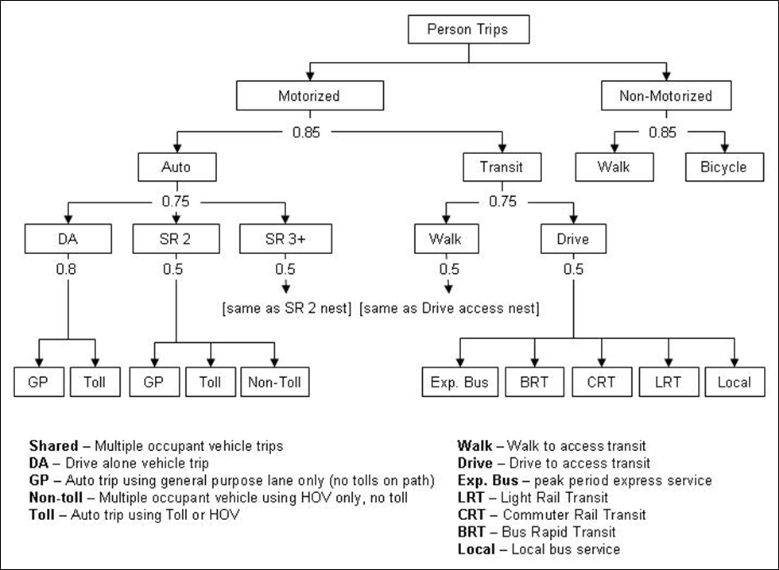

**Figure 2: Current WF mode choice model**

# Expected Outcomes

Utah is currently the fastest growing state in the U.S., and this growth will most likely translate into increased VMT. Current long-range planning in Utah deals with the AV-MaaS technology in only a qualitative way. This research proposes to address this gap by providing **solid quantitative modeling** to answer key questions about future VMT and travel behavior.

MaaS and its interaction with other modes, particularly public transit, will play a significant role in future demand management and transit ridership. However, the possible impact and magnitude of MaaS on travel demand is not well understood. This research can provide a foundation from which additional MaaS questions can be investigated:

1. How will different demographic groups respond differentially to the AV-MaaS technology?
2. What is the impact of zero-occupant vehicle trips (repositioning trips)?
3. What is the impact of AV-MaaS on trip lengths?

To help address these questions, a foundation of understanding related to MaaS market penetration needs to be established, which is the key objective of this project.

# Relevance to Strategic Goals

This project primarily addresses USDOT strategic goal of “Economic Competitiveness”.

A high quality and fully functioning transportation system is vital to the economy development and livability of citizens, it is also the prerequisite for future growth. This project establishes a quantitate modeling framework to address disruptive technologies in the planning process. As we move towards this type of planning, the need to precisely forecast the future becomes less important. The ability to understand the cause and effect relationship between technology, transportation investment, land use policies, and travel behavior becomes more important. The planning and forecasting of AV-MaaS’s impact will naturally shift towards creating systems which puts us in the best position to meet our stated goals, and which are capable of adapting to a variety of external influences.

# Educational Benefits

One graduate student will be heavily involved in this research. He/she will lead the preparation of journal publications resulting from the work, and in most cases, deliver conference presentations. The project will serve as a basis for his/her dissertation work. The PI is currently offering a graduate level course “Transportation Network Modeling” every Fall semester. The quantitively modeling framework developed in this research will lead to new material included in the course to teach the students practical skills on simulation and analytic techniques for modeling AV-MaaS’s impact on transportation network.

# Technology Transfer

The research will inform the Long Range Transportation plans of UDOT, WFRC, and MAG. It is clear that AV-MaaSs will integrate into the vehicle fleet over the time frame of the analysis, to 2040. Not accounting for their impact will certainly underestimate future VMT. This research will result in greater certainty surrounding the impacts of AV-MaaS on VMT, and may be used to understand future capacity needs, as well as point to operational needs during the transition period when these disruptive technologies begin getting absorbed into the overall vehicle fleet, but represent small fractions thereof.

The potential audiences for this research are individuals involved in the traffic operations and transportation asset management, including traffic engineers, planners, and senior leaders at FHWA, state DOTs, and MPOs. The following agencies, offices, and committees are those most likely to take a leadership role in implementing the research results:

* Utah Department of Transportation
* FHWA Office of Planning
* TRB Highway Capacity and Quality of Service Committee
* TRB Managed Lanes Committee

The proposed principal investigator routinely interacts with UDOT, WFRC, UTA, FHWA, SHRP 2 Reliability Program, and the listed TRB Committees. The 2020 Midyear Meetings of TRB Highway Capacity and Quality of Service Committee and TRB Managed Lane Committee will be an opportunity to share early results and future directions of the research project. The proposed principal investigator will work with the committee chairs to possibly get a presentation on the project added to the agenda. The proposed principal investigator and her graduate students routinely attend TRB’s annual meeting as well. At least one TRB paper on this work will be submitted for presentation and publication.

# Work Plan

1. Stakeholder meetings (1 month)

Assemble a group of stakeholders from UDOT, UTA, WFRC, MAG, and other transportation planning organizations to advise the research. A total of three meetings is envisioned:

1. kick off and introduce the project;
2. present the MaaS improvements and method for adding MaaS + Transit mode; and
3. present findings from an Exploratory Analysis.

2. Review analytical methods (3 months)

Review the most recent methods in incorporating the MaaS and MaaS + as transit access modes in travel models. Identify the most suitable method for improving MaaS mode and adding MaaS + Transit mode to WF travel model.

3. WF model improvements (5 months)

Following the review analytical methods, the research team will implement the improvement to existing MaaS mode and add MaaS + Tranist mode to WF travel model. The research team will also perform multiple test runs to ensure the implemented improvements are working correctly. Before proceeding to task 5, Scenario Testing, the research team will meet with the stakeholder group (meeting #2) to ensure the proposed and implemented improvements are satisfying.

4. Scenario development (2 months)

Following the review analytical methods, the research team will develop an Exploratory Modeling and Analysis (EMA) framework for investigating the macro-level demand impacts of CAV-MaaS. The EMA approach mirrors that used in the 2017 UTRAC research. EMA: 1) specifies a range of input assumptions to vary and; 2) uses an experimental design to define a set of model runs to test the varying assumption. The proposed scenarios will be based on most recent research and stakeholders’ input.

5. Scenario testing (3 months)

After establishing agreement on the model improvements and experimental design with the Stakeholder group, we will modify and parameterize the WF travel demand model to conduct a total of 9 model runs (3 MaaS mode costs scenarios X 3 MaaS + Transit mode costs scenarios). In travel modeling parlance, this refers to changing the MaaS mode cost function (e.g. cost per mile cost, cost per travel time, and initial cost). A similar set of 3 scenarios will be developed for MaaS + Transit mode costs. Before proceeding to Task 5, Scenario Testing, the research team will meet with the stakeholder group (meeting #3) to propose the 3X3 experimental design, with 3 MaaS mode costs scenarios and 3 MaaS + Transit mode costs scenarios. Travel models such as the WF travel model are useful for evaluating a subset of the questions relating to MaaS that impact travel demand. At the end of the research, the transportation planning community will have greater confidence in mode share forecasts incorporating specific assumptions about AV-MaaS market penetration and use.

6. Final report (2 month)

# Project Cost

Total Project Costs: $90,000

MPC Funds Requested: $40,000

Matching Funds: $50,000

Source of Matching Funds: Utah Department of Transportation, financial support

# References

Fagnant, D.J. and Kockelman, K.M., 2018. Dynamic ride-sharing and fleet sizing for a system of shared autonomous vehicles in Austin, Texas. Transportation, 45(1), pp.143-158.

WFRC/MAG Demand Model Version 8.1 Calibration & Validation Report, 2016. Report, Utah.