MPC-630

August 25, 2020

Project Title
Automated Real-Time Weather Detection System using Artificial Intelligence

University
University of Wyoming

Principal Investigators
Mohamed Ahmed, Ph.D., P.E.
Associate Professor
Civil and Architectural Engineering Department
University of Wyoming
Phone: (307) 766-5550
Email: mahmed@uwyo.edu
ORCID: 0000-0002-1921-0724

Research Needs
Adverse weather conditions, such as snow, rain, and fog, can directly impact roadway safety, by reducing the visibility and roadway surface friction, negatively affecting vehicle as well as drivers’ performance, and potentially increasing required stopping sight distance. The Federal Highway Administration (FHWA) reported that adverse weather is responsible for around 21% of total vehicle crashes, 19% of crash injuries, and 16% of crash fatalities each year in the U.S. (1). Previous studies concluded that weather-related factors could increase traffic fatalities and injuries by 25% and 45%, respectively (2, 3). Several studies have concluded that adverse weather can increase the severity of crashes and involve multiple vehicles (4). Falling and blowing snow, blizzards, fog, and rain can result in a sudden reduction in visibility on the roadways. Moreover, the road surface friction could be also reduced significantly due to icing and hydroplaning. The low surface friction of snow-covered roadways coupled with reduced visibility from fog, and frozen rain/ falling snow could result in dangerous conditions for drivers, making it one of the major causes of motor vehicle crashes. According to the FHWA, approximately 688 fatal crashes, 41,860 injury crashes, and 186,076 property damage only (PDO) crashes occur every year in the U.S. because of snow (1). In addition, many pile-up crashes have occurred in recent years due to the presence of fog which caused many fatalities, injuries, and property damages. For instance, a multi-vehicle crash due to dense fog occurred on I-94, Michigan on January 9, 2015, which caused the death of one person, injuries of approximately 23 people, and the closure of the interstate for longer than one day (5). The study of Moore and Copper noted that despite a 20% decrease in traffic in thick fog, there was an increase of 16% in the total number of personal injury accidents (6). Another study revealed that crashes occurred in heavy fog tend to involve multiple vehicles (7). Considering rainy weather, it was found that the risk of injury crashes in rainy weather conditions could be two times greater than in clear weather conditions (8). Several studies concluded that crashes increase due to vision obstruction during heavy rainfall by 100% or more (8), while others found more moderate but still statistically significant increases (9). However, in the state of Wyoming, the number of snow-related crashes are particularly significant. Merely in winter 2018, there were 1,438 snow-related crashes, which resulted in fatalities, extended closures, and significant economic loss (10). This is mainly due to Wyoming’s adverse winter weather events (such as low visibility and icy road surface from blizzard conditions) and the state’s roadway and traffic flow conditions (i.e., a large number of low volume rural two-lane highways, and mountainous freeways with high percentage of heavy inter- and intra-state freight traffic). In practice, the negative impact of snowy weather on roadway safety can be effectively mitigated through the implementation of various safety countermeasures, such as Dynamic Massage Sign (DMS) and Variable Speed Limit (VSL) (11, 12). Nevertheless, these countermeasures require accurate and real-time road surface and weather information to operate effectively and reliably. Therefore, the detection of real-time weather condition and providing drivers with appropriate warnings are crucial for safe driving during adverse weather conditions, including snow, in Wyoming. This is considered by the Wyoming Department of Transportation (WYDOT) Travel Information Service as a primary task (13).
The state-of-practice of collecting and broadcasting road weather information to travelers has been predominantly based on roadside weather stations and Road Weather Information Systems (RWIS). Although RWIS can provide quantitative weather data, such as temperature, humidity, wind speed, visibility, and precipitation, these systems are expensive. According to the U.S. Department of Transportation (USDOT), the average total cost of implementing a RWIS is about $52,000 per unit (14). Therefore, their widespread implementation might not be feasible. In addition, sensors on the weather stations are usually not mounted at the road surface level. Many weather conditions, such as blowing snow, may reduce the visibility only at the road surface level due to the accumulation of snow on the side of the road and wind, especially in mountainous regions. In such cases, the visibility distance at higher elevations identified by weather stations might not represent the actual visibility and road surface conditions. Moreover, these weather stations are location-specific and cannot provide real-time trajectory-level weather data. In comparison, the use of fixed webcams, as well as in-vehicle cameras, tends to be a more cost-effective and reliable alternative, and could be installed where power and communication are available. Also, they can provide road weather conditions including surface condition unlike RWIS.
Figure 1 shows the existing Webcam locations in Wyoming Road Network. Merely on the 402-mile Interstate Freeway 80 (I-80) in Wyoming, currently there are 56 fixed webcams with each location having three views of the roadway, including west bound, east bound, and road surface. The real-time road surface conditions can also be collected unlike RWIS since the webcams are also capable of providing images of the road surface, as shown in Figure 2.
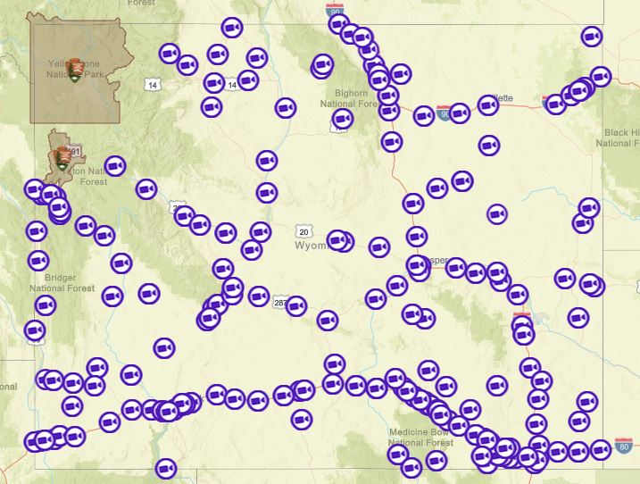
Figure 1 Webcam locations in Wyoming Road Network (Source: wyoroad.info)
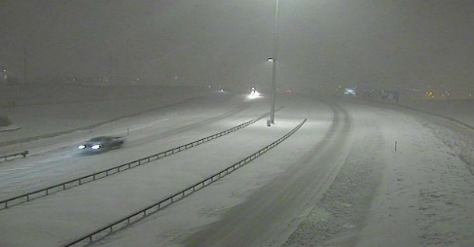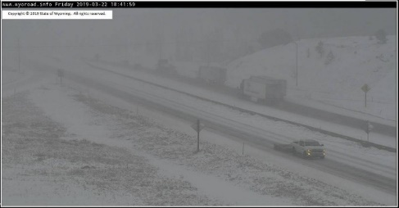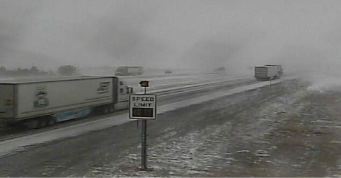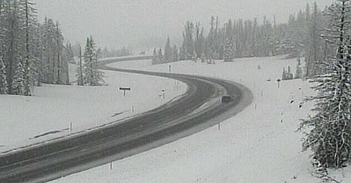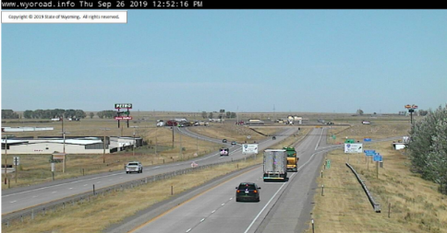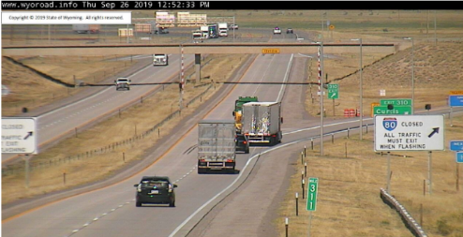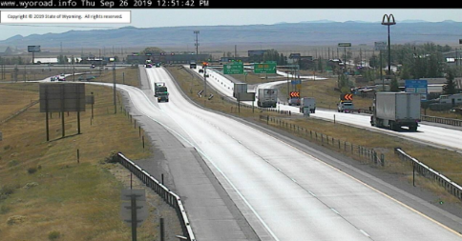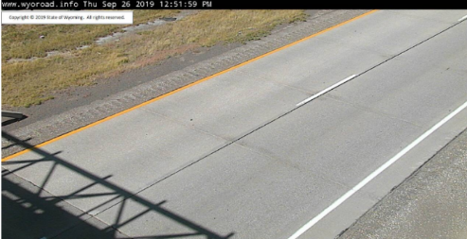
- Clear Weather (EB, WB, and Road Surface Images collected from WYDOT webcams)
- Adverse Weather (EB, WB, and Road Surface Images collected from WYDOT webcams)
Figure 2 Sample Images in Adverse and Clear Weather Collected from Webcams in Wyoming (Source: wyoroad.info)
Nevertheless, there are a couple of limitations with existing webcam and in-vehicle video cameras for real-time weather detection. One of the major limitations is the amount of data collected and the manual resources needed to reduce and process the images collected. In addition, under extreme adverse weather conditions, particularly, when snowstorm or blizzard events occur, the low visibility might impede webcams recognizing road surface level weather. Although in-vehicle cameras can well address this issue, regular vehicles might have to cancel their trips under such weather events, which makes using a regular vehicle for weather data collection not always applicable. As mentioned by the WYDOT snowplow priority plan, the WYDOT snowplow crews will provide service on interstates, high volume highways, principal arterial and urban routes up to 24 hours a day with a goal of maintaining clear roadways for driving safely at reasonable speeds (10) . In current practice, reporting of real-time road surface winter weather information is mostly based on snowplow drivers. In Wyoming, the WYDOT defined 8 and 9 codes (code #1 to code #7) to represent various road surface weather conditions. Snowplow truck drivers will manually select a code to describe the prevailing surface weather condition of a road segment based on his/her experience, and report the code to WYDOT Traffic Management Center (TMC). However, due to variation of how various weather conditions might be perceived by individual drivers, there might be inconsistencies between reported road weather conditions to TMC. In addition, existing weather codes cannot differentiate the intensity of adverse weather conditions, indicating that the code reported to TMC might not accurately capture the actual adverse weather condition.
The rapid evolution of Information Technologies (IT) presents opportunities of using Machine Vision and Artificial Intelligence to provide image-based automatic detection and analysis of real-time road weather conditions. Machine Vision is an integration of a series of technologies, software and hardware products; it is the science of getting computers to automatically detect patterns in data, and then use the uncovered patterns to predict future data, or to perform other kinds of decision making under uncertainty. The overall Machine Vision process includes planning the details of the requirements and project, and then creating a solution. During run-time, the process starts with imaging, followed by automated analysis of the image and extraction of the required information. Given the advantages of Machine Vision technology, such as real-time processing of road surface level weather conditions, accuracy of weather detection, cost-effectiveness, etc., it has been extensively used in various fields of engineering for image classification, pattern recognition, and text categorization (15).
With consideration of the limitations of the existing WYDOT weather detection systems, and in view of the opportunity of the emerging automatic video-image processing technologies, this research aims at developing an affordable weather detection system, which will use video images collected primarily by the WYDOT roadside fixed webcams and secondarily by examining the feasibility of extending the algorithms to snow plows trajectory-level cameras. It is worth mentioning that WYDOT operates and maintains many roadside webcams. It is not feasible for WYDOT TMC operators to review and process them timely. The weather information will be processed based on Machine Vision techniques. Eventually, the product of this research will assist WYDOT staff with providing road users with accurate and reliable road surface weather condition, which will result in safer travel decisions and more conservative driving behaviors to mitigate the negative impacts of adverse weather on traffic safety.

Research Objectives
The main research objectives of this study are to: 1) improve safety associated with adverse weather conditions in Wyoming, 2) develop a weather detection system using AI, 3) facilitate maintenance operations, and 4) enhance Traveler Information System.

Research Methods
The objectives of this study will be achieved by performing the following overarching tasks; a) automate the data collection of images from WYDOT roadway webcams, b) annotate weather conditions, c) develop, train, and test AI algorithms to automatically detect weather and surface conditions, d) provide recommendations to WYDOT on integrating the system within their road weather impact and traveler information systems. Detailed tasks are provided in the research methods. The PI has a vast experience with developing machine learning techniques applied to transportation problems including weather detection (16-22).

Expected Outcomes
In Wyoming, harsh weather conditions such as snow, low visibility due to thick fog, icy road surface, blowing snow and blizzards have resulted in remarkable crashes on the state’s highways. The fatality rates are typically higher than the national average, particularly truck-related crashes. Although the negative impact of adverse weather on roadway safety could be reduced by providing drivers with real-time traveler information messages via Intelligent Transportation Systems and other safety countermeasures (such as Advanced Traveler Information Systems, Wyoming 511, Dynamic Massage Signs, and Variable Speed Limits), these systems require accurate real-time road weather information. Nevertheless, existing weather detection systems in Wyoming is mostly based on roadside weather stations, which do not necessarily represent real-time road weather conditions at the surface level.
Although WYDOT operates and maintains a significant number of webcams installed throughout the state and recently implemented an innovative road condition monitoring system using tablets mounted in snow plows and maintenance vehicles, these systems have several limitations. Reviewing and processing images form webcams require significant personnel resources. The monitoring system installed in snow plows and maintenance vehicles require drivers to report weather conditions manually by tapping 9 codes on the tablet touchscreen while driving. The system is using Automatic Vehicle Location (AVL) to link the specific weather code to the actual milepost. Both techniques may result in inaccuracy of reported weather conditions because of the variation of perception of technicians and drivers due to the subjectivity in reporting the different conditions. More importantly, the snow plow manual tracking system may pose some risks to drivers, especially; with their very challenging driving environment during adverse weather conditions. In addition, manual identification of weather by the drivers of the maintenance vehicles and processing this information by the WYDOT TMC personnel to link it to the corresponding road networks are often subjected to human errors and require lots of processing time. On the contrary, the proposed study will automatically collect and extract images from fixed webcams, and will detect real-time weather conditions by using machine learning techniques as well as will linking/ integrating the weather conditions to the corresponding road networks automatically without any human involvement. Therefore, the proposed study will provide more accurate and consistent weather information in real-time that can be made readily available to be used by road users and other transportation practitioners.
The proposed study will help in facilitating and improving maintenance operations and enhance the safety and convenience of highway travel. This will be achieved by addressing the limitations discussed above by developing an automatic weather detection system based on image processing of video recording collected by webcams already installed on numerous locations in the state of Wyoming road network. One of the major benefits of the proposed study is that it will not require any additional camera installations and hence could be an affordable source of collecting accurate weather information in real-time. Furthermore, the weather detection system will be able to provide weather conditions throughout the year, including winter and summer, since it will consider seven levels of weather conditions: clear, light rain, heavy rain, light snow, heavy snow, light fog, and thick fog. It is worth noting that fog, rain, and snow do not usually occur at the same time of the year in the state of Wyoming. Therefore, separate detection models will be developed for winter and summer to eliminate any possible reduction in detection accuracy.
The system will utilize still images collected from IP cameras already installed on highways in Wyoming. An image-based weather detection system using global features combined with machine vision approaches has the ability of overcoming the inconsistency problem. Moreover, a well-trained machine learning model is accurate and cost-effective in determining real-time weather conditions. The automated weather detection system proposed in this research will not require a lot of technical support, and only needs existing video cameras.
The WYDOT Travel Information Service has considered detecting real-time weather conditions and providing drivers with appropriate warnings as the principle task for safe driving under winter weather conditions in Wyoming. In this regard, this study will be crucial for WYDOT to develop more effective traffic management strategies. In addition, the research results will benefit both the scientific community and authorities responsible for traffic safety and decision-making, and will be a key to ensure the least adverse effects of severe weather events on the safety of road users.
The methodology provided in this proposal could be extended to develop other potential future applications to aid in traffic count, vehicle classification, maintenance operations, identification and archiving of work zones, pedestrians, and unexpected incidents, including crashes and road closures. It is worth noting that the implementation costs of a roadside camera unit is relatively low compared to weather stations and traffic count sensors including inductive loop detector (36). Therefore, the proposed study has the potential to become an excellent source for not only real-time weather and surface conditions detection, but also traffic volume and classifications on a single hardware platform without including an array of expensive sensors.

Relevance to Strategic Goals
This project fits under the local and rural roadways safety area. The proposed project and its expected outcomes will help in better situational awareness, traveler information systems as well as improving traffic safety related to winter conditions. The outcomes will aid in selecting the most cost-effective strategies to reduce crashes and/ or their severities.

Educational Benefits
Students will be involved in various tasks including; conducting review of literature, data collection from the WYDOT CCTV webcams, data cleansing and annotation, defining Artificial Intelligence and Machine Learning techniques, participating in documenting the results and writing and presenting scientific journal papers.

Technology Transfer
The research results will be disseminated through technical paper publications and presentations in academic venues and press releases using media outlets. The technology transfer activities in this project will benefit both the scientific community and authorities responsible for decision-making and road weather maintenance.

Work Plan
Eleven tasks will be conducted over two-year performance period to fulfill the main objectives of this study. The study will employ Wyoming Webcam data to detect various weather conditions. Based on the automatic weather detection algorithm developed in the primary phase, a secondary phase will be proposed focusing on in-vehicle camera data collected by WYDOT snowplow crew to identify more detailed snow weather events. Tasks for Phase I are summarized as follows:
Task 1: Review of literature and practice related to Computer Vision (NTP – Month 6 – Extended throughout the project period)
Conduct a comprehensive literature review of the state-of-the-practice of weather detection and warning systems, and the state-of-the-art of image-based weather detection methodologies.
Task 2: Data Acquisition and Processing for the WYDOT Road Webcams (Month 3 – Month 12)
Collect video recordings under various weather conditions from the webcams installed in the Wyoming road networks, extract images from the videos at 10 frames per minute sampling rate.
Task 3: Data Preparation and Annotation (Month 6 – Month 15)
Annotate image dataset describing the classification of weather conditions: clear, light rain, heavy rain, light snow, heavy snow, light fog, and thick fog, and divide the original image dataset to training and validations datasets.
Task 4: Machine Learning Development (Month 12 – Month 16)
Develop automatic real-time weather detection algorithms using various Machine Vision technologies and Artificial Intelligence algorithms.
Task 5: Weather and Surface Detection (Month 13 – Month 20)
Train the developed weather detection algorithms using the processed video image datasets, and applying the trained algorithms to detect different weather events.

Task 6: Machine Learning Techniques Testing and Validation (Month 15 – Month 22)
Compare the automatically detected weather events with the manually classified ones to validate the accuracy of each algorithm.
Task 7: Develop Weather Detection System (Month 18 – Month 22)
Develop a system capable of providing time-lapse from a series of image files, develop an index of weather deterioration/improvement, and provide WYDOT a practice-ready automatic weather detection system and a user manual.
Task 8: Final report (Month 22 – Month 24)
The research team will summarize the study in a formal final report. Technical reports and memos will be developed throughout the study. The final report will compile all developed documents including the review of literature and practice, methodologies to assess the accuracy and effectiveness of the developed AI-based weather detection algorithms.

Project Cost
Total Project Costs: $ 162,315
MPC Funds Requested: $ 45,934
Matching Funds: $ 116,381
Source of Matching Funds: Wyoming Department of Transportation

References
1. FHWA. How Do Weather Events Impact Roads? - FHWA Road Weather Management. https://ops.fhwa.dot.gov/weather/q1_roadimpact.htm. Accessed Sep. 20, 2019.
2. Perry, A. H., and L. Symons. Highway Meteorology. Taylor & Francis Books, Inc, 2003.
3. Andrey, J., B. Mills, M. Leahy, and J. Suggett. Weather as a Chronic Hazard for Road Transportation in Canadian Cities. 2003, pp. 319–343.
4. Ahmed, M., H. Huang, M. Abdel-Aty, and B. Guevara. Exploring a Bayesian Hierarchical Approach for Developing Safety Performance Functions for a Mountainous Freeway. Accident Analysis & Prevention, Vol. 43, No. 4, 2011, pp. 1581–1589. https://doi.org/10.1016/J.AAP.2011.03.021.
5. Harry Brown. The 20 Largest Traffic Accidents in Recent US History. https://www.harrybrownlaw.com/blog/20-largest-traffic-accidents-in-united-states. Accessed Mar. 28, 2018.
6. Moore, R. L., and L. Cooper. Fog and Road Traffic. Crowthorne, 1972.
7. Codling, P. J. Thick Fog and Its Effect on Traffic Flow and Accident. Transport and Road Research Laboratory, TRRL Report LR 397, 1971.
8. Brodsky, H., and A. S. Hakkert. Risk of Road Accident in Rainy Weather. Accident Analysis and Prevention, Vol. 20, No. 3, 1988, pp. 161–176.
9. Andreescu, M. P., and D. B. Frost. Weather and Traffic Accidents in Montreal, Canada. Climate Research, Vol. 9, No. 3, 1998, pp. 225–230.
10. WYDOT. Wyoming Report on Traffic Crashes – 2018. Highway Safety Program, Wyoming Department of Transportation, Cheyenne, WY, 2019.
11. Promothes Saha, Mohamed M. Ahmed, and Rhonda Kae Young. Safety Effectiveness of Variable Speed Limit System in Adverse Weather Conditions on Challenging Roadway Geometry. Transportation Research Record: Journal of the Transportation Research Board, No. 2521, 2015, pp. 45–53. https://doi.org/10.3141/2521-05.
12. Sui, Y., and R. Young. Impact of Dynamic Message Signs on Speeds Observed on a Rural Interstate. Journal of Transportation Engineering, Vol. 140, No. 6, 2014.
13. WYDOT. Snowplow Priority Plan. Wyoming Department of Transportation, Cheyenne, WY, 2019.
14. U.S. Department of Transportation. RITA | ITS | Costs: Road Weather Information System (RWIS) Environmental Sensor Station (ESS).
15. Wiley, V., and T. Lucas. Computer Vision and Image Processing: A Paper Review. International Journal of Artificial Intelligence Research, Vol. 2, No. 1, 2018, p. 22. https://doi.org/10.29099/ijair.v2i1.42.
16. Khan, M. N., and M. Ahmed. Snow Detection Using In-Vehicle Video Camera with Texture-Based Image Features Utilizing K-Nearest Neighbor, Support Vector Machine, and Random Forest. Transportation Research Record: Journal of the Transportation Research Board, Vol. In Press, 2019. https://doi.org/10.1177/0361198119842105.
17. Abdel-Aty, M., A. Oloufa, H. Hassan, M. Ahmed, C. Siddiqui, and R. Morrow. Portable Visibility Warning System for The. Proceedings of 17th ITS World Congress, 2010, pp. 1–12.
18. Ghasemzadeh, A., B. E. Hammit, M. M. Ahmed, and H. Eldeeb. Unlocking New Potentials of SHRP2 Naturalistic Driving Study Data: Complementary Methodologies to Supplement Real-Time Weather Conditions and Effective Frameworks for Data Reduction and Preparation. Safety Science, Vol. In Press, 2019. https://doi.org/10.1016/j.ssci.2019.01.006.
19. Ahmed, M. M., A. Ghasemzadeh, B. Hammit, M. N. Khan, A. Das, E. Ali, R. K. Young, and H. Eldeeb. Driver Performance and Behavior in Adverse Weather Conditions: An Investigation Using the SHRP2 Naturalistic Driving Study Data-Phase 2. Final Report WY-18/05F, 2018.
20. Elhashemi, A., M. N. Khan, and Mohamed Ahmed. Detecting Realtime Snowy Weather on Freeways Based on Machine Vision and Vehicle Kinamatics: A Non-Parametric Data Fusion Technique. Proceedings of the 99th Transportation Research Board Annual Meeting, 2019.
21. Khan, M. N., M. Ahmed, Trajectory-level Fog Detection Based on In-vehicle Video Camera with TensorFlow Deep Learning Utilizing SHRP2 Naturalistic Driving Data, Journal of Accident Analysis and Prevention, Volume 142, 105521, 2020. https://doi.org/10.1016/j.aap.2020.105521
22. Khan, M. N., M. Ahmed, Fog Detection based on Images with Neural Network using TensorFlow Utilizing the SHRP2 Naturalistic Driving Study Data. Proceedings of the Transportation Research Board 99th Annual Meeting, 2020.

