MPC-647

March 26, 2021

# Project Title

A Systems-level Analysis of Left-turning Vehicle-Pedestrian Crashes

# University

University of Colorado Denver

# Principal Investigators

Wesley Marshall, PhD, PE

Professor

Department of Civil Engineering  
University of Colorado Denver

Phone: (303) 315-7568  
Email: wesley.marshall@ucdenver.edu

ORCID: 0000-0002-3106-7342

Bruce Janson, PhD

Professor

Department of Civil Engineering  
University of Colorado Denver

Phone: (303) 315-7569  
Email: bruce.janson@ucdenver.edu

ORCID: 0000-0003-2901-8506

# Research Needs

More than 6,500 pedestrians died on U.S. roads last year (NHTSA 2020). This represents nearly 17% of all U.S. road fatalities, despite walking comprising less than 3% of commuting mode share. What is more worrisome than stats suggesting an overrepresentation of such crashes is that pedestrians had the right of way in far too many of these crashes. In San Francisco, for instance, one-third of pedestrian fatalities took place in a crosswalk when the pedestrian should have been yielded the right of way (Elinson 2013).

One such vehicle-pedestrian crash type occurs at signalized intersections with permissive phasing, where pedestrians have a walk signal when drivers are trying to turn into that adjacent crosswalk. A typical left-turning driver scans the adjacent crosswalk, looks for a gap in the oncoming traffic, and then makes their turn. Yet, high workloads during left-turns – especially with respect to looking for a gap in the oncoming traffic on busy or multilane roads – often leads to drivers skipping some tasks and proceeding improperly (Richard, Campbell et al. 2006). In fact, between 4 and 7% of drivers fail to ever fixate on the pedestrian in the conflicting crosswalk (Marnell, Tuss et al. 2013). The backpressure of waiting vehicles also trying to make the left turn can exacerbate this issue. For a driver turning left, the unfortunate reality is that the pedestrian is not the primary concern; they are the peripheral one and less concerning than the oncoming traffic (Lord, Smiley et al. 1998). Even from the pedestrian’s perspective, our signage rarely differentiates between a fully protected, all-pedestrian phase and one that coincides with turning cars.

In terms of left-turning intersection crashes more generally, they represent the third most frequent, only trailing rear-end and right-angle crashes (Chen, Chen et al. 2015). They are the “critical pre-crash event” in more than 22% of intersection crashes with only 1.2% being attributed to right turns (Choi 2010). More than 53% of crossing-path crashes include left-turning vehicles, as compared to less than 6% for right turns (Najm, Smith et al. 2001). Other than head-on collisions, they also tend to be much more severe than other crash types (Wang and Abdel-Aty 2008). In point of fact, UPS delivery trucks purposely minimize left-turn as much as possible on arterials in an effort to improve both safety as well as efficiency (McFarland 2014). They estimate that more than 90% of UPS truck turning movements are right-hand turns.

Left-turning crashes are particularly dangerous for pedestrians, as three to four times more pedestrians die from left-turning vehicles than right-turning vehicles (Lord, Smiley et al. 1998, NYCDOT 2016). There are a number of hypothesized reasons for this discrepancy. One problem is that cars turning left tend to go faster than cars turning right due to differences in turning radii (Roudsari, Kaufman et al. 2006). Another known issue is that the A-Pillar of many cars obscures a left-turning driver’s vision of the adjacent crosswalk (Reed 2008), as shown in Figure 1. Headlights – typically designed to shed light to the right of the driver rather than the left, so as not to blind oncoming drivers – exacerbate this issue at night (Arason 2014) and represent an additional safety issue for crossing pedestrians (Stamatiadis, Taylor et al. 1991).

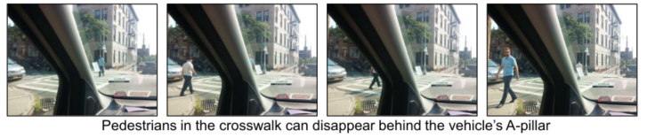

**Figure 1** – Left-Turning Vehicle with Obscured Pedestrian Behind A-Pillar (source: NYC DOT)

Most of the existing research related to this issue focuses on comparing protected-left turn phasing to permissive or permissive-protected phasing (Harkey, Srinivasan et al. 2008). Despite numerous intersection-level studies identifying the safety benefits of protected-left turn phasing, some results remain mixed, differing by time of day or other place-specific factors (Upchurch , Perfater 1983, Cox and Basha 2003, Srinivasan, Lyon et al. 2012, Yi, Chen et al. 2012, Schultz, Dowell et al. 2014, Chen, Chen et al. 2015). Because of these inconsistencies, many engineers remain hesitant to trade-off additional delay for improved safety (Chen, Chen et al. 2015). Thus, approaches vary significantly from municipality to municipality, and protected-left turn phasing tends to be less common than one might assume given the existing research.

Moreover, there are numerous other signal approaches looking to manage this crash type such as exclusive pedestrian phasing, lag left-turn phasing, Barnes Dance phasing, or via the elimination of left turns altogether. There are also alternative intersection designs that would seem to help minimize this crash type such as traffic circles, roundabouts, median U-turn intersections, or diverging diamonds (Rodegerdts, Bansen et al. 2010, Reid, Sutherland et al. 2014). Many of these approaches remain under-researched, with relatively few studies focusing on crash severity (Schultz, Dowell et al. 2014) or specifically on pedestrians, particularly with the shift towards flashing yellow arrow left-turn signals since 2009 when that signal design was adopted by the MUTCD (Bonneson, Geedipally et al. 2012). Moreover, a lot of the existing research is simulation based rather than empirical (Wang and Abdel-Aty 2008, Wang and Abdel-Aty 2008, Marnell, Tuss et al. 2013).

The academic literature also lacks research on the newer approaches to managing this crash type such as leading pedestrian intervals that attempt to minimize pedestrian exposure (Goughnour, Carter et al. 2018) or via designs such as that hardened centerline that looks to slow turning cars and increase visibility of crossing pedestrians for the driver (Hu and Cicchino 2020). Figure 2 depicts a hardened centerline treatment. Thus far, the academic literature has only studied conﬂicts between left-turning vehicles and pedestrians and vehicle speeds at hardened centerline installations (Hu and Cicchino 2020). While the results are promising, there are no studies based upon actual safety outcomes.

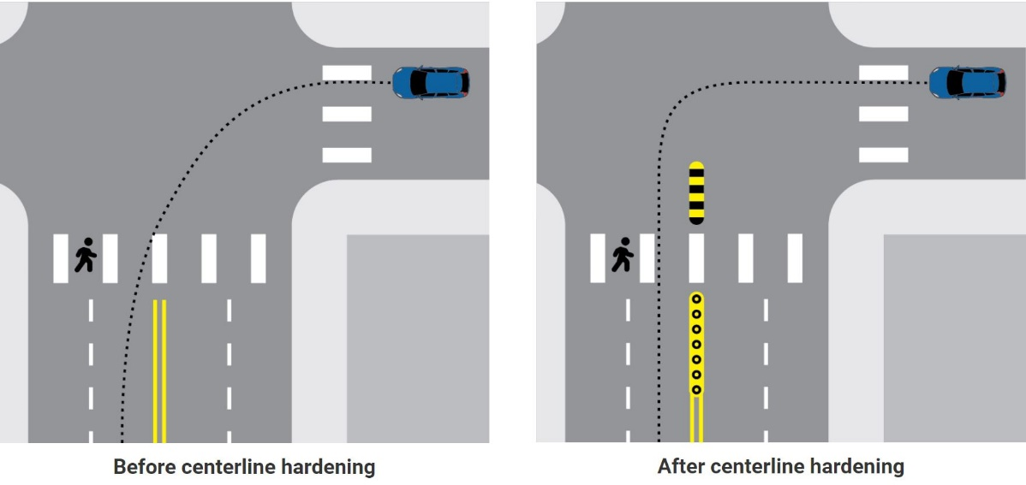

**Figure 2** – Hardened Centerline Design (source: IIHS)

If a left-turning driver does not properly stop or yield to a pedestrian in an adjacent crosswalk, it is easy for traffic engineers to tally such crashes among the more than 90% of fatal crashes that we attribute to human error. Yet, the data suggests that left-turning vehicle-pedestrian crashes are a systematic crash type rather than random (Medina, Shea et al. 2019). Accordingly, what this proposed project seeks is a systems-level understanding of the issue. In other words, instead of another simulation or intersection-level study, we will conduct empirical, macroscopic analysis of eight cities across multiple years. The intent is to: i) determine where this crash type is over- or under-represented while controlling for the level of pedestrian activity; and ii) statistically evaluate what combination of signal, design, and/or policy approaches associates with better or worse safety outcomes while accounting for crash migration.

# Research Objectives

The key steps for this project are the following:

1. Conduct literature review;
2. Collect and geocode crash data;
3. Collect relevant traffic exposure data, traffic signal data, built environment data, and land use data;
4. Statistically investigate the relationship between left-turning vehicle-pedestrian crashes and signal, design, and/or policy approaches;
5. Advance knowledge by carrying out analyses to answer our research questions;
6. Advance policy and practice with respect to building safer cities;
7. Advance education through the training of students; and
8. Build an evidence base by disseminating findings through publications and presentations.

# Research Methods

To achieve the above objectives, we will carry out a road safety study that includes the following: i) data collection and site selection; ii) statistical data analysis; and iii) dissemination.

*Data Collection and Site Selection*

The initial data collection efforts will focus on crash data from the Fatality Analysis Reporting System (FARS). Maintained by the National Highway Traffic Safety Administration, FARS is a national repository of fatal traffic crashes. By first focusing on fatal crashes, we can maintain better consistency in the data, as severity levels often differ from state to state. It also limits the bias caused by the know underreporting of pedestrian crashes, particularly at lower severity levels (Elvik and Mysen 1999). After site selection, we will collect non-fatal crash data for each city separately.

In order to study left-turning vehicle-pedestrian crash types, we also need to know where to focus our attention. Existing crash data suggests this crash type as primarily an urban phenomenon. Across the country, almost 90% of left-turning vehicle-pedestrian crashes take place in urban areas, and few other crash types are so heavily urban (Thomas 2018). The existing research shows that left-turning vehicle-pedestrian crashes tend to occur at signalized intersections (between two-thirds and three-quarters) and that the pedestrian had the right-of-way and was in the crosswalk for between 26% and 57% of incidents (Choi 2010, NYCDOT 2016, Thomas 2018).

It is also not uncommon for municipalities to find that a relatively small percentage of streets is responsible for a relatively high percentage of injuries and fatalities. Denver’s High Injury Network study, for instance, finds that more than 50% of traffic deaths occur on just 5% of the overall street mileage (see Figure 3). These streets tend to be the larger arterials roads, many of which are managed by the state DOTs. Pedestrians are particularly at risk along such roads. Existing research suggests that more than 60% of pedestrian fatalities take place on arterials; moreover, pedestrian-vehicle crashes on arterials roads are more than 60% more likely to result in a fatality than on a non-arterial road (Shankar 2003, Chang 2008).

Accordingly, we will focus our site selection process on urban areas, and more specifically on cities where the appropriate intersection- and street-level data on arterials is obtainable. In our preliminary investigation, we have acquired sufficiently useful data from Denver, CO, Seattle, WA, and Austin, TX. We anticipate studying a minimum of eight major U.S. cities.

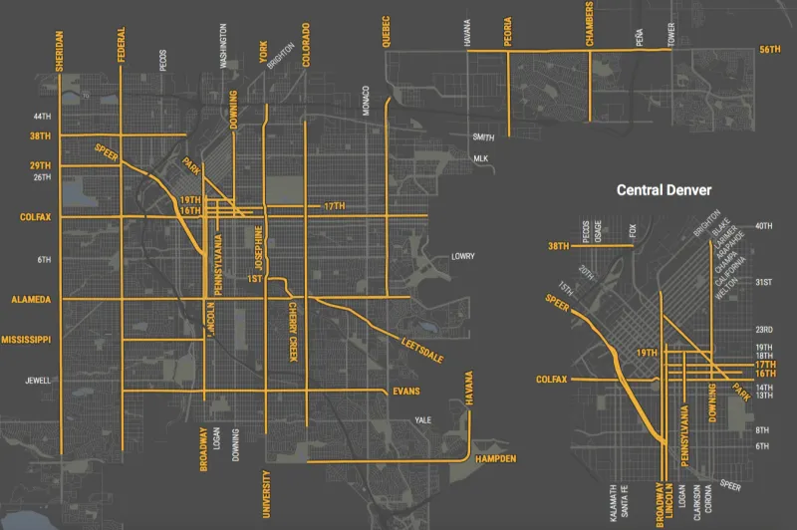

**Figure 3** – Denver’s High Injury Network where Half of All Traffic Deaths Occur on 27 Streets Representing 5% of the City’s Total Street Mileage (source: City and County of Denver)

Beyond the preliminary data collection and site selection efforts, exposure data represents one of the complications with any pedestrian-related safety study. To help resolve this problem, we will rely until in-kind StreetLight data. StreetLight is an on-demand mobility analytics platform that collects third-party cell phone data to facilitate analysis of trips by mode, length, speed, time, vehicle type, time of day, and day of week. We will supplement and verify this big data source with city-level pedestrian and vehicle counts when such data is available.

Much of the remaining data collection efforts focus on built environment data. While one principal source will be publicly available GIS data, we will supplement with historic satellite imagery and Google StreetView data to assess intersection and street design (e.g. number of lanes, one-way vs. two-way, presence of median, presence of crosswalks, signalization, etc.) along the arterial roads of our selected cities.

*Statistical Data Analysis*

Given our research question and that the dependent outcome variable will be crash counts, a conventional linear regression model may not be appropriate for this analysis because of the requirement that the dependent response variable be normally distributed (Long 1997). To resolve this issue, we intend to employ a generalized linear model (GLM) that can account for a non-normal distribution using a link function that relates the linear portion of the model to the mean of the dependent variable. Link functions allow the dependent variable to relate to the explanatory variables in a nonlinear way and can take various forms such as log, logit, inverse, or inverse squared (Long 1997). Given that our data will also likely be overdispersed and not normally distributed, we anticipate that the negative binomial model – with injury crashes and/or fatality counts as the outcome variable – will likely be the appropriate statistical model.

The negative binomial model is a generalized version of the Poisson model that accounts for overdispersion by introducing a random stochastic component to the log-linear Poisson mean function relationship, as follows (Long 1997, Noland and Quddus 2004):



where:

μi = Randomized version of conditional mean of expected crash count of area i

Xi = Independent predictor variables

β = Estimated vector of coefficients representing effects of the covariates

εi = Stochastic component representing random error used to account for overdispersion

The negative binomial probability distribution is determined by (Long 1997):



where:

Г = Gamma distribution function

νi = Gamma distribution parameter that affects the shape of the distribution

yi = Crash count of area i

The variance of the negative binomial distribution is shown by (Long 1997):



If the dispersion parameter, α, begins to approach zero, then a Poisson model would become appropriate. The dispersion parameter relates to the gamma distribution parameter via (Long 1997):

νi = α-1 for α > 0

In terms of statistically modeling crash counts, the negative binomial model has become accepted practice (Zhou, Ivan et al. 2009). Accordingly, we will develop crash models by crash severity type to help shed light on a systems level approach to minimizing left-turning vehicle-pedestrian crashes.

*Dissemination*

We will look to target both academic and practitioner audiences with results of this research. Academic audiences will be reached via conference presentations and peer-reviewed journal papers. Given the universal nature of the subject matter, we also will seek to reach a broader audience via popular press articles.

# Expected Outcomes

With this research, we expect to determine:

1. Who is involved in these crashes in terms of pedestrian, driver, and vehicle type;
2. What are the circumstances of the crash in terms of vehicular and pedestrian movements;
3. When are these crashes happening in terms of seasonality, time of day, and day of week;
4. Where are these crashes happening in terms of street and intersection characteristics as well as in terms of land use; and
5. Why are these crashes happening in terms of safe systems design

The outcomes of this research will assist in the planning and design of streets and intersections, particularly along urban arterials. The subsequent report and presentations will lead to further research on treatment evaluations, and in turn, a treatment toolbox that engineers can use in the planning and design of their urban transportation infrastructure. Such recommendations will advance policy and practice with respect to building a safer transportation system

# Relevance to Strategic Goals

This project primarily links to the FAST Act strategic goals of promoting safety.

# Educational Benefits

This project will be integrated into Dr. Marshall’s Transportation System Safety graduate-level course. These efforts will give students an opportunity to participate in and build up skills with respect to data collection, data analysis, as well as paper writing and presentations. The data will be made available to students for use in term projects, master’s reports, and PhD dissertations.

# Technology Transfer

The goal is to disseminate knowledge and findings through personal correspondence, publications, and conference attendance. We will also be sure to collect and organize our data and results in a non-proprietary format so that other researchers can contribute to the work.

# Work Plan

The proposed effort is scheduled for a one-year timeframe that will begin with a literature review on left-turn vehicle-pedestrian crashes. During this time, we will also be collecting and evaluating crash data and built environment data as well as our StreetLight exposure data. This will be followed by data analysis and the drafting of papers and presentation materials. This work will also be incorporated into lessons for a teaching module within graduate-level Transportation System Safety course.

|  |  |
| --- | --- |
| Task | Timeline |
| Literature review | Months 1 – 2 |
| Data collection and evaluation | Months 2 – 5 |
| Select cities for analysis | Month 3 |
| Analyze data | Months 6 – 9 |
| Incorporate lessons into classes  Draft paper and presentation materials | Months 7 – 10  Months 10 – 12 |

# Project Cost

Total Project Costs: $ 206,346

MPC Funds Requested: $ 103,173

Matching Funds: $ 103,173

Source of Matching Funds: University of Colorado Denver

# References

Arason, N. (2014). No accident : eliminating injury and death on Canadian roads. Waterloo, Ontario, Canada, Wilfrid Laurier University Press.

Bonneson, J. A., S. Geedipally, M. P. Pratt and D. Lord (2012). Safety Prediction Methodology and Analysis Tool for Freeways and Interchanges. Washington, D.C., Transportation Research Board of the National Academies.

Chang, D. (2008). National Pedestrian Crash Report. Springfield, VA, National Center for Statistics and Analysis.

Chen, L., C. Chen and R. Ewing (2015). "Left-turn phase: Permissive, protected, or both? A quasi-experimental design in New York City." Accident Analysis and Prevention 76: 102-109.

Choi, E.-H. (2010). Crash Factors in Intersection-related Crashes: An On-scene Perspective. Washington, D.C., National Highway Traffic Safety Administration.

Cox, P. C. and P. E. Basha (2003). "A study of accidents with lead versus lag left turn phasing." Ite Journal-Institute of Transportation Engineers 73(5): 24-28.

Elinson, Z. (2013). Bay Area drivers who kill pedestrians rarely face punishment, analysis finds, The Center for Investigative Reporting.

Elvik, R. and A. Mysen (1999). "Incomplete Accident Reporting: Meta-analysis of Studies Made in 13 Countries." Transportation Research Record 1665(1): 133-140.

Goughnour, E., D. L. Carter, C. Lyon, B. Persaud, B. Lan, P. Chun, I. Hamilton and K. Signor (2018). Safety Evaluation of Protected Left-Turn Phasing and Leading Pedestrian Intervals on Pedestrian Safety, Federal Highway Administration.

Harkey, D. L., R. Srinivasan, J. Baek, F. M. Council, K. Eccles, N. Lefler, F. Gross, B. Persaud, C. Lyon, E. Hauer and J. A. Bonneson (2008). NCHRP Report 617: Accident Modification Factors for Traffic Engineering and ITS Improvements. Washington, D.C., Transportation Research Board of the National Academies.

Hu, W. and J. B. Cicchino (2020). "The effects of left-turn traffic-calming treatments on conflicts and speeds in Washington, D.C." Journal of Safety Research.

Long, J. S. (1997). Regression Models for Categorical and Limited Dependent Variables. Thousand Oaks, SAGE Publications.

Lord, D., A. Smiley and A. Haroun (1998). Pedestrian accidents with left-turning traffic at signalized intersections: Characteristics, human factors, and unconsidered issues. Transportation Research Board. Washington, D.C.

Marnell, P., H. Tuss, D. Hurwitz, K. Paulsen and C. Monsere (2013). Permissive left-turn behavior at the flashing yellow arrow in the presence of pedestrians. Driving Assessment Conference, Bolton Landing, New York.

McFarland, M. (2014). The case for almost never turning left while driving. The Washington Post. Washington, D.C.

Medina, J. C., M. S. Shea and N. Azra (2019). Safety Effects of Protected and Protected/Permissive Left-Turn Phases. Fargo, ND.

Najm, W., J. D. Smith and D. L. Smith (2001). Analysis of Crossing Path Crashes. Cambridge, MA, Volpe National Transportation Systems Center.

NHTSA (2020). Fatality Analysis Reporting System (FARS) Web-Based Encyclopedia. Washington, D.C., National Highway Traffic Safety Administration.

NYCDOT (2016). Don't Cut Corners: Left-Turn Pedestrian & Bicyclist Crash Study, New York City DOT.

Perfater, M. A. (1983). "Motorists' Reaction to Exclusive-Permissive Left-Turn Signal Phasing." Transportation Research Record 926.

Reed, M. (2008). Intersection kinematics: a pilot study of driver turning behavior with application to pedestrian obscuration by A-pillars. Ann Arbor, Michigan, Transportation Research Institute.

Reid, J., L. Sutherland, B. Ray, A. Daleiden, P. Jenior and J. Knudsen (2014). Median U-turn informational guide. Washington, D.C., Federal Highway Administration.

Richard, C. M., J. L. Campbell and J. L. Brown (2006). Task analysis of intersection driving scenarios: Information processing bottlenecks. McLean, Virginia, Turner-Fairbank Highway Research Center.

Rodegerdts, L., J. Bansen, C. Tiesler, J. Knudsen, E. Myers, M. Johnson, M. Moule, B. Persaud, C. Lyon, S. Hallmark, H. Isebrands, R. B. Crown, B. Guichet and A. O’Brien (2010). Roundabouts: An informational guide. Washington, D.C., Transportation Research Board.

Roudsari, B., R. Kaufman and T. Koepsell (2006). "Turning at intersections and pedestrian injuries." Traffic Injury Prevention 7(3): 283-289.

Schultz, G. G., A. L. Dowell, R. Roundy, M. Saito and C. S. Reese (2014). "Evaluating the Safety Effects of Signal Improvements." Transportation Research Record(2435): 19-26.

Shankar, U. (2003). Pedestrian Roadway Fatalities. Springfield, VA, National Center for Statistics and Analysis.

Srinivasan, R., C. Lyon, B. Persaud, J. Baek, F. Gross, S. Smith and C. Sundstrom (2012). "Crash Modification Factors for Changes to Left-Turn Phasing." Transportation Research Record(2279): 108-117.

Stamatiadis, N., W. C. Taylor and F. X. Mckelvey (1991). "Elderly Drivers and Intersection Accidents." Transportation Quarterly 45(3): 377-390.

Thomas, L. (2018). Webinar: PBIC Crash Types Series Left-Turn Crashes Involving Pedestrians. Chapel Hill, NC, Pedestrian and Bicycle Information Center,.

Upchurch, J. "Comparison of Left-turn Accident Rates for Different Types of Left-turn Phasing." Transportation Research Record 1324(5): 33-40.

Wang, X. S. and M. Abdel-Aty (2008). "Analysis of left-turn crash injury severity by conflicting pattern using partial proportional odds models." Accident Analysis and Prevention 40(5): 1674-1682.

Wang, X. S. and M. Abdel-Aty (2008). "Modeling left-turn crash occurrence at signalized intersections by conflicting patterns." Accident Analysis and Prevention 40(1): 76-88.

Yi, Q., X. Chen, L. Yu, Y. Wang, M. Zhang, P. Yuan and K. R. Persad (2012). Use of Flashing Yellow Operations to Improve Safety at Signals with Protected-Permissive Left Turn Operations. Houston, TX, Texas Southern University.

Zhou, H., J. Ivan and A. Sadek (2009). Safety Effects of Exclusive Left Turn Lanes at Unsignalized Intersections and Driveways. Transportation Research Board 88th Annual Meeting, Washington D.C.