MPC-649

March 26, 2021

Project Title
Assessment of Safe Work Indicators in Transportation Construction Using Personal Monitoring Systems

University
University of Colorado Denver

Principal Investigators
Caroline M. Clevenger
Associate Professor
University of Colorado Denver
Phone: (303) 315-7567
Email: caroline.clevenger@ucdenver.edu
ORCID: 0000-0003-2265-8447
Moatassem Abdallah
Assistant Professor
University of Colorado Denver
Phone: (303) 315-7566
Email: moatassem.abdallah@ucdenver.edu
ORCID: 0000-0002-3077-6518

Research Needs
The construction industry consistently maintains high rates of injuries and fatalities compared to other industries. Working on construction sites involves risk, can be physically demanding, and is significantly impacted by environmental conditions. In addition, stress can be increased by working next to an active roadway. Many construction activities involve heavy lifting, awkward work postures, vibrations, pushing and pulling, and forceful exertions (Hartmann & Fleischer, 2005). Some of these activities can cause immediate injuries, but most of these activities may adversely affect a worker over time. In addition to physical health, physically demanding work can also alter the mental state, which may lead to decreased productivity, poor judgement, inattentiveness, poor work quality, job dissatisfaction, and ultimately more accidents and injuries (Abdelhamid & Everett, 2002). A construction environment is generally more hazardous than most other work environments due to the use of heavy equipment, dangerous tools, and hazardous materials, all of which increase the potential for accidents and injuries (Abudayyeh et al. 2006). Furthermore, construction work is dynamic, temporary, and “ever evolving” (Brunette 2005). Finally, infrastructure work is often conducted along active roadways, where workers may be susceptible to mobile hazards or temperature-related injuries. Of concern, data from Occupational Safety and Health Administration (OSHA) has stated that heat exhaustion contributes to approximately 30 deaths every year in the construction industry and also significantly impacts worker productivity (Williams, 2013). Despite such safety risks and potentially short- as well as long-term negative health impacts, limited research exists focused on improving worker health and safety beyond toolbox talks and hazard preventions.

Research Objectives
The objective of this research is to develop and implement a non-intrusive system for monitoring and providing feedback regarding individual transportation construction workers’ physical health and performance. Our piloted system synchronizes physiological data with video recordings. Specifically, the system links Zephyr Bioharness, an off-the-shelf physiological monitoring (PSM) device (chest strap) to on-site construction video capture (GoPro or security camera system video recordings). Monitored stress indicators include: heart rate, breathing rate, posture, physiological load, and mechanical load.
Data from the proven system provides the opportunity to retrospectively assess the physical impact of construction work on individual construction workers in terms of physical stress and instantaneous and cumulative exertion levels (Clevenger et. al, 2018). This research will focus on the applicability and effectiveness of such a system in a construction environment related to horizontal (infrastructure) construction and, in particular, along active roadways. Future iterations could include automated alarm systems to alert individual workers if their personal stress measures indicate they need to modify or stop their construction activity(ies) for health, safety, or productivity reasons.
Specific research objectives are to test:
- To what extent do PSMs facilitate the collection of data capable of generating observable patterns for individuals performing transportation related construction activities?
- What opportunities exist for linking and synchronizing livestream data of PSM devices with video data of transportation related construction activities?

Research Methods
The PMS device selected for this study is the Zephyr BioHarness, an off-the-shelf product capable of remote physiological monitoring and location tracer without hindering the flexibility and freedom of the individual (Zephyr 2013, 2016).
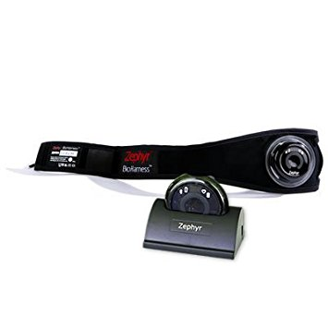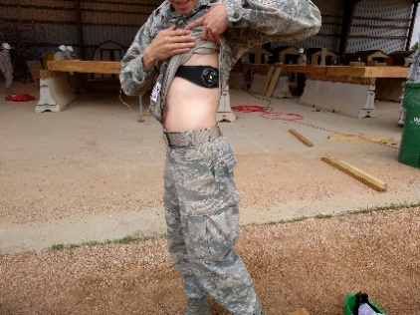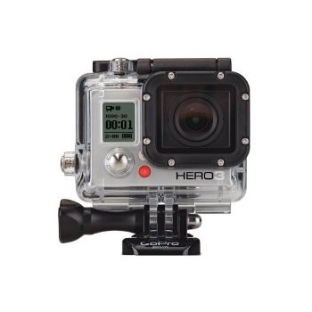
Figure 1: Equipment used to collect and monitor physiological data on-site (L). Volunteer wearing bio-harness while performing construction activities (R).
The following metrics will be analyzed: heart rate, breathing rate, core temperature, mechanical load, physiological load and posture for ten transportation construction workers under various conditions.
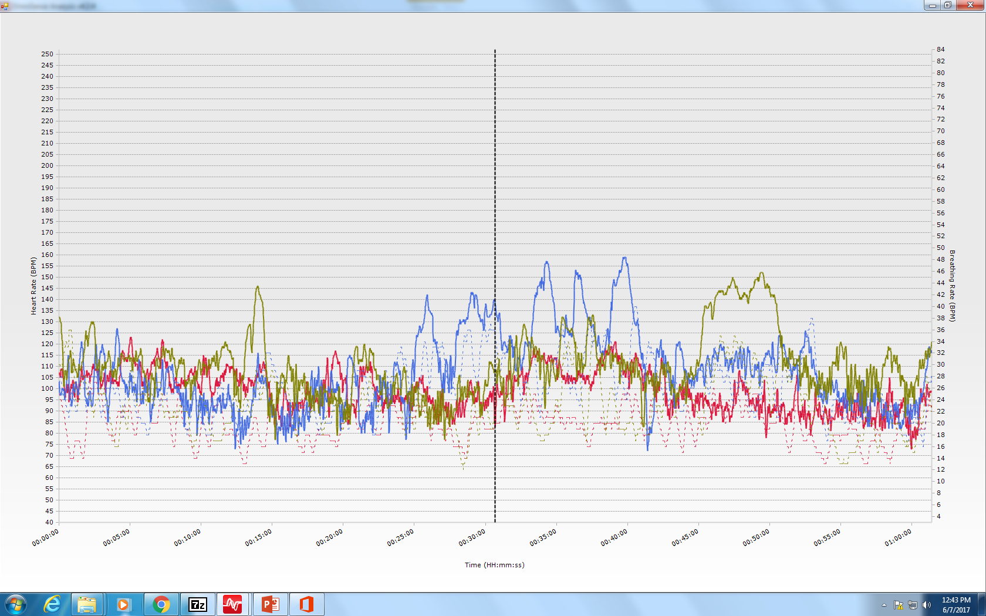
Figure 2: Sample data for three Construction Worker’s heart rate (solid) and breathing rate (dashed) shown one hour when performing wood framing activity.
General research methods for data collection will be to use sensors to instrument individual transportation construction workers while performing daily tasks, and then to perform statistical data analysis and comparison across metrics to generate observable and statically significant trends as relevant to worker health and productivity.
Additional research methods will use DashWare as the pairing software to synchronize and simultaneously display a dashboard of physiological data on a video feed. Researchers will generate storyboards of multiple stress indicators from multiple individuals and link them to activities being performed on the transportation construction site.
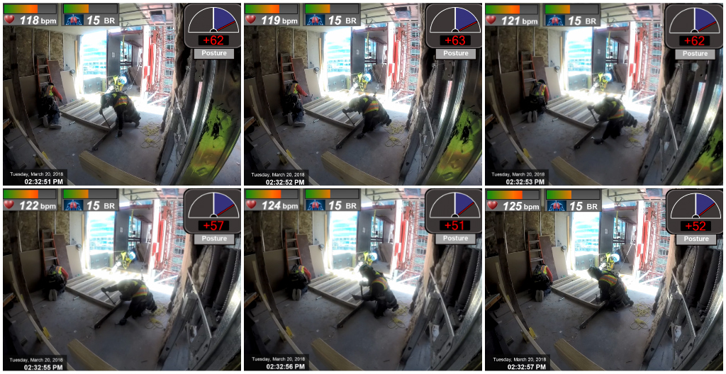
Figure 3: Sample time-stamp series of video feed showing synchronous display of construction worker physiological data and activity.

Expected Outcomes
The expected outcomes of this research beyond an MPC research report include:
- Advances in modeling of psychological stress indicators for transportation construction workers
- Related academic publication(s), such as conference proceeding(s) and/or journal publication
- Workshop or conference presentations summarizing findings and highlighting opportunities
The primary contribution of the research is to apply a piloted method developed by the contributing researchers that facilitates comparison of discrete physiological metrics across individuals performing a range of construction activities. This information will be valuable to managers deciding how to schedule transportation construction workers to maximize both productivity and health, as well as, to establish indicators and real-time warning systems to prevent undue worker physical stress, with a focus on particular activities and extreme weather conditions. Tangible products in addition to MPC reports and academic publications may include established benchmarks for transportation construction worker physiological health and performance as well as written guidelines for “best practices” conducting physical construction activities when constructing physical infrastructure projects.

Relevance to Strategic Goals
As a broader impact, the proposed project relates and supports U.S. Department of Transportation strategic goal of Safety to improve public health and safety by reducing transportation-related fatalities and injuries. Namely, safety will be improved through promotion of construction worker physical health and performance, as well as documentation and eventual reduction in stress and fatigue levels potentially contributing to accidents on-site or long-term physical injuries of workers.

Educational Benefits
Students will be involved in all levels of research from data collection, to analysis to dissemination. To date, two master students have completed related reports which have also led to academic publications. In the future, opportunities exist for both undergraduate and graduate student participation particularly in the data collection (undergraduate) and data analysis (graduate) research phases. Such involvement is particularly valuable because it provides students opportunities to observe and document real-world construction activities as performed by professional construction workers on and around horizontal (transportation) construction projects.
Finally, study of the physiological impacts of construction work on health and performance is a rich, innovative and interdisciplinary field of research with significant potential application to various academic coursework including: Construction Safety, Project Management and Construction Materials and Methods classes.

Technology Transfer
Findings will be disseminated to other researchers through academic publications and documented through the MPC repository and archival journals. Technology transfer will occur mainly through conference presentations and, potentially a workshop. The goal is to use findings to establish benchmarks and develop guidelines for “best practices” to maintain worker health and productivity. Potential exists for commercialization of a product or service that provides an on-site early warning and alarm system built on evidence-based state-of-the-art models capable of analyzing and enhancing worker health, productivity and safety on transportation construction projects.

Work Plan
The following tasks will be completed during the research.
- Identify an industry partner and appropriate infrastructure construction project for data collection.
- Collect and synchronize physiological data using a Zephyr Bioharness system; video data using either GoPro or security video cameras.
- Extract data by sorting parameters and filter as necessary (example eliminate potentially erroneous biometric data associated with a low Heart Rate Confidence (HRC) level).
- Analyze data and identify trends across performance metrics via spreadsheets or a statistical analysis packages.
- Disseminate research findings through research and publication channels.
The primary research focus for this project is to document and analyze the physical impact of construction work on real-world transportation construction workers. Specific industry partner(s) and select construction site/project(s) will be determined subsequent to project award. Past partners in related research have included GE Johnson Construction Company, Saunders Construction and the United States Air Force Academy. The research project has a two year timeline, estimated to proceed according to the following rough schedule. Starting fall, 2019: 3-4 months to identify an industry partner, construction project and on-site research volunteers (note that all necessary human subject protocols will be strictly developed and adhered to). Student researchers will also be identified during this time; 3-4 months to collect on-site psychological and video data from 10-20 professional construction workers; 1-2 month for data treatment (scrub, filter parse etc.); 6 month for statistical data analysis; 6 months for report writing and dissemination.

Project Cost
Total Project Costs: $ 120,000
MPC Funds Requested: $ 60,000
Matching Funds: $ 60,000
Source of Matching Funds: GE Johnson equipment donation, $18,000
ORS Large Grant, $12,000
Faculty Academic Salary, $10,000
University of Colorado Denver, $20,000

References
Abdelhamid, T. S., and Everett, J. G. (2002). Physiological demands during construction work. Journal of Construction Engineering and Management, 128(5), 427–437.
Abudayyeh, O., Fredericks, T. K., Butt, S. E., & Shaar, A. (2006). An investigation of management’s commitment to construction safety, International Journal of Project Management 24, 167–174. https://doi.org/10.1016/j.ijproman.2005.07.005
Brunette, M. J. (2005). Development of educational and training materials on safety and health: Targeting Hispanic workers in the construction industry. Family and Community Health, 28(3), 253-266.
Clevenger, C., Pillsbury, W., Abdallah, M., Brothers, H. (2018) Pilot Assessment of Physiological Measures for Construction Workers. Proceedings of the Associated Schools of Construction 54th Annual International Conference April 18-21, 2018, Minneapolis, Minnesota
Hartmann, B., & Fleischer, A. G. (2005). Physical load exposure at construction sites. Scandinavian Journal of Work, Environment & Health, Vol. 31, Supplement 2. Construction Workers and Occupational Health Care (2005), Pp. 88-95.
Williams, M. D. L. (2013). OSHA News Release - Region 4. Retrieved October 15, 2017, from https://www.osha.gov/news/newsreleases/region4/05302013
Zephyr. (2013). “BioHarness BT User Guide.”
Zephyr. (2016). “OmniSense Live Help.” Zephyr Technologies.

