MPC-661

August 24, 2021

Project Title
Environmentally Sustainable Accelerated Partial Bridge Deck Removal Methods

University
Utah State University

Principal Investigators
Andrew Sorensen, Ph.D.
Assistant Professor
Dept. of Civil and Environmental Engineering
Utah State University
Phone: (435) 797-6377
Email: andrew.sorensen@usu.edu
ORCID: 0000-0001-9998-2021

Shuna Ni, Ph.D.
Assistant Professor
Dept. of Civil and Environmental Engineering
Utah State University
Phone: (435) 797-0990
Email: shuna.ni@usu.edu
ORCID: 0000-0002-8795-176X

Research Needs
Recently significant advances have been made in the development of rapid setting cementitious materials for partial depth bridge deck repair. The rapid set times of these materials allow for traffic to be re-opened onto the bridge deck in a number of hours, versus days, once the material has been placed [1]. While this is a substantial improvement in reducing the traffic closure time, a significant amount of time is still spent on the removal of damaged and deteriorated bridge deck patches and in prepping the concrete cutouts for placement of the rapid set material. Partial deck removal is a much more delicate process than full deck or pavement removal as the soundness of the concrete surrounding and below the cut out must be maintained (see Figure 1). As demonstrated in Figure 1, the patch preparation process is extremely labor intensive. With the recent development of autonomous machinery, such as 3-D printers, this labor intensive process may be able to become more efficient. However, prior to developing autonomous machines to prep the patches, foundational research on methods that reduce preparation time and that can be easily automated need to be carried out.
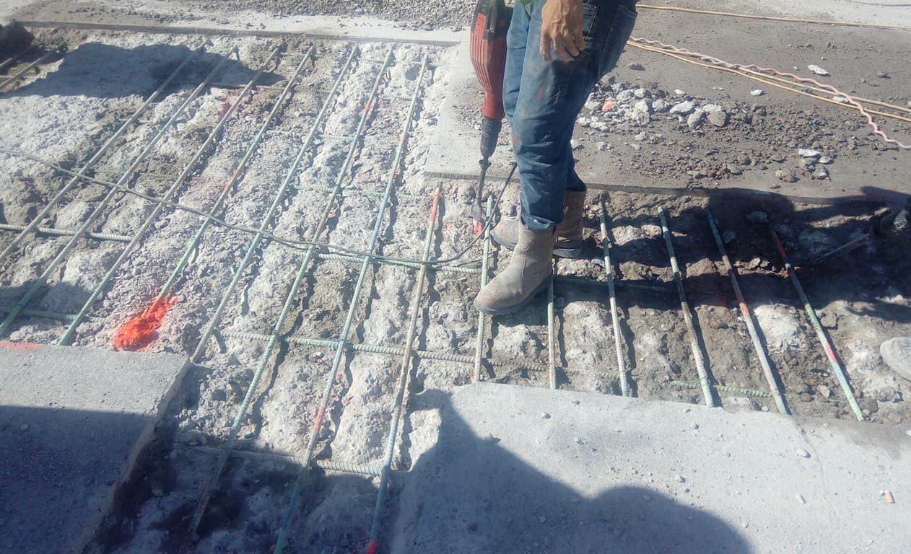  - Remove concrete using jackhammer | - Prepare area using pressure washer
- Place new concrete patch | - Apply curing material
Figure 1: Construction steps of partial-depth repair for concrete bridge deck
In addition to the large amount of time that it takes to prepare the patches, and with the objective of identifying potentially automated methods, it is also noteworthy to acknowledge that some removal and preparation methods have more of an environmental impact than others. Kucukvar and Tatari stated that the construction and maintenance activities of roads, highways, and bridges are major sources of environmental pollutants including air, water, and soil [2]. In general, the transportation sector is the second-largest emissions contributor after the building sector [3]. The U.S Environmental Protection Agency (EPA) reported that the transportation sector accounted accounts for nearly 28% of U.S greenhouse gas (GHG) emissions which means it is the largest contributor to the GHG emissions. During the period from 1990 to 2018, the GHG emissions from the transportation sector increased rapidly when compared to other sectors [4]. Improving sustainability and reducing the pollutants from transportation is featured objective of the Utah Department of Transportation and other state DOT’s.
This project seeks to study different removal methods to decrease traffic closure time due to the preparation process for partial depth replacement as well as evaluate the life cycle sustainability of those techniques. The initial portion of the study will begin by evaluating the current partial deck removal techniques discussed in recent literature, currently used by UDOT, and also from other surrounding state DOT’s. A preliminary review of these sources has identified sawing, jackhammering, drilling, grinding, and waterjet as some commonly utilized methods for concrete removal. Each one of these methods has advantages and disadvantages when it comes to partial deck removal. However, no study could be found that included a combination of methods coupled with their environmental impact. The experimental portion of this study will evaluate different concrete removal techniques based on removal time, life cycle sustainability, and the effect on the concrete surrounding the patch. In addition to single techniques, combinations of different techniques will also be evaluated. For example, rather than just sawing the edges of the patch location, a discretization of the patch (such as shown in the Figure 2 below) could be sawn which in theory will reduce the amount of time a jackhammer is needed to remove the concrete.
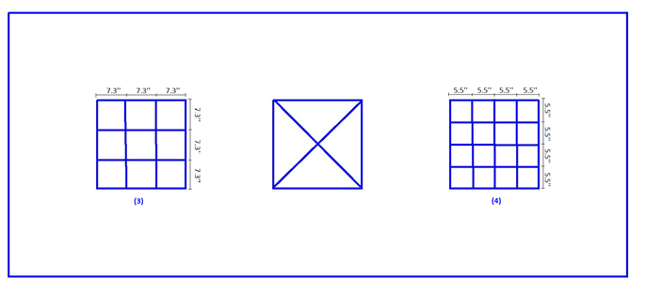
Figure 2: Patch Discretization

Research Objectives
The overall objective of this project seeks to study different removal methods to decrease traffic closure time due to the preparation process for partial depth replacement as well as evaluate the life cycle sustainability of those techniques. To achieve this objective the following specific research objectives are:
- Identify commonly used concrete patch removal methods used in partial depth bridge deck replacement.
- Quantify the removal time for commonly used concrete patch removal methods.
- Identify additional techniques that decrease the removal time of partial deck patches. This objective also includes identifying techniques that may be automated.
- Determine the environmental sustainability of different concrete removal techniques relative to the partial bridge deck removal.

Research Methods
This objectives of this research will be attained by separating the project into discrete tasks as outlined below.
Task 1: Literature review and concrete removal technique identification. Identify concrete removal methods commonly used specific to partial depth bridge deck repair. Additionally, a review of state DoT construction standards for partial depth bridge deck repair will be identified and analyzed. The focus of the literature review will not only be to determine methods of removal but also the equipment utilized as well the removal efficiency.
Task 2: Experimentally determine concrete removal time and efficiency for different removal techniques. Once the commonly utilized removal methods are identified from Task 1, the removal techniques will then be analyzed for the time removal efficiency. Concrete slabs, similar to those shown in Figure 2, will be cast. Three-inch-deep patches will then be removed from the slab using the different removal techniques. The removal time will be measured for each technique to determine their efficiency. These times will also be used in Task 4 for determining the environmental impacts of each removal technique. Additionally, different optimizing techniques will also be evaluated using discretized sawing/cutting, drilling, water-jet, and jackhammering as shown in Figure 2. It is envisioned that these discretized techniques are more viable for automated removal. The removal times and equipment usage times for these experiments will also be timed.
Task 3: Determine the negative effects to the concrete around the concrete patches due to patch removal. In addition to investigating the efficiency of the patch removal techniques, the effect of these removal methods to the surrounding concrete is also of interest. Using the concrete slabs utilized in Task 2, non-destructive testing of the surround concrete will be undertaken to determine any negative effects to the surrounding concrete. For example, preliminary literature review has shown that water-blast demolition leaves the surrounding areas of concrete water saturated and with weaker compressive strengths [5]. Preservation of the soundness of the surrounding concrete is essential to preserving the life cycle capabilities of the bridge deck.
Task 4: Environmental impact evaluation of removal techniques. Using the time of removal data collected from Task 2, as well as any information from existing literature, the environmental impact of each removal technique will be evaluated in terms of pollutant emissions. Emissions are determined using the equipment usage time collected in Task 2 and matching the equipment to equipment in standard sustainability models such as GREET (https://greet.es.anl.gov/) and MOVES (https://www.epa.gov/moves), which provide pollutant emissions in grams per hour of usage. The total pollutants can then be calculated by summing the pollutants from all equipment usage. The different removal techniques can then compared by comparing the pollutant amounts in gram generated per cubic foot of concrete removed.
Task 5: Final Report. A final report will document the results of Tasks 1 through 4 with an emphasis on reporting practical implications to transportation decision makers.

Expected Outcomes
The objective of this research is to improve the partial depth bridge repair method in terms of reduced construction time and improved environmental sustainability. Additionally, this research is seen as a precursor to developing automated methods for accomplishing this task. It is expected that the completion of this research will result in better removal techniques and methods for reduced time in partial depth patch preparation that also protect the surrounding, non-damaged concrete. These results will help bridge maintenance asset managers to select removal techniques that preserve the non-damaged concrete sections and reduce construction emissions. Recommend changes, if warranted, to UDOT construction standards will also be recommended.

Relevance to Strategic Goals
This research aligns with the USDOT’s strategic goal of Environmental Sustainability. This project directly addresses the strategic goal to by preserving and extending the service life of current bridge structures as well as developing sustainable repair practices that limit the emissions resulting from partial depth bridge deck replacement.

Educational Benefits
The majority of the research work on this project will be carried out by a dedicated Ph.D. level graduate student with assistance from other students in the PI’s research group and under the PI’s supervision. Students will gain invaluable experience into carrying out physical experiments on transportation infrastructure. It is anticipated that the students will also present the results of the research at regional and national conferences. The PI also participates in the USU College of Engineering’s annual summer program for high school juniors, Engineering State.

Technology Transfer
The results of this research will be published in peer-reviewed technical publications as well as presented as conferences. Additionally, the findings will be presented to the UDOT Materials and Bridge Divisions for any changes that may need to be made to their current standards and best management practices.

Work Plan
The proposed research will be carried out over a 12 month period with time allotted to each task item identified in the Research Methods section of this proposal as follows:
Task 1: 2 months
Task 2: 6 months
Task 3: 2 months
Task 4: 4 months (carried out parallel to Tasks 2 and 3)
Task 5: 2 months

Project Cost
Total Project Costs: $ 160,000
MPC Funds Requested: $ 80,000
Matching Funds: $ 80,000
Source of Matching Funds: Utah LTAP

References
[1] Thomas, R.J., Maguire, M., Sorensen A.D., & Quezada, I. 2018. “Calcium Sulfoaluminate (CSA) Cement: Benefits and Applications.” Concrete International, Vol. 40(4), pp. 65-69.
[2] Kucukvar, Murat, and Omer Tatari. 2013. “Towards a Triple Bottom-Line Sustainability Assessment of the U.S. Construction Industry.” International Journal of Life Cycle Assessment, Vol. 18(5), pp. 958–972.
[3] Liu, Xiaoyu, Qingbin Cui, and Charles Schwartz. 2014. “Greenhouse Gas Emissions of Alternative Pavement Designs: Framework Development and Illustrative Application.” Journal of Environmental Management, Vol. 132, pp. 313–322.
[4] EPA. 2020. “Carbon Pollution from Transportation | Transportation, Air Pollution, and Climate Change | US EPA.” U.S Environmental Protection Agent (EPA). Retrieved April 1, 2021 (https://www.epa.gov/transportation-air-pollution-and-climate-change/carbon-pollution-transportation).
[5] Frentress, D. P. & Harrington, D. S. 2012. “Guide for Partial-Depth Repair of Concrete Pavements.” Iowa State University Institute for Transportation.

