MPC-670

September 24, 2021

Project Title
Numerical Simulation of Strengthening of Bridge Decks with Partial-Depth Precast Deck Panels

University
University of Utah

Principal Investigators
Chris P. Pantelides, Ph.D., P.E., S.E
Professor
Dept. of Civil and Environmental Engineering
University of Utah
Phone: (801) 585-3991
Email: c.pantelides@utah.edu
ORCID 0000-0003-3309-3488

Research Needs
In several states, bridge deck delamination of reinforced concrete bridge decks built with partial-depth-precast (PDP) concrete panels and cast-in-place decks has been observed. The PDP panels are typically prestressed. Recently, one such failure was observed in the Utah. There is a need to develop strengthening and repair methods to re-laminate the precast concrete panel and cast-in-place (CIP) deck, ensure composite behavior through mechanical connections, or strengthen the panel such that bridge deck delamination does not pose a safety risk. The goal of the study is to develop numerical models to predict the response of structurally delaminated concrete decks and the response of strengthened decks.

Research Objectives
The objectives of this project are:
- Develop numerical finite element model to predict the response of structurally delaminated concrete decks built with PDP and CIP concrete
- Develop numerical finite element models to predict the response of strengthened deck panels with post-installed shear studs or carbon fiber reinforced polymer (CFRP) anchors for delaminated concrete decks built with PDP and CIP concrete
- Compare the results of the numerical finite element models with experiments of full-scale deck panels

Research Methods
The most common problem with the use of partial-depth panel decks is cracking in the cast-in-place concrete portion of the deck at both the transverse joints between panels and at the locations where the panels bear on the girders. This type of cracking has prompted WSDOT to use partial-depth slabs only in dead load positive moment regions of the bridge deck (Hieber et al. 2005).
Localized failures of precast deck panels on major highways in Florida, led to a decision to replace selected bridge decks by full-depth cast-in-place concrete slabs (Sen et al. 2005). The results of the investigation indicated that in all cases the cause was failure of re-repairs. The finite element analyses predicted that long term creep and shrinkage effects could lead to separation of the panel from the CIP slab at the vertical interface which was corroborated in on-site forensic studies. The cause of longitudinal reflective cracking was found to be due to the separation of the prestressed panel from the CIP slab. The role of fiberboard bearings was clearly demonstrated; the fiberboard’s inability to support panels resulted in non-composite action under shear that led to localized punching failures. Simplified code analysis indicated that such failure could occur at loads below design wheel loads.
The New Hampshire Department of Transportation began using partial depth precast deck panel construction with a concrete overpour as a means to speed up bridge deck construction and reconstruction (Whittemore et al. 2006); by the late 1990’s, the use of this technique was becoming frequent and problems with deck cracking were becoming evident. Research investigated whether the bond strength between precast panels and concrete overpour was sufficient to allow the panels and the overpour to act compositely, and also if the concrete overpour adequately transferred traffic loads across the interface between panels without causing reflective cracking. The results showed that the bond between the precast deck panel sections and the concrete overpour was excellent and that the strength of the bond was actually improving over time. Based on these results, standard design practice was modified to include the use of partial depth precast deck panel construction as a “Contractor’s Option” on all single and multi-span bridges regardless of the traffic volume.
In a comprehensive study of precast prestressed concrete (PPC) deck panels in Missouri, it was found that evidence of delamination was found at the interface between the CIP topping and PPC panels, particularly at panel joint locations, despite the roughened surface PPC panel surface (Sneed et al. 2010). It was found that delamination at the interface could affect the composite behavior of the bridge deck system. Accordingly, epoxy-injection was recommended for interface delamination regions.
Numerical models will be used in this research to predict the response of structurally delaminated concrete decks and strengthened decks. This will involve a finite element analysis to capture details of the deck panels and their expected performance; this includes modeling delamination of CIP and partial depth precast deck panels, as well as modeling of strengthened panels with post-installed steel shear studs, and carbon fiber reinforced polymer (CFRP) anchors and CFRP sheets.

Expected Outcomes
The proposal will provide an effective approach for developing high fidelity finite element models which will be able to capture initial delamination; moreover, in the actual samples taken from the 800 South bridge decks it was observed that thinned section of the CIP portion of the deck were present and these will also be modeled. The loading used in the finite element model will simulate the experimental loading of the companion UDOT project to determine at which load the delamination begins. Finally, the finite element model will be used to verify the experimental results of both the as-built and strengthened specimens.

Relevance to Strategic Goals
The column-to-footing joints to be analyzed in this proposal are important for developing bridges using precast columns for high seismic regions. Under current design specifications, bridge collapse under severe earthquakes is prevented but damage is allowed. New ABC techniques are emerging for connecting precast columns to footings or cap beams in high seismic regions. A new concept consisting of recessed mechanical connectors, in this case grouted splice sleeves, will enable the development of precast bridge column-to-footing joints that would perform similar to monolithic cast-in place bridges under strong earthquakes. The numerical models developed will be compared to experimental results.
The numerical models developed will predict the response of structurally delaminated concrete decks and strengthened decks. This will involve a finite element analysis to capture details of the deck panels and their expected performance; this includes modeling of strengthened panels with carbon fiber reinforced polymer (CFRP) anchors and CFRP sheets. The proposed research will promote longevity and cost-effective maintenance of bridges.

Education Benefits
One PhD student and one MSc will be involved in the analytical work. The technology transfer activity will involve high school students through an Annual Exploring Engineering Camp, during which small-scale models will be built to show details of the bridge columns. In addition, small-scale models will be constructed by students during a mini-engineering day. The P.I. will make a presentation at the annual UDOT Engineering Conference and at other national conferences including the Annual AASHTO Subcommittee on Bridges and Structures Meetings and the Annual Transportation Research Board Meeting.

Technology Transfer
The main objective of this research is to create numerical models to predict the response of structurally delaminated concrete decks and strengthened decks. Moreover, the numerical models developed will be compared to experimental results. There is a need for this research to ensure composite behavior of such bridge deck panels through mechanical connections, and for strengthening such panels so that bridge deck delamination does not pose a safety risk.
The work will be presented at conferences such as the Transportation Research Board Meeting and leading journals such as the Journal of Bridge Engineering, ASCE. In addition, a webinar will be arranged through the Mountain Plains Consortium and a presentation will be made at the Utah Department of Transportation Annual Conference. Technology transfer will also be implemented through workshops, web pages, social media, and seminars.

Work Plan
The proposed study will consist of the following tasks:
Task 1. Build numerical finite element model to predict the response of structurally delaminated concrete decks built with PDP and CIP concrete – 3 months
A numerical model for PDP and CIP concrete composite panels will be built to predict the response of the bridge deck panels to vertical loads, as shown in Figure 1. The finite element model will include the effects of initial delamination. The numerical model will be validated with experiments through both displacement and load response comparisons. The experiments will be performed during the companion UDOT project, as shown in Figure 2.
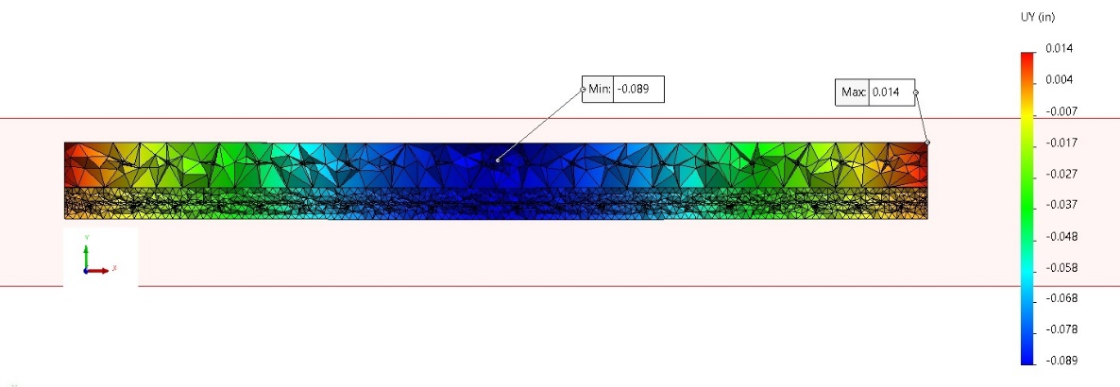
Figure 1. Schematic of numerical finite element model for PCP and CIP bridge deck panels
Figure 2. Schematic of experiments of PCP and CIP bridge deck panels
Task 2. Perform numerical analysis to predict the response of strengthened deck panels with post-installed shear studs or carbon fiber reinforced polymer (CFRP) anchors and sheets – 6 months
The objective of this part of the computational study is to develop a predictive modeling strategy for simulation of the strengthened deck panels. The numerical model for PDP and CIP concrete composite panels will capture the effects of the strengthening method used in the experiments which will include post-installed shear studs, as shown in Figure 3, and carbon fiber reinforced polymer anchors and sheets, as shown in Figure 4. The finite element model will include the effects of initial delamination, and thinned CIP deck cross-section.
Figure 3. Test of bridge deck panels strengthened with post-installed steel shear studs
Figure 4. Test of bridge deck panels strengthened with CFRP short anchors and sheets
Task 3. Comparison of numerical finite element model results with experiments of full-scale deck panels – 3 months
In this task, the numerical model will be used to validate with experiments through both displacement and load response comparisons. The numerical model comparisons will include static pushover analysis, and half-sine wave compression loading to failure, as shown in Figure 5.
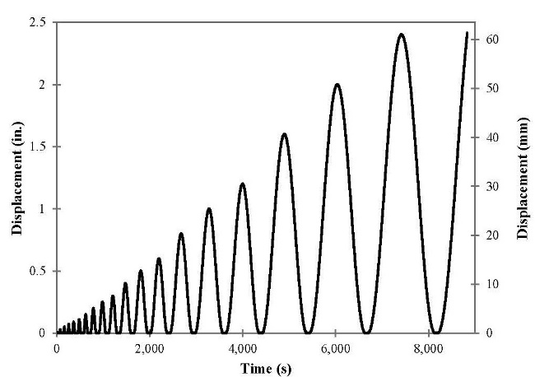
Figure 5. Displacement procedure for bridge deck panel

Project Cost
Total Project Costs: $ 119,541
MPC Funds Requested: $ 50,741
Matching Funds: $ 68,800
Source of Matching Funds: Utah Department of Transportation, financial support

References
Hieber, D.G., Wacker, J.M., Eberhard, M.O., Stanton, J.F. (2005). “State-of-the-Art Report on Precast Concrete Systems for Rapid Construction of Bridges.” Washington State Transportation Center (TRAC), Seattle, WA, 112 pg.
Sen, R., Mullins, G., Ayoub, A., Pai, N. (2005). “Replacement Prioritization of Precast Deck Panel Bridges.” Florida Department of Transportation, Tallahassee, FL, 304 pg.
Whittemore, M.D., Stamnas, P.E., Wellman, R. (2006). “Precast Concrete Deck Panel Performance on Long Span High Traffic Volume Bridges.” New Hampshire Department of Transportation, Concord, NH, 42 pg.
Sneed, L., Belarbi, A., You, Y.M. (2010). “Spalling Solution of Precast-Prestressed Bridge Deck Panels.” Missouri Department of Transportation Research, Development and Technology, Jefferson City, MO, 211 pg.

