MPC-685

February 9, 2022

Project Title
MPC Regional Emergency Evacuation Analysis in Traffic with Connected and Autonomous Vehicles

University
North Dakota State University

Principal Investigators
Pan Lu
Associate Professor
Department of Transportation, Logistics, and Finance
UGPTI, NDSU Dept. 2880, P.O. Box 6050
Fargo, ND 58108-6050
Phone: (701) 212-3795
Email: pan.lu@ndsu.edu
ORCID: 0000-0002-1640-3598
Ying Huang
Associate Professor
Department of Civil, Construction and Environmental Engineering
NDSU Dept. 2470, P.O. Box 6050
Fargo, ND 58108-6050
Phone: (701) 231-7651
Email: ying.huang@ndsu.edu
ORCID: 0000-0003-4119-9522

Research Needs
Caused by the heat from coal seams and the deposits of coal found in the ground in the U.S. western area, historically, wild fire in western U.S. is a famous type of disaster in the nation. In recent years, the situation turned worse. Especially in 2021, the western US was at its driest in 20 years. Such a drought induced numerous wide fires and more are expected in addition to power failures. The Mountain-Plains Consortium (MPC) including North Dakota, South Dakota, Wyoming, Colorado, and Utah, is among the risk area of such wild fires. Figure 1 (a) shows an example of drought monitor of the nation on August 3, 2021. Compared with the drought situation in 2020 and earlier, it can be seen that the MPC region was experiencing exceptional drought in 2021. At the time when this proposal is drafting (October 4, 2021), there are three wild fires ongoing in Wyoming with 15,542 acres of land impacted and one wild fire ongoing in Colorado with 3,792 acres of impacted land. To combat these wild fires, thousands of residents are impacted and billions of dollars are lost.
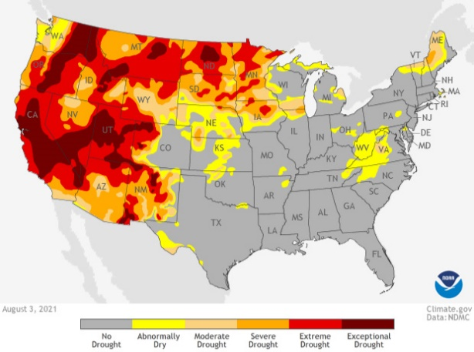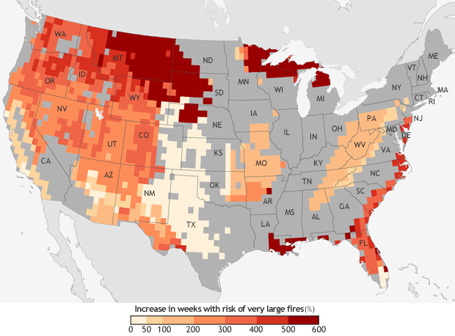
Figure 1 (a) left national drought monitor on August 3, 2021 and (b) right predicted increase in the number of “very large fire" weeks mid-century
Figure 1 (b) shows the predicted increase in the number of “very large fire" weeks, which are the weeks in which conditions are favorable to the occurrence of very large fires by mid-century (2041-2070) compared to the recent past thirty years based on the possible emissions scenario known RCP 8.5, which assumes continued increases in carbon dioxide emissions (Barbera et al, 2015). It can be seen that the MPC region is expected to have even more significant increase in the wild fire risks in the future decades. Additionally, the MPC region is also affected by the tornados. Each year, tornado would induce significant life and property losses in this region.
During natural disasters such as wild fires or tornado, to protect the residents’ life, emergency evacuation sometime cannot be avoided. For instance, in August 2021, at least 6,000 homes in eastern Utah were forced to evacuate because of the fast-moving Parleys Canyon Fire. Traditionally, during wild fire or tornado emergency evacuation event, the residents themselves are responsible to know the community’s emergency response plan, know where to go (the closest and most reachable evacuation shelter if any, or community centers, schools, etc.), when to go (wait for the order or evacuate immediately), and decide the best routes for leaving the current location to the evacuation site. If time allows, emergency evacuation officials will attempt to advise the residents of the safest evacuation routes. Depending on the locations of the resident house and the wild fire spread speed, the safe site to be evacuated may not always be close and easy to reach. In addition, the residents may not always have the knowledge before evacuation for where to go and what is the best route with limited information known. All these may post threats to the evacuators during an evacuation. As the fast development of connected vehicles and autonomous vehicles, real-time data collected from the connected or autonomous vehicles may provide valuable information to assist emergency evacuation during the wide spread of natural disasters such as wild fires. However, at the MPC region, although the needs continue to grow, there is yet any systematical emergency evacuation analysis to support the residents and officials.

Research Objectives
This project is proposed to address the MPC region’s urgent needs for best utilizing the existing infrastructure during emergency evacuation by natural disasters such as wild fires by taking advantages of the fast development in data collection from connected and autonomous vehicles. Such an analysis is expected to provide the emergency evacuation officials and residents suggested action plan based on the simulation predictions of hazard spreading. Specifically, three objectives will be aligned to achieve such an overarching goal:
- Obtaining and transferring the real-time data from the database obtained from connected and autonomous vehicles followed by converting the data into appropriate format for microsimulation software;
- Setting up and validating the microsimulation model for emergency evacuation analysis based on the collected traffic and infrastructure data during previous evacuation experiences. Focus will be given to Wyoming, Colorado, and Utah based on the more frequency of wild fire disasters;
- Predicting and making recommendations for future evacuation needs.

Research Methods
To achieve the above-mentioned objectives, in this research, we will purchase historical vehicle movement data collected from the connected and autonomous vehicles of cities among the MPC region which are significantly impacted by the wild fires. These data can be purchased from companies such as Wejo or StreetLight, which commercialize the data collected from the connected and autonomous vehicles. With the cities selected, the traffic in these cities will be modeled using VISSIM, a microsimulation tool. After the VISSIM model was set up, one recent historical evacuation event in 2020 or 2021 with sufficient information for evacuation areas and time will be used for the calibration of the model. Then another event in 2020 or 2021 in similar but bigger city with less evacuation information will be used as validation. After calibration and validation, the VISSIM model will be used to conduct sensitivities of the evacuation needs in similar cities in the region and provide suggestions and guidance to the residents and officials in the regions with wild fire risk.

Expected Outcomes
Successful development of the proposed emergency evacuation analysis will provide the residents and officials very useful information when an evacuation is a need in the wild fire impacted areas:
- Analyzed traffic patterns during a wild fire evacuation to understand how the residents respond during such an event,
- Calibrated and validated microsimulation models for evacuation planning,
- Understand how real-time infrastructure condition information can improve the evacuation plan,
- Recommendations for more effective evacuation planning in key impacted cities based on the sensitivity study.

Relevance to Strategic Goals
This proposed research will reduce losses during wild fire evacuation with real-time traffic and infrastructure condition information through connected autonomous vehicles, which is directly tied to the strategic goal of the MPC region for better utilizing existing infrastructures and operation information to support sustainable and safe movement of people of the MPC region. It will improve public health and safety by reducing transportation-related fatalities and injuries.

Educational Benefits
This project will include at least five graduate students including three Ph.D. students and two master students. In addition, as the project proceeds, several undergraduate student researchers may also be involved if recruited successfully. Outreach will be also extended to underrepresented K12 students such as Native American students, African American students, etc.

Technology Transfer
To achieve a broader T2 impact, the PIs will include a broad range of partnership activities including internal university collaborations and events engaging state transportation departments, and other stakeholders. The following list of events will be conducted for T2 impact:
- Presenting the findings of the research at transportation workshop, conference, and others
- Organize on-line webinars and workshops to present sensitivity study findings for future evacuation planning
- Social media (Facebook, Twitter, LinkedIn Group, and YouTube recorded presentation and webinars) communication to connect with industries and incubators interested in our focused research and research findings.
- Document and share recommendations for more effective evacuation planning in key impacted cities based on the sensitivity study.

Work Plan
The main tasks are as follows:
TASK 1: Literature Review and Data Collection (Months 1 – 3)
- Conduct literature search to provide an update of the present state-of-the-art
- Select cities of interested (with historical evacuation event in 2020 or 2021 with evacuation data and without evacuation data) and obtain the historical and real-time database from connected and autonomous vehicle
- Transfer the data into an appropriate format to input into VISSIM
TASK 2: Microsimulation analysis (Months 4 – 6)
- Set up and calibrate the microsimulation model in VISSIM
- Validate the simulation model
TASK 3: Sensitivity Study and Planning for Future Evacuation (Months 6 – 9)
- Sensitivity study using the validated VISSIM model for key cities in MPC regions impacted by wild fire disasters
- Provide recommendations for future evacuation planning in these cities

Project Cost
Total Project Costs: $330,254
MPC Funds Requested: $165,127
Matching Funds: $165,127
Source of Matching Funds: North Dakota State University

