MPC-700

October 13, 2022

Project Title
Numerical Analysis of ABC Hybrid Bridge Bents Constructed with Hybrid Reinforcement

University
University of Utah

Principal Investigators
Chris P. Pantelides, Ph.D., P.E., S.E
Professor
Dept. of Civil and Environmental Engineering
University of Utah
Phone: (801) 585-3991
Email: c.pantelides@utah.edu
ORCID: 0000-0003-3309-3488

Research Needs
Accelerated Bridge Construction (ABC) has been implemented in bridge because it has significant advantages for commuters in urban areas. Prefabrication of bridge structural components is a highly effective method and is one of the ABC methods of Prefabricated Bridge Elements and Systems (PBES) proposed by the Federal Highway Administration. Connections between such precast components play an important part in the overall seismic performance of bridges. There is a need to develop analysis models for hybrid bents in bridges located in high-seismic regions. The hybrid bridge bent in this investigation considers the use of buckling restrained braces (BRBs); the columns of the hybrid bridge bent are reinforced with mild steel and glass fiber reinforced polymer (GFRP) bars and GFRP spirals, with or without post-tensioned (PT) high strength steel bars. It is expected that hybrid bridge bents constructed with columns reinforced in this manner will have different levels of self-centering as well as corrosion resistance. Moreover, such hybrid bridge bents are expected to perform very well in high seismic regions.

Research Objectives
The objectives of this project are:
- Develop analytical models to implement the use of alternate designs for columns in hybrid bridge bents in high seismic regions
- Examine the use of alternate designs of columns in hybrid bridge bents with buckling restrained braces (BRBs) in high seismic regions
- Present the results at national conferences and journal publications

Research Methods
The proposed research will evaluate the performance of alternate bridge column-to-footing joints constructed with ABC methods under cyclic loads simulating earthquakes. The research will be performed by comparing the analytical results to experiments of prototype hybrid bridge bents with columns constructed using ABC methods with various details in terms of reinforcement (mild steel, GFRP bars, PT steel bars). Analytical models will be developed for implementing these systems using OpenSees (McKenna et al. 2000). The methods of analysis will include quasi-static cyclic analysis and nonlinear dynamic analysis under scaled earthquakes.

Expected Outcomes
The proposal will provide an effective approach for constructing new hybrid bridges using ABC in high seismic zones. Analytical models will be developed in OpenSees with design recommendations for implementation. One of the expected outcomes of the study is bridge bents with low damage after large earthquake events. A second outcome of the study is to determine the effectiveness of post-tensioning on self-centering of such hybrid bridge bents.

Relevance to Strategic Goals
The hybrid bridge bents to be analyzed in this proposal are important for developing bridges using precast columns for high seismic regions. Under current design specifications, bridge collapse under severe earthquakes is prevented but damage is acceptable. New ABC techniques are emerging for novel hybrid bridge bents in high seismic regions. A new concept consisting of an external dissipater, in this case a BRB, to dissipate hysteretic energy as well as PT steel bars and GFRP bars to improve self-centering in an earthquake will be investigated. The analytical methods developed will be compared to experimental results.

Educational Benefits
One PhD student and one MSc student will be involved in the analytical work. The technology transfer activity will involve high school students through an Annual Exploring Engineering Camp, during which small-scale models will be built to show details of the bridge columns. In addition, small-scale models will be constructed by students during a mini-engineering day. The PI will make a presentation at the annual UDOT Engineering Conference and at other national conferences including the Annual AASHTO Subcommittee on Bridges and Structures Meetings and the Annual Transportation Research Board Meeting.

Technology Transfer
The main objective of this research is to analyze and design an alternate hybrid bridge bent that can dissipate a large amount of hysteretic energy and yet be able to re-center. There is a need for developing such innovative technology and the proposal addresses that need. The resulting technology will create bridges that are seismically resilient which exceed the performance of cast-in-place bridges. The work will be presented at conferences such as the Transportation Research Board Meeting and leading journals such as the Journal of Bridge Engineering, ASCE. In addition, a webinar will be arranged through the Mountain Plains Consortium and a presentation will be made at the Utah Department of Transportation Annual Conference. Technology transfer will also occur through workshops, web pages, social media, and seminars.

Work Plan
The proposed study will build on previous research and it is estimated that it can be completed in one calendar year. The research will consist of the following tasks:
Task 1. Build analytical model – 6 months
The proposed hybrid bridge bent consists of an external dissipater, in this case a BRB, to dissipate hysteretic energy; the columns are reinforced with PT high strength steel bars and GFRP bars to improve self-centering, as well as mild steel bars to improve displacement ductility. The columns of the hybrid bridge bent are identified as four different types, shown in Figure 1. The first two types (Type I and II) are precast columns with bars extended into galvanized steel ducts in the footing; in addition, cast-in-place columns with the same details without the grouted ducts will also be modeled. The next two types (Type III and IV) are precast columns with bars extended into galvanized steel ducts in the footing and in addition they are post-tensioned with high strength steel PT bars. The specific details of the four column types are as follows:
- Type I: Double GFRP spirals with longitudinal mild steel and GFRP bars
- Type II: Double GFRP spirals with longitudinal steel bars
- Type III: Double GFRP spirals with longitudinal mild steel and GFRP bars and PT bars
- Type IV: Double GFRP spirals with longitudinal steel bars and PT bars

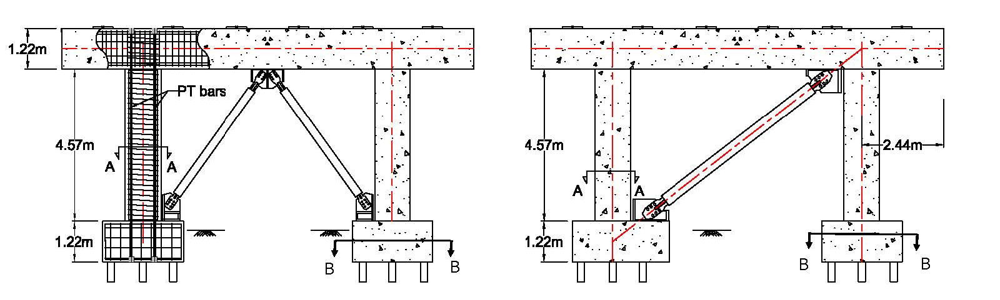
Section A-A |  | Section B-B | Section A-A | Section B-B
TYPE I |  |  | TYPE II
Section A-A | Section B-B |  | Section A-A |  | Section B-B
TYPE III |  |  | TYPE IV
Figure 1: Hybrid bridge bent with hybrid reinforcement and buckling restrained braces.

The double GFRP spiral has several benefits including high tensile strength and superior corrosion resistance (Pantelides et al. 2013; Wright and Pantelides 2021). The longitudinal GFRP bars inherently provide self-centering under seismic loads because of the linear elastic stress-strain performance of the material (Hales et al. 2016).
An analytical model for a cast-in-place and a precast bridge bent will be built using OpenSees. Force-based beam-column elements with fiber sections will be used to construct the computational model based on plastic hinge weighted integration, for the hybrid columns shown in Figure 1. The model will include the effects of low-cycle fatigue and bond-slip (Ameli and Pantelides 2017). The BRB will be modeled utilizing the Giuﬀré-Menegotto-Pinto (Steel02) material model in OpenSees which includes isotropic and kinematic hardening (Upadhyay et al. 2019). The BRB hysteretic response is a combination of kinematic and isotropic hardening behavior. The proposed model, shown in Figure 2, will be validated with experiments through both local and global response comparisons from previous work (Ameli et al. 2015, 2016; Dangol and Pantelides 2022; Dangol et al. 2022).
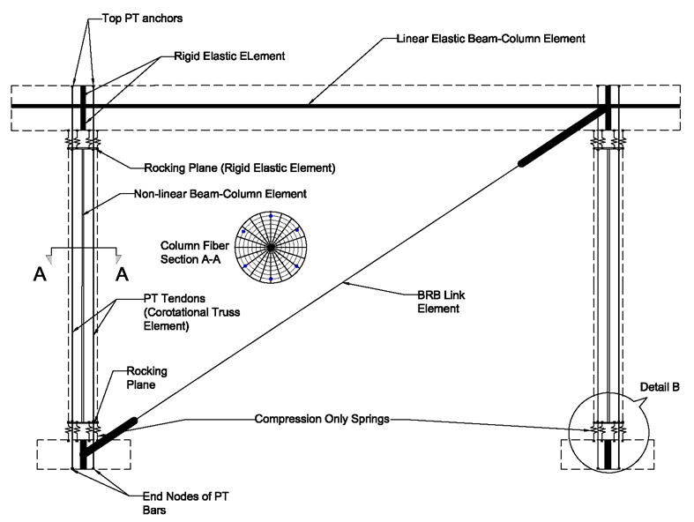
Figure 2: Schematic of numerical model using fiber elements for hybrid bridge bent with mild steel bars, GFRP bars, PT bars and BRB.
Task 2. Analysis and seismic design of bridge bent – 6 months
In this task, a numerical model will be created to assist in the development of a design method for implementing the proposed hybrid bridge bents. The model will be calibrated with the results of Task 1. Two types of analysis will be performed: (1) cyclic analysis to find the capacity of the hybrid bridge bents, and (2) nonlinear time-history dynamic analysis to find the level of demand on the bridge bent. This will provide information on capacity-demand relationships and reveal more insight into the overall behavior of the bridge under various input ground motions. Four parameters will be used to determine their influence on the design and seismic response of the prototype bridge bent, which are: design displacement ductility, column axial load, column height, and number of column longitudinal bars. The results will examine both overall seismic performance as well as self-centering efficiency.

Project Cost
Total Project Costs: $ 119,513
MPC Funds Requested: $ 59,513
Matching Funds: $ 60,000
Source of Matching Funds: Corebrace, LLC

References
Ameli, M.J., Parks, J.E., Brown, D.N., and Pantelides, C.P. (2015). “Seismic evaluation of grouted splice sleeve connections for reinforced precast concrete column-to-cap beam joints in accelerated bridge construction.” PCI Journal, 60(2), 80-103. DOI: 10.15554/pcij.03012015.80.103.
Ameli, M.J., Brown, D.N., Parks, J.E., and Pantelides, C.P. (2016). “Seismic column-to-footing connections using grouted splice sleeves.” ACI Structural J., 113(5), 1021-1030. DOI: 10.14359/51688755.
Ameli, M.J., and Pantelides, C.P. (2016). “Seismic analysis of precast concrete bridge columns connected with grouted splice sleeve connectors.” J. Structural Engineering, 143(2). DOI: 10.1061/(ASCE)ST.1943-541X.0001678.
Dangol, I., and Pantelides, C.P. (2022). “Resilient posttensioned bridge bent with buckling restrained brace.” J. Bridge Engineering, 27(2). DOI: 10.1061/(ASCE)BE.1943-5592.0001823.
Dangol, I., Thapa, D., and Pantelides, C.P. (2022). “Experimental evaluation of post-tensioned bridge bent under cyclic loads and comparison to hybrid bridge bents.” Engineering Structures, 256, 113962. DOI: 10.1016/j.engstruct.2022.113962.
Hales, T.A., Pantelides, C.P., and Reaveley, L.D. (2016). “Experimental evaluation of slender high-strength concrete columns with GFRP and hybrid reinforcement.” J. Composites for Construction, 20(6). DOI: 10.1061/(ASCE)CC.1943-5614.0000709.
McKenna, F., Fenves, G., and Scott, M. (2000). “Open System for Earthquake Engineering Simulation (OpenSees).” Univ. of California, Berkeley, CA. (https://opensees.berkeley.edu/).
Pantelides, C.P., Gibbons, M.E., and Reaveley, L.D. (2013). “Axial load behavior of concrete columns confined with GFRP spirals.” J. Composites for Construction, 17(3), 305-313. DOI: 10.1061/(ASCE)CC.1943-5614.0000357.
Upadhyay, A., Pantelides, C.P., and Ibarra, L. (2019). “Residual drift mitigation for bridges retrofitted with buckling restrained braces or self-centering energy dissipation devices.” Engineering Structures, 199, 109663. DOI: 10.1016/j.engstruct.2019.109663.
Wright, J.W., and Pantelides, C.P. (2021). “Axial compression capacity of concrete columns reinforced with corrosion-resistant hybrid reinforcement.” Construction and Building Materials, 302, 124209. DOI: 10.1016/j.conbuildmat.2021.124209.

